1.13 Intro to Nucleic Acids

(We will do a whole unit on DNA and genetics later in the year!)
- Describe the structure and function of the four major types of organic compounds, focusing on nucleic acids.
You may have heard that something is "encoded in your DNA." What does that mean?
Nucleic acids are essentially the "instructions" or "blueprints" of all life. Deoxyribonucleic acid, or DNA, is the blueprint all living things use to build their parts. Some viruses use RNA, others use DNA as their instructions (REMEMBER: even though viruses have some characteristics of living things they do not have all of the characteristics we identify in a living thing!)
In sexually reproducing organisms, like humans, half of these blueprints come from your mother, and half from your father. Therefore, every person that has ever lived has his or her own unique set of blueprints - or instructions - or DNA.
A nucleic acid is an organic compound; examples are DNA and RNA, that is built of small units called nucleotides. Many nucleotides bind together to form a chain called a polynucleotide (again, specific examples are DNA and RNA!). The nucleic acid DNA (deoxyribonucleic acid) consists of two polynucleotide chains each made of a sequence of DNA nucleotides. The nucleic acid RNA (ribonucleic acid) consists of just one polynucleotide chain made of a sequence of RNA nucleotides.
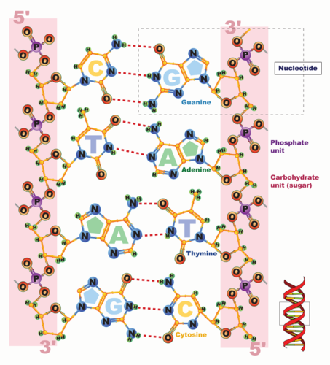
An overview of DNA can be seen at http://www.youtube.com/user/khanacademy#p/c/7A9646BC5110CF64/4/_-vZ_g7K6P0 (28:05).
Go to http://goo.gl/erfcSs for more content. As you view DNA, focus on the structure and role of DNA in all living things.

Basic Structure of Nucleic Acids
Each nucleotide consists of three smaller molecules bound together with covalent bonds:
- sugar
- phosphate group
- nitrogen base
The nitrogen bases in a nucleic acid stick out from the backbone. There are five different types of nitrogen bases: cytosine (C), adenine (A), guanine (G), and either thymine (T) in DNA only, or uracil (U) in RNA only. So, DNA is made of nucleotides that contain AGCT nitrogen bases, RNA are made of nucleotides that contain AGCU bases.
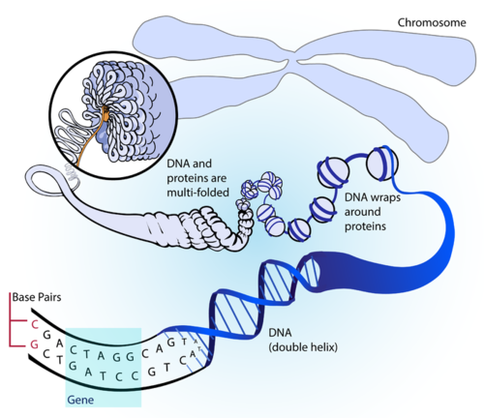
DNA is a double-stranded molecule. In DNA, weak, hydrogen bonds form between bases on the two polynucleotide chains to hold the chains together. Each type of base binds with just one other type of base: cytosine always binds with guanine, and adenine always binds with thymine. These pairs of bases are called complementary base pairs. So, hydrogen bonds between complementary bases (C with G, A with T) hold two polynucleotide chains together.
The binding of complementary bases allows DNA molecules to take their well-known shape, called a double helix, which is shown in the Figure to the right. A double helix is like a spiral staircase. The double helix shape forms naturally, due to chemical attractions between the components of the polynucleotide strands. Bonds between complementary bases help form the double helix of a DNA molecule.
The DNA nucleotides A, T, G, and C (with stands for the bases adenine, thymine, guanine, and cytosine) are in a specific sequence for each of your genes. REMEMBER: genes are sequences of DNA found on chromosomes that contain the code to build proteins! Shown above is how the DNA “supercoils” into a chromosome.
An animation of DNA structure can be viewed at http://www.youtube.com/watch?v=qy8dk5iS1f0&feature=related .

Roles of Nucleic Acids
DNA is also known as the hereditary material or genetic information. Sequences of DNA make up genes; the specific sequence is a code of instructions. Between "starts" and "stops," the code carries instructions for the correct sequence of amino acids in a protein (see Figure below). DNA and RNA have different functions relating to the genetic code and proteins.
DNA is the blueprint to build, where genetic information is stored. RNA uses the information in DNA to assemble the correct amino acids and help make the protein; RNA communicates/uses the DNA information to assemble the protein based on the specific code of nucleotides (the AGCT sequence).
The information in DNA is passed from parent cells to daughter cells whenever cells divide. The information in DNA is also passed from parents to offspring when organisms reproduce. This is how inherited characteristics are passed from one generation to the next.
SUMMARY:
- DNA and RNA are nucleic acids. Nucleic acids are built of small units (monomers) called nucleotides.
- There are three components to every nucleotide: a sugar, a phosphate group and a nitrogen base.
- The bases of DNA are adenine (A), guanine (G), cytosine (C) and thymine (T). In RNA, thymine is replaced by uracil (U).
- DNA is always double-stranded; in DNA, A always binds to a T on the second, neighboring strand, and G always binds to C.
- The shape of the DNA molecule is known as a double helix.
- DNA contains the genetic instructions for the correct sequence of amino acids in proteins. RNA uses the information in DNA to assemble the correct amino acids and help make the protein.
- There are covalent bonds (hard to break!) between the component of one polynucleotide (one strand of DNA) and weaker, Hydrogen bonds between the two polynucleotides that make up double-stranded DNA.

1.13 Nucleic Acids Practice
- DNA consist of monomers called RNA nucleotides. ( True/False )
- The double-stranded nucleic acid that makes up the genes/hereditary info in all living things is called DNA. ( True/False )
- Organic compounds such as DNA or RNA are called amino acids. ( True/False )
- The shape of the DNA molecule is known as a triple helix. ( True/False )
- The nucleic acid RNA (ribonucleic acid) consists of just one polynucleotide chain. ( True/False )
- All living things have DNA as their genetic “blueprint”. ( True/False )
- DNA contains instructions to build what every living thing is made of ( True/False )
- DNA is inherited from parent to offspring ( True/False )
- DNA instructions provide the variation that Natural Section acts on for the evolution of a population/species ( True/False )

10. A single-stranded nucleic acid that helps in making proteins in a cell is _____.

  - RNA
  - DNA
  - Nucleotides
  - Polynucleotide

11. Identify the three parts of a DNA or RNA nucleotide.

12. How are DNA and RNA related to proteins?

