2.1 Common Parts of the Cell
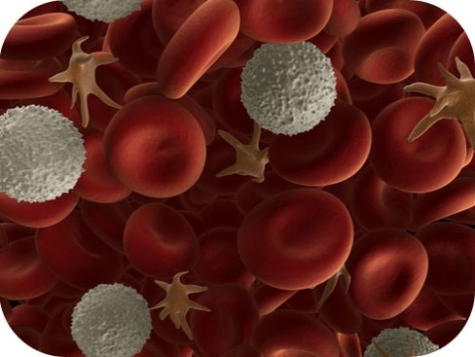
- Identify the parts that all cells have in common.
What's the same between a bacterial cell and one of your cells?
There are many different types of cells, but they all have certain parts in common. As this image of human blood shows, cells come in different shapes and sizes. The shapes and sizes directly influence the function of the cell. Yet, all cells - cells from the smallest bacteria to those in the largest whale - do some similar functions, so they do have parts in common.

Common Parts of Cells

Cell Diversity
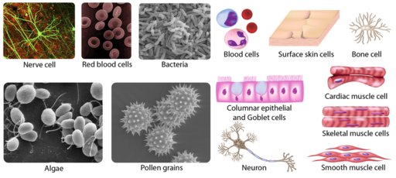
Cells with different functions often have different shapes. The cells pictured in Figure below are just a few examples of the many different shapes that cells may have. Each type of cell in the figure has a shape that helps it do its job. For example, the job of the nerve cell is to carry messages to other cells. The nerve cell has many long extensions that reach out in all directions, allowing it to pass messages to many other cells at once. Do you see the tail-like projections on the algae cells? Algae live in water, and their tails help them swim. Pollen grains have spikes that help them stick to insects such as bees. How do you think the spikes help the pollen grains do their job? (Hint: Insects pollinate flowers.)
As these pictures show, cells come in many different shapes. How are the shapes of these cells related to their functions?

Four Common Parts of a Cell
Although cells are diverse, all cells have certain parts in common. The parts include a plasma membrane, cytoplasm, ribosomes, and DNA.
- The plasma membrane (also called the cell membrane) is a thin coat of phospholipids that surrounds a cell. It forms the physical boundary between the cell and its environment, so you can think of it as the “skin” of the cell.
- Cytoplasm refers to all of the cellular material inside the plasma membrane, other than the nucleus. Cytoplasm is made up of a watery substance called cytosol, and contains other cell structures such as ribosomes.
- Ribosomes are structures in the cytoplasm where proteins are made.
- DNA is a nucleic acid found in cells. It contains the genetic instructions that cells need to make proteins.
These parts are common to all cells, from organisms as different as bacteria and human beings. How did all known organisms come to have such similar cells? The similarities show that all life on Earth has a common evolutionary history.
A nice introduction to the cell is available at http://www.youtube.com/user/khanacademy#p/c/7A9646BC5110CF64/33/Hmwvj9X4GNY (21:03).
Go to http://goo.gl/DO7Tod for more content.

Summary
- Cells come in many different shapes. Cells with different functions often have different shapes.
- Although cells come in diverse shapes, all cells have certain parts in common. These parts include the plasma membrane, cytoplasm, ribosomes, and DNA.

Practice I
Use this resource to answer the questions that follow.
- http://www.hippocampus.org/Biology Biology for AP* Search: Cellular Organelles
- What is included in a cell's cytoplasm? What is in the cytosol?
- How much cytosol is in a cell, compared to the total cell volume?
- Where are ribosomes made? What are ribosomes made from?
- How many ribosomes are in a typical liver cell?
- What are the two general locations ribosomes are located in the cell?

Practice II
- Label the Structure of Bacteria at http://www.neok12.com/diagram/Microorganisms-01.htm .
- Animal Cell at http://www.neok12.com/diagram/Cell-Structures-02.htm .

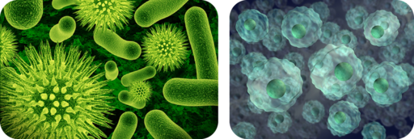
2.2 Prokaryotic and Eukaryotic Cells
- Contrast prokaryotic and eukaryotic cells.
How many different types of cells are there?
There are many different types of cells. For example, in you there are blood cells and skin cells and bone cells and even bacteria. Here we have drawings of bacteria and human cells. Can you tell which depicts various types of bacteria? However, all cells - whether from bacteria, human, or any other organism - will be one of two general types. In fact, all cells other than bacteria will be one type, and bacterial cells will be the other. And it all depends on how the cell stores its DNA.

Two Types of Cells
There is another basic cell structure that is present in many but not all living cells: the nucleus. The nucleus of a cell is a structure in the cytoplasm that is surrounded by a membrane (the nuclear membrane) and contains DNA. Based on whether they have a nucleus, there are two basic types of cells: prokaryotic cells and eukaryotic cells. You can watch animations of both types of cells at the link below. http://www.learnerstv.com/animation/animation.php?ani=162&cat=biology

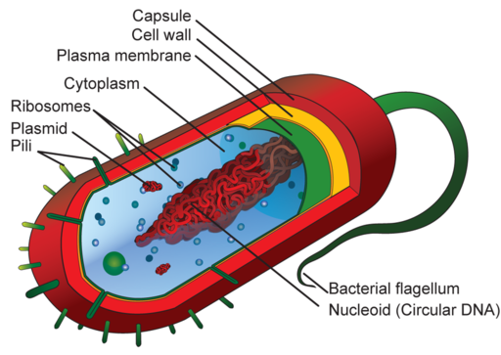
Prokaryotic Cells
Prokaryotic cells are cells without a nucleus. The DNA in prokaryotic cells is in the cytoplasm rather than enclosed within a nuclear membrane. Prokaryotic cells are found in single-celled organisms, such as bacteria, like the one shown in Figure beside. Organisms with prokaryotic cells are called prokaryotes. They were the first type of organisms to evolve and are still the most common organisms today.
Prokaryotic Cell. This diagram shows the structure of a typical prokaryotic cell, a bacterium. Like other prokaryotic cells, this bacterial cell lacks a nucleus but has other cell parts, including a plasma membrane, cytoplasm, ribosomes, and DNA. Identify each of these parts in the diagram.
Bacteria are described in the following video http://www.youtube.com/user/khanacademy#p/c/7A9646BC5110CF64/16/TDoGrbpJJ14 (18:26).
Go to http://goo.gl/4Xl5Dm for more content.

Eukaryotic Cells
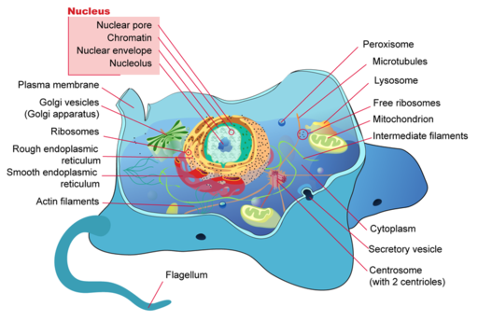
Eukaryotic cells are cells that contain a nucleus. A typical eukaryotic cell is shown in Figure below. Eukaryotic cells are usually larger than prokaryotic cells, and they are found mainly in multicellular organisms. Organisms with eukaryotic cells are called eukaryotes, and they range from fungi to people. Eukaryotic cells also contain other organelles besides the nucleus. An organelle is a structure within the cytoplasm that performs a specific job in the cell. Organelles called mitochondria, for example, provide energy to the cell, and organelles called vacuoles store substances in the cell. Organelles allow eukaryotic cells to carry out more functions than prokaryotic cells can. Ribosomes, the organelle where proteins are made, are the only organelles in prokaryotic cells.
Eukaryotic Cell. Compare and contrast the eukaryotic cell shown here with the prokaryotic cell. What similarities and differences do you see?
In some ways, a cell resembles a plastic bag full of Jell-O. Its basic structure is a plasma membrane filled with cytoplasm. Like Jell-O containing mixed fruit, the cytoplasm of the cell also contains various structures, such as a nucleus and other organelles. You can also explore the structures of an interactive animal cell at this link: http://www.cellsalive.com/cells/cell_model.htm .

Summary
- Prokaryotic cells are cells without a nucleus.
- Eukaryotic cells are cells that contain a nucleus.
- Eukaryotic cells have other organelles besides the nucleus. The only organelles in a prokaryotic cell are ribosomes.

Practice I
Use this resource to answer the questions that follow.
- http://www.hippocampus.org/Biology Biology for AP* Search: Prokaryotes and Eukaryotes
- What is the general difference between prokaryotic and eukaryotic cells?
- Which cells have a nucleus?
- Prokaryotes include members of which Domain(s)?
- Why are prokaryotes described as having a relatively simple structure?
- Define organelle.
- List three organelles specific to eukaryotic cells.
- What is one difference between plant cells and animal cells?
- What is the main function of the chloroplast?
- What does endosymbiosis refer to?

Practice II
- Typical Animal Cell at http://www.wisc-online.com/Objects/ViewObject.aspx?ID=AP11403 .
- Eukaryotic or Prokaryotic, #1 at http://www.neok12.com/quiz/CELSTR03 .
- Eukaryotic or Prokaryotic, #2 at http://www.neok12.com/quiz/CELSTR04 .

2.3 Viruses
- Describe a virus.
What is a virus? Is it even a living organism?
This alien-looking thing is a virus. But is it prokaryotic or eukaryotic? Or neither? Or both? A virus is essentially genetic material surrounded by protein. That's it. So, is a virus prokaryotic or eukaryotic? Or neither? Or both?

Viruses: Prokaryotes or Eukaryotes?
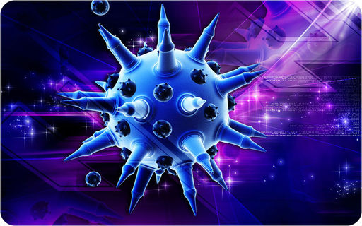
Viruses, like the one depicted in Figure below, are tiny particles that may cause disease. Human diseases caused by viruses include the common cold and flu. Do you think viruses are prokaryotes or eukaryotes? The answer may surprise you. Viruses are not cells at all, so they are neither prokaryotes nor eukaryotes.

Cartoon of a flu virus. The flu virus is a tiny particle that may cause illness in humans. What is a virus? Is it a cell? Is it even alive?

Viruses contain DNA but not much else. They lack the other parts shared by all cells, including a plasma membrane, cytoplasm, and ribosomes. Therefore, viruses are not cells, but are they alive? All living things not only have cells; they are also capable of reproduction. Viruses cannot reproduce by themselves. Instead, they infect living hosts, and use the hosts’ cells to make copies of their own DNA. For these reasons, most scientists do not consider viruses to be living things.
An overview of viruses can be seen at http://www.youtube.com/user/khanacademy#p/c/7A9646BC5110CF64/17/0h5Jd7sgQWY (23:17).
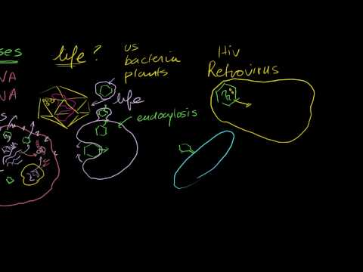
Go to http://goo.gl/DA8FN0 for more content.

Summary
- Viruses are neither prokaryotic or eukaryotic.
- Viruses are not made of cells. Viruses cannot replicate on their own.
- Most scientists do not consider viruses to be living.

Practice
Use this resource to answer the questions that follow.
- http://www.hippocampus.org/Biology Non-Majors Biology Search: Viruses
- Describe a virus.
- Why are viruses considered parasites?
- Describe the outside covering of a virus.
- What do the lytic and lysogenic cycles describe?

Review
1. What is a virus?
2. Explain why viruses are not considered to be living.

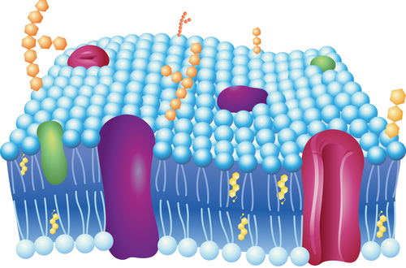
2.4 Phospholipid Bilayers
- Describe the structure and function of the plasma membrane.
All cells have a plasma membrane. This membrane surrounds the cell. So what is its role?
Can molecules enter and leave the cell? Yes. Can anything or everything enter or leave? No. So, what determines what can go in or out? Is it the nucleus? The DNA? Or the plasma membrane?

The Plasma Membrane
The plasma membrane (also known as the cell membrane) forms a barrier between the cytoplasm inside the cell and the environment outside the cell. It protects and supports the cell and also controls everything that enters and leaves the cell. It allows only certain substances to pass through, while keeping others in or out. The ability to allow only certain molecules in or out of the cell is referred to as selective permeability or semipermeability. To understand how the plasma membrane controls what crosses into or out of the cell, you need to know its composition.
The plasma membrane is discussed at http://www.youtube.com/watch?v=-aSfoB8Cmic (6:16).

A Phospholipid Bilayer
The plasma membrane is composed mainly of phospholipids, which consist of fatty acids and alcohol. The phospholipids in the plasma membrane are arranged in two layers, called a phospholipid bilayer. As shown in Figure below, each phospholipid molecule has a head and two tails. The head “loves” water (hydrophilic) and the tails “hate” water (hydrophobic). The water-hating tails are on the interior of the membrane, whereas the water-loving heads point outwards, toward either the cytoplasm or the fluid that surrounds the cell. Molecules that are hydrophobic can easily pass through the plasma membrane, if they are small enough, because they are water-hating like the interior of the membrane. Molecules that are hydrophilic, on the other hand, cannot pass through the plasma membrane—at least not without help—because they are water-loving like the exterior of the membrane.

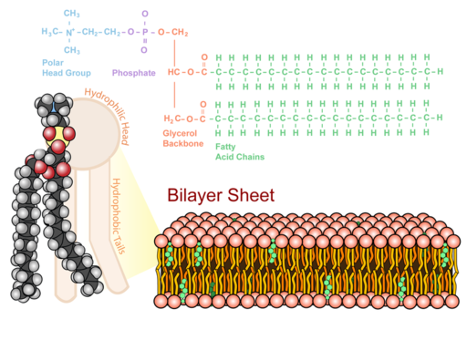
Phospholipid Bilayer. The phospholipid bilayer consists of two layers of phospholipids, with a hydrophobic, or water-hating, interior and a hydrophilic, or water-loving, exterior. The hydrophilic (polar) head group and hydrophobic tails (fatty acid chains) are depicted in the single phospholipid molecule. The polar head group and fatty acid chains are attached by a 3-carbon glycerol unit.
See Insights into cell membranes via dish detergent at http://ed.ted.com/lessons/insights-into-cell-membranes-via-dish-detergent-ethan-perlstein for additional information on the cell membrane.

Summary
- The plasma membrane forms a barrier between the cytoplasm and the environment outside the cell. The plasma membrane has selective permeability.
- The plasma membrane is primarily composed of phospholipids arranged in a bilayer, with the hydrophobic tails on the interior of the membrane, and the hydrophilic heads pointing outwards.

Practice
Use these resources to answer the questions that follow.
- Construction of the Cell Membrane at http://www.wisc-online.com/Objects/ViewObject.aspx?ID=AP1101 .
- What are the two main components of the cell membrane?
- Describe the types of proteins that live in the cell membrane.
- Describe the orientation of the phospholipid molecule in the cell membrane.
- Cell Membranes at http://johnkyrk.com/cellmembrane.html .
- Are all cells surrounded by a membrane?
- Why are phospholipids considered an amphipathic molecule?
- What is a glycolipid?
- Describe the role of cholesterol in the cell membrane.

Review
1. Describe the role of the plasma membrane.
2. Describe the composition of the plasma membrane.
3. Explain why hydrophobic (“water-hating”) molecules can easily cross the plasma membrane, while hydrophilic (“water-loving”) molecules cannot.

2.5 Membrane Proteins
- Describe the structure and function of the plasma membrane.
Can anything or everything move in or out of the cell?
No. It is the semipermeable plasma membrane that determines what can enter and leave the cell. So, if not everything can cross the membrane, how do certain things get across?

Membrane Proteins
The plasma membrane contains molecules other than phospholipids, primarily other lipids and proteins. The green molecules in Figure below, for example, are the lipid cholesterol. Molecules of cholesterol help the plasma membrane keep its shape. Many of the proteins in the plasma membrane assist other substances in crossing the membrane.
The plasma membranes also contain certain types of proteins. A membrane protein is a protein molecule that is attached to, or associated with, the membrane of a cell or an organelle. Membrane proteins can be put into two groups based on how the protein is associated with the membrane.
Integral membrane proteins are permanently embedded within the plasma membrane. They have a range of important functions. Such functions include channeling or transporting molecules across the membrane. Other integral proteins act as cell receptors. Integral membrane proteins can be classified according to their relationship with the bilayer:
- Transmembrane proteins span the entire plasma membrane. Transmembrane proteins are found in all types of biological membranes.
- Integral monotopic proteins are permanently attached to the membrane from only one side.
Some integral membrane proteins are responsible for cell adhesion (sticking of a cell to another cell or surface). On the outside of cell membranes and attached to some of the proteins are carbohydrate chains that act as labels that identify the cell type. Shown in Figure below are two different types of membrane proteins and associated molecules.
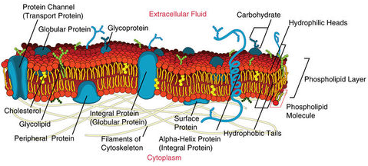
Peripheral membrane proteins are proteins that are only temporarily associated with the membrane. They can be easily removed, which allows them to be involved in cell signaling. Peripheral proteins can also be attached to integral membrane proteins, or they can stick into a small portion of the lipid bilayer by themselves. Peripheral membrane proteins are often associated with ion channels and transmembrane receptors. Most peripheral membrane proteins are hydrophilic.
Some of the membrane proteins make up a major transport system that moves molecules and ions through the polar phospholipid bilayer.

The Fluid Mosaic Model
In 1972 S.J. Singer and G.L. Nicolson proposed the now widely accepted Fluid Mosaic Model of the structure of cell membranes. The model proposes that integral membrane proteins are embedded in the phospholipid bilayer, as seen in Figure above. Some of these proteins extend all the way through the bilayer, and some only partially across it. These membrane proteins act as transport proteins and receptors proteins.
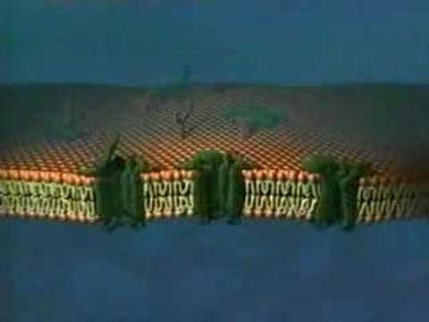
Their model also proposed that the membrane behaves like a fluid, rather than a solid. The proteins and lipids of the membrane move around the membrane, much like buoys in water. Such movement causes a constant change in the "mosaic pattern" of the plasma membrane.
A further description of the Fluid Mosaic Model can be viewed at http://www.youtube.com/watch?v=ULR79TiUj80 (1:27).
Go to http://goo.gl/3SfHzU for more content.

Extensions of the Plasma Membrane
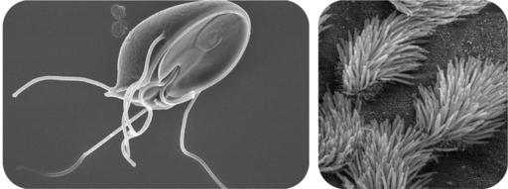
The plasma membrane may have extensions, such as whip-like flagella or brush-like cilia. In single-celled organisms, like those shown in Figure below, the membrane extensions may help the organisms move. In multicellular organisms, the extensions have other functions. For example, the cilia on human lung cells sweep foreign particles and mucus toward the mouth and nose.
Flagella and Cilia. Cilia and flagella are extensions of the plasma membrane of many cells.

Summary
- The plasma membrane has many proteins that assist other substances in crossing the membrane.
- The Fluid Mosaic Model depicts the biological nature of the plasma membrane.
- Cilia and flagella are extensions of the plasma membrane.

Practice
Use these resources to answer the questions that follow.
- Cell Membranes at http://johnkyrk.com/cellmembrane.html .
- What is the major role of many membrane proteins?
- How much of a cell's genetic material may code for membrane proteins?
- What are transmembrane proteins, and what is their main function?
- How can a protein "tunnel" form through the membrane?
- How can a protein "channel" form through the membrane?
- Construction of the Cell Membrane at http://www.wisc-online.com/Objects/ViewObject.aspx?ID=AP1101.
- How may water molecules enter the cell?
- How may ions enter the cell?
- What type(s) of protein(s) identify the cell?

Review
1. What are the main differences between the types of proteins associated with the plasma membrane?
2. Discuss the Fluid Mosaic Model.
3. What are flagella and cilia?

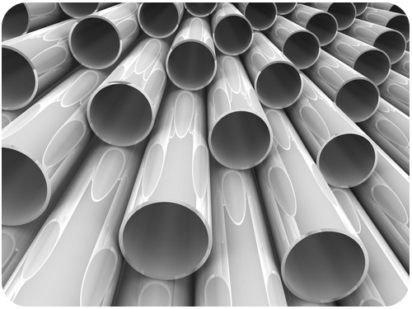
2.6 Cytoplasm and Cytoskeletons
- Identify the roles of the cytoplasm and cytoskeleton.
Does a cell have, or even need, a "skeleton"?
What do you get if you take some tubing, and make the tubes smaller and smaller and smaller? You get very small tubes, or microtubes. Very small tubes, or microtubules, together with microfilaments, form the basis of the "skeleton" inside the cell.

The Cytoplasm and Cytoskeleton
The cytoplasm consists of everything inside the plasma membrane of the cell, excluding the nucleus in an eukaryotic cell. It includes the watery, gel-like material called cytosol, as well as various structures. The water in the cytoplasm makes up about two thirds of the cell’s weight and gives the cell many of its properties.

Functions of the Cytoplasm
The cytoplasm has several important functions, including:
- suspending cell organelles.
- pushing against the plasma membrane to help the cell keep its shape.
- providing a site for many of the biochemical reactions of the cell.

The Cytoskeleton
The cytoskeleton is a cellular "scaffolding" or "skeleton" that crisscrosses the cytoplasm. All eukaryotic cells have a cytoskeleton, and recent research has shown that prokaryotic cells also have a cytoskeleton. The eukaryotic cytoskeleton is made up of a network of long, thin protein fibers and has many functions. It helps to maintain cell shape. It holds organelles in place, and for some cells, it enables cell movement. The cytoskeleton also plays important roles in both the intracellular movement of substances and in cell division. Certain proteins act like a path that vesicles and organelles move along within the cell. The threadlike proteins that make up the cytoskeleton continually rebuild to adapt to the cell's constantly changing needs. Three main kinds of cytoskeleton fibers are microtubules, intermediate filaments, and microfilaments.
- Microtubules, shown in Figure (a), are hollow cylinders and are the thickest of the cytoskeleton structures. They are most commonly made of filaments which are polymers of alpha and beta tubulin, and radiate outwards from an area near the nucleus called the centrosome. Tubulin is the protein that forms microtubules. Two forms of tubulin, alpha and beta, form dimers (pairs) which come together to form the hollow cylinders. The cylinders are twisted around each other to form the microtubules. Microtubules help the cell keep its shape. They hold organelles in place and allow them to move around the cell, and they form the mitotic spindle during cell division. Microtubules also make up parts of cilia and flagella, the organelles that help a cell move.
- Microfilaments, shown in Figure (b), are made of two thin actin chains that are twisted around one another. Microfilaments are mostly concentrated just beneath the cell membrane, where they support the cell and help the cell keep its shape. Microfilaments form cytoplasmatic extentions, such as pseudopodia and microvilli, which allow certain cells to move. The actin of the microfilaments interacts with the protein myosin to cause contraction in muscle cells. Microfilaments are found in almost every cell, and are numerous in muscle cells and in cells that move by changing shape, such as phagocytes (white blood cells that search the body for bacteria and other invaders).
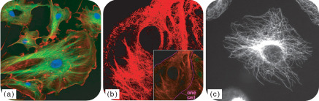
- Intermediate filaments, shown in Figure (c), differ in make-up from one cell type to another. Intermediate filaments organize the inside structure of the cell by holding organelles and providing strength. They are also structural components of the nuclear envelope. Intermediate filaments made of the protein keratin are found in skin, hair, and nails cells.
(a) The eukaryotic cytoskeleton. Microfilaments are shown in red, microtubules in green, and the nuclei in blue. By linking regions of the cell together, the cytoskeleton helps support the shape of the cell. (b) Microscopy of keratin filaments (intermediate filaments) inside cells. (c) Microtubules in a methanol-fixated cell, visualized with anti-beta-tubuline antibodies.
Cytoskeleton Structure
 | Microtubules | Intermediate Filaments | Microfilaments
Fiber Diameter | About 25 nm | 8 to 11 nm | Around 7 nm
Protein Composition | Tubulin, with two subunits, alpha and beta tubulin | One of different types of proteins such as lamin, vimentin, and keratin | Actin
Shape | Hollow cylinders made of two protein chains twisted around each other | Protein fiber coils twisted into each other | Two actin chains twisted around one another
Main Functions | Organelle and vesicle movement; form mitotic spindles during cell reproduction; cell motility (in cilia and flagella) | Organize cell shape; position organelles in cytoplasm; provide structural support of the nuclear envelope and sarcomeres; involved in cell-to-cell and cell-to-matrix junctions | Keep cellular shape; allow movement of certain cells by forming cytoplasmatic extensions or contraction of actin fibers; involved in some cell-to-cell or cell-to-matrix junctions
Image | 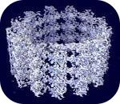Molecular structure of microtubules. | 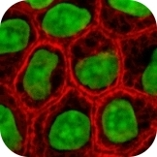 Keratin intermediate filaments in skin cells (stained red). | 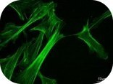 Actin cytoskeleton of mouse embryo cells.
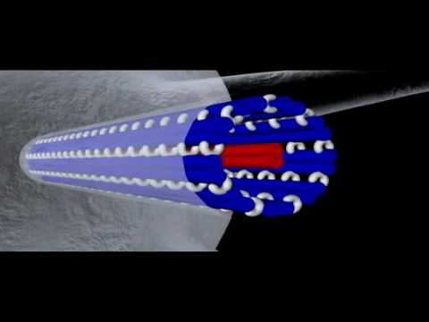
The cytoskeleton is discussed in the following video: http://www.youtube.com/watch?v=5rqbmLiSkpk&feature=related (4:50).

Go to http://goo.gl/NOAvcQ for more content

Summary
- The cytoplasm consists of everything inside the plasma membrane of the cell.
- The cytoskeleton is a cellular "skeleton" that crisscrosses the cytoplasm. Three main cytoskeleton fibers are microtubules, intermediate filaments, and microfilaments.
- Microtubules are the thickest of the cytoskeleton structures and are most commonly made of filaments which are polymers of alpha and beta tubulin.
- Microfilament are the thinnest of the cytoskeleton structures and are made of two thin actin chains that are twisted around one another.

Practice
Use this resource to answer the questions that follow.
- http://www.hippocampus.org/Biology Biology for AP* Search: Cell Structure and Movement
- Identify the roles of the cytoskeleton.
- Describe the structure and functions of microtubules.
- What is a centrosome?
- What are the subunits that make up microfilaments?
- What is the nuclear lamina?
- What is the primary component of cilia and flagella?
- What is the goal of cytoplasmic streaming?

Review
1. What is the difference between cytoplasm and cytosol?
2. List two roles of the cytoplasm.
3. What type of molecule is common to all three parts of the cytoskeleton?
4. Name the three main parts of the cytoskeleton.
5. List two functions of the eukaryotic cytoskeleton.

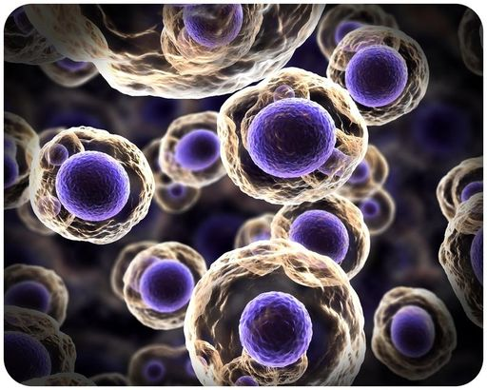
2.7 Cell Nucleus
- Outline the form and function of the nucleus.
Where does the DNA live?
The answer depends on if the cell is prokaryotic or eukaryotic. The main difference between the two types of cells is the presence of a nucleus. And in eukaryotic cells, DNA lives in the nucleus.

The Nucleus
The nucleus is a membrane-enclosed organelle found in most eukaryotic cells. The nucleus is the largest organelle in the cell and contains most of the cell's genetic information (mitochondria also contain DNA, called mitochondrial DNA, but it makes up just a small percentage of the cell’s overall DNA content). The genetic information, which contains the information for the structure and function of the organism, is found encoded in DNA in the form of genes. A gene is a short segment of DNA that contains information to encode an RNA molecule or a protein strand. DNA in the nucleus is organized in long linear strands that are attached to different proteins. These proteins help the DNA coil up for better storage in the nucleus. Think how a string gets tightly coiled up if you twist one end while holding the other end. These long strands of coiled-up DNA and proteins are called chromosomes. Each chromosome contains many genes. The function of the nucleus is to maintain the integrity of these genes and to control the activities of the cell by regulating gene expression. Gene expression is the process by which the information in a gene is "decoded" by various cell molecules to produce a functional gene product, such as a protein molecule or an RNA molecule.
The degree of DNA coiling determines whether the chromosome strands are short and thick or long and thin. Between cell divisions, the DNA in chromosomes is more loosely coiled and forms long, thin strands called chromatin. Before the cell divides, the chromatin coil up more tightly and form chromosomes. Only chromosomes stain clearly enough to be seen under a microscope. The word chromosome comes from the Greek word chroma (color), and soma (body), due to its ability to be stained strongly by dyes.

The Nuclear Envelope
The nuclear envelope is a double membrane of the nucleus that encloses the genetic material. It separates the contents of the nucleus from the cytoplasm. The nuclear envelope is made of two lipid bilayers, an inner membrane and an outer membrane. The outer membrane is continuous with the rough endoplasmic reticulum. Many tiny holes called nuclear pores are found in the nuclear envelope. These nuclear pores help to regulate the exchange of materials (such as RNA and proteins) between the nucleus and the cytoplasm.

The Nucleolus
The nucleus of many cells also contains a non-membrane bound organelle called a nucleolus, shown in Figure below. The nucleolus is mainly involved in the assembly of ribosomes. Ribosomes are organelles made of protein and ribosomal RNA (rRNA), and they build cellular proteins in the cytoplasm. The function of the rRNA is to provide a way of decoding the genetic messages within another type of RNA (called mRNA), into amino acids. After being made in the nucleolus, ribosomes are exported to the cytoplasm, where they direct protein synthesis.
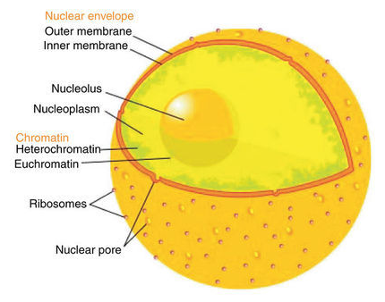
The eukaryotic cell nucleus. Visible in this diagram are the ribosome-studded double membranes of the nuclear envelope, the DNA (as chromatin), and the nucleolus. Within the cell nucleus is a viscous liquid called nucleoplasm, similar to the cytoplasm found outside the nucleus. The chromatin (which is normally invisible), is visible in this figure only to show that it is spread throughout the nucleus.

Summary
- The nucleus is a membrane-enclosed organelle, found in most eukaryotic cells, which stores the genetic material (DNA).
- The nucleus is surrounded by a double lipid bilayer, the nuclear envelope, which is embedded with nuclear pores.
- The nucleolus is inside the nucleus, and is where ribosomes are made.

Review
1. What is the role of the nucleus of a eukaryotic cell?
2. Describe the nuclear membrane.
3. What are nuclear pores?
4. What is the role of the nucleolus?

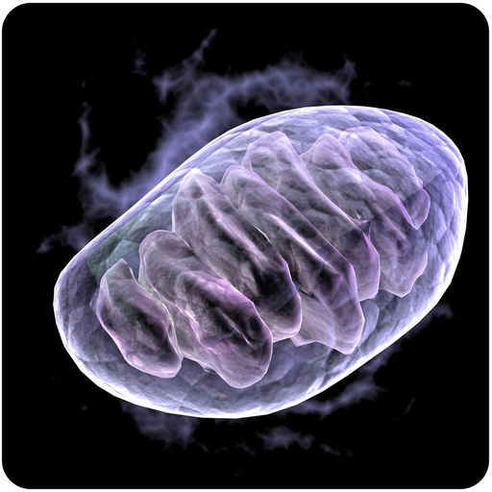
2.8 Ribosomes & Mitochondria
- Outline the form and function of organelles, including ribosomes and mitochondria.
Sperm cells and muscle cells need lots of energy. What do they have in common?
They have lots of mitochondria. Mitochondria are called the power plants of the cell, as these organelles are where most of the cell's energy is produced. Cells that need lots of energy have lots of mitochondria.

Other Organelles
In addition to the nucleus, eukaryotic cells have many other organelles, including ribosomes and mitochondria. Ribosomes are present in all cells.

Ribosomes
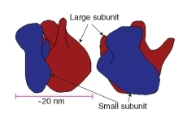
Ribosomes are small organelles and are the site of protein synthesis (or assembly). They are made of ribosomal protein and ribosomal RNA. Each ribosome has two parts, a large and a small subunit, as shown in Figure below. The subunits are attached to one another. Ribosomes can be found alone or in groups within the cytoplasm. Some ribosomes are attached to the endoplasmic reticulum (ER) (as shown in Figure below), and others are attached to the nuclear envelope.
The two subunits that make up a ribosome, small organelles that are intercellular protein factories.

Ribozymes are RNA molecules that catalyze chemical reactions, such as translation. Translation is the process of ordering the amino acids in the assembly of a protein, and translation will be discussed more in another concept. Briefly, the ribosomes interact with other RNA molecules to make chains of amino acids called polypeptide chains, due to the peptide bond that forms between individual amino acids. Polypeptide chains are built from the genetic instructions held within a messenger RNA (mRNA) molecule. Polypeptide chains that are made on the rough ER (discussed below) are inserted directly into the ER and then are transported to their various cellular destinations. Ribosomes on the rough ER usually produce proteins that are destined for the cell membrane.
Ribosomes are found in both eukaryotic and prokaryotic cells. Ribosomes are not surrounded by a membrane. The other organelles found in eukaryotic cells are surrounded by a membrane.

Mitochondria
A mitochondrion (mitochondria, plural), is a membrane-enclosed organelle that is found in most eukaryotic cells. Mitochondria are called the "power plants" of the cell because they use energy from organic compounds to make ATP (adenosine triphosphate). ATP is the cell's energy source that is used for such things such as movement and cell division. Some ATP is made in the cytosol of the cell, but most of it is made inside mitochondria. The number of mitochondria in a cell depends on the cell’s energy needs. For example, active human muscle cells may have thousands of mitochondria, while less active red blood cells do not have any.
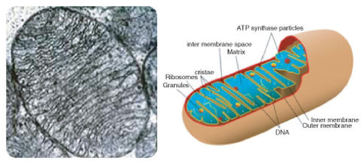
(a): Electron micrograph of a single mitochondrion, within which you can see many cristae. Mitochondria range from 1 to 10 μm in size. (b): This model of a mitochondrion shows the organized arrangement of the inner and outer membranes, the protein matrix, and the folded inner mitochondrial membranes.
As Figure above (a) and (b) show, a mitochondrion has two phospholipid membranes. The smooth outer membrane separates the mitochondrion from the cytosol. The inner membrane has many folds, called cristae. The fluid-filled inside of the mitochondrion, called matrix, is where most of the cell’s ATP is made.
Although most of a cell's DNA is contained in the cell nucleus, mitochondria have their own DNA. Mitochondria are able to reproduce asexually, and scientists think that they are descended from prokaryotes. According to the endosymbiotic theory, mitochondria were once free-living prokaryotes that infected ancient eukaryotic cells. The invading prokaryotes were protected inside the eukaryotic host cell, and in turn the prokaryote supplied extra ATP to its host.

Summary
- Ribosomes are small organelles and are the site of protein synthesis. Ribosomes are found in all cells.
- Mitochondria are where energy from organic compounds is used to make ATP.

Practice
Use this resource to answer the questions that follow.
- http://www.hippocampus.org/Biology Biology for AP* Search: Cellular Organelles
- What happens at the ribosome?
- Describe the structure of a ribosome.
- Where in the cell are ribosomes located?
- Why is the mitochondrion referred to as the "power plant" of the cell?
- Describe the structure of a mitochondrion. What is the cristae?

Review
1. What is the function of a ribosome?
2. What is a significant difference between the structure of a ribosome and other organelles?
3. Identify the reason why mitochondria are called "power plants" of the cell.

2.9 Other Cell Organelles
- Outline the form and function of organelles.
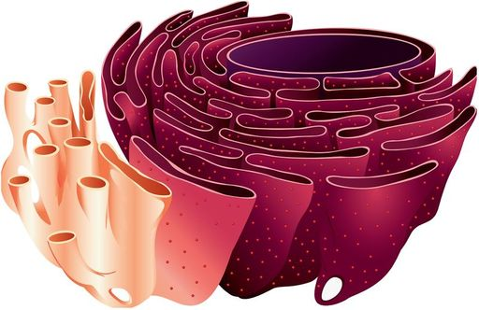
Does a cell have its own ER?
Yes, but in this case, the ER is not just for emergencies. True, there might be times when the cell responds to emergency conditions and the functions of the ER may be needed, but usually the cell's ER is involved in normal functions. Proteins are also made on the outside of the ER, and this starts a whole process of protein transport, both around the inside of the cell and to the cell membrane and out.

Other Organelles
In addition to the nucleus, eukaryotic cells have many other organelles, including the endoplasmic reticulum, Golgi apparatus, vesicles, vacuoles, and centrioles.

Endoplasmic Reticulum
The endoplasmic reticulum (ER) (plural, reticuli) is a network of phospholipid membranes that form hollow tubes, flattened sheets, and round sacs. These flattened, hollow folds and sacs are called cisternae. The ER has two major functions:
- Transport: Molecules, such as proteins, can move from place to place inside the ER, much like on an intracellular highway.
- Synthesis: Ribosomes that are attached to ER, similar to unattached ribosomes, make proteins. Lipids are also produced in the ER.
There are two types of endoplasmic reticulum, rough endoplasmic reticulum (RER) and smooth endoplasmic reticulum (SER).
- Rough endoplasmic reticulum is studded with ribosomes, which gives it a "rough" appearance. These ribosomes make proteins that are then transported from the ER in small sacs called transport vesicles. The transport vesicles pinch off the ends of the ER. The rough endoplasmic reticulum works with the Golgi apparatus to move new proteins to their proper destinations in the cell. The membrane of the RER is continuous with the outer layer of the nuclear envelope.
- Smooth endoplasmic reticulum does not have any ribosomes attached to it, and so it has a smooth appearance. SER has many different functions, some of which include lipid synthesis, calcium ion storage, and drug detoxification. Smooth endoplasmic reticulum is found in both animal and plant cells and it serves different functions in each. The SER is made up of tubules and vesicles that branch out to form a network. In some cells there are dilated areas like the sacs of RER. Smooth endoplasmic reticulum and RER form an interconnected network.
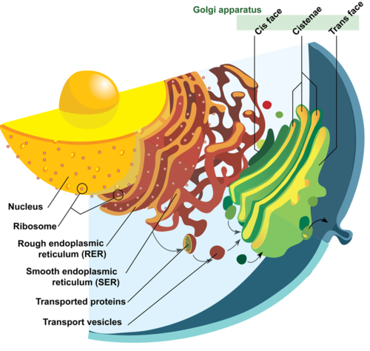
Image of nucleus, endoplasmic reticulum and Golgi apparatus, and how they work together. The process of secretion from endoplasmic reticuli to Golgi apparatus is shown.

Golgi Apparatus
The Golgi apparatus is a large organelle that is usually made up of five to eight cup-shaped, membrane-covered discs called cisternae, as shown in Figure above. The cisternae look a bit like a stack of deflated balloons. The Golgi apparatus modifies, sorts, and packages different substances for secretion out of the cell, or for use within the cell. The Golgi apparatus is found close to the nucleus of the cell, where it modifies proteins that have been delivered in transport vesicles from the RER. It is also involved in the transport of lipids around the cell. Pieces of the Golgi membrane pinch off to form vesicles that transport molecules around the cell. The Golgi apparatus can be thought of as similar to a post office; it packages and labels "items" and then sends them to different parts of the cell. Both plant and animal cells have a Golgi apparatus. Plant cells can have up to several hundred Golgi stacks scattered throughout the cytoplasm. In plants, the Golgi apparatus contains enzymes that synthesize some of the cell wall polysaccharides.

Vesicles
A vesicle is a small, spherical compartment that is separated from the cytosol by at least one lipid bilayer. Many vesicles are made in the Golgi apparatus and the endoplasmic reticulum, or are made from parts of the cell membrane. Vesicles from the Golgi apparatus can be seen in Figure above. Because it is separated from the cytosol, the space inside the vesicle can be made to be chemically different from the cytosol. Vesicles are basic tools of the cell for organizing metabolism, transport, and storage of molecules. Vesicles are also used as chemical reaction chambers. They can be classified by their contents and function.
- Transport vesicles are able to move molecules between locations inside the cell. For example, transport vesicles move proteins from the rough endoplasmic reticulum to the Golgi apparatus.
- Lysosomes are vesicles that are formed by the Golgi apparatus. They contain powerful enzymes that could break down (digest) the cell. Lysosomes break down harmful cell products, waste materials, and cellular debris and then force them out of the cell. They also digest invading organisms such as bacteria. Lysosomes also break down cells that are ready to die, a process called autolysis.
- Peroxisomes are vesicles that use oxygen to break down toxic substances in the cell. Unlike lysosomes, which are formed by the Golgi apparatus, peroxisomes self-replicate by growing bigger and then dividing. They are common in liver and kidney cells that break down harmful substances. Peroxisomes are named for the hydrogen peroxide (H ₂ O ₂ ) that is produced when they break down organic compounds. Hydrogen peroxide is toxic, and in turn is broken down into water (H ₂ O) and oxygen (O ₂ ) molecules.

Vacuoles
Vacuoles are membrane-bound organelles that can have secretory, excretory, and storage functions. Many organisms will use vacuoles as storage areas and some plant cells have very large vacuoles. Vesicles are much smaller than vacuoles and function in transporting materials both within and to the outside of the cell.

Centrioles
Centrioles are rod-like structures made of short microtubules. Nine groups of three microtubules make up each centriole. Two perpendicular centrioles make up the centrosome. Centrioles are very important in cellular division, where they arrange the mitotic spindles that pull the chromosome apart during mitosis.

Summary
- The endoplasmic reticulum (ER) is involved in the synthesis of lipids and synthesis and transport of proteins.
- The Golgi apparatus modifies, sorts, and packages different substances for secretion out of the cell, or for use within the cell.
- Vesicles are also used as chemical reaction chambers. Transport vesicles, lysosomes, and peroxisomes are types of vesicles.
- Vacuoles have secretory, excretory, and storage functions.
- Centrioles are made of short microtubules and are very important in cell division.

Practice I
- Where in the cell are the endoplasmic reticulum and Golgi apparatus located?
- What are the roles of the ER, the Golgi apparatus, and the lysosome?
- How do proteins move from the ER to the Golgi apparatus?
- Why do digestive enzymes have to be located in a lysosome and not the cytosol?
- What is the main difference between a lysosome and a peroxisome?

Practice II
- Eucaryotic Cell Interactive Animation: Animal Cell at http://www.cellsalive.com/cells/cell_model.htm .
- Quiz on Cell Organelles #1 at http://www.neok12.com/quiz/CELSTR05 .
- Quiz on Cell Organelles #2 at http://www.neok12.com/quiz/CELSTR06 .
- Quiz on Cell Organelles #3 at http://www.neok12.com/quiz/CELSTR07 .
- Who Does What, Quiz #1 at http://www.neok12.com/quiz/CELSTR11 .

Review
1. List five organelles eukaryotes have that prokaryotes do not have.
2. Explain how the following organelles ensure that a cell has the proteins it needs: nucleus, rough and smooth ER, vesicles, and Golgi apparatus.
3. What is the main difference between rough endoplasmic reticulum and smooth endoplasmic reticulum?
4. Describe the three types of vesicles.

2.10 Plant Cell Structures
- List special structures of plant cells, and state what they do.
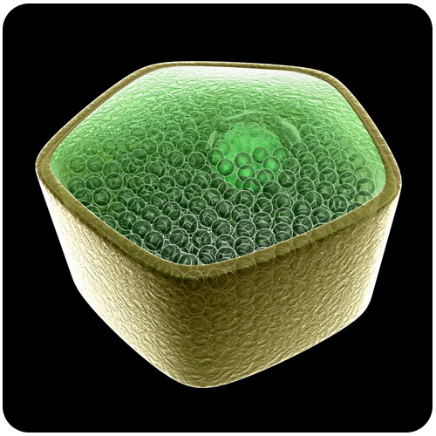
What do plants have to do that animals don't?
Many plant cells are green. Why? Plant cells also usually have a distinct shape. The rigid exterior around the cells is necessary to allow the plants to grow upright. Animal cells do not have these rigid exteriors. There are other distinct differences between plant and animal cells. These will be the focus of this concept.

Plant Cells

Special Structures in Plant Cells
Most organelles are common to both animal and plant cells. However, plant cells also have features that animal cells do not have: a cell wall, a large central vacuole, and plastids such as chloroplasts.
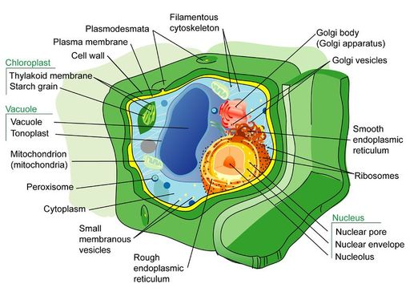
Plants have very different lifestyles from animals, and these differences are apparent when you examine the structure of the plant cell. Plants make their own food in a process called photosynthesis. They take in carbon dioxide (CO ₂ ) and water (H ₂ O) and convert them into sugars. The features unique to plant cells can be seen in Figure below.
In addition to containing most of the organelles found in animal cells, plant cells also have a cell wall, a large central vacuole, and plastids. These three features are not found in animal cells.

The Cell Wall
A cell wall is a rigid layer that is found outside the cell membrane and surrounds the cell. The cell wall contains not only cellulose and protein, but other polysaccharides as well. The cell wall provides structural support and protection. Pores in the cell wall allow water and nutrients to move into and out of the cell. The cell wall also prevents the plant cell from bursting when water enters the cell.
Microtubules guide the formation of the plant cell wall. Cellulose is laid down by enzymes to form the primary cell wall. Some plants also have a secondary cell wall. The secondary wall contains a lignin, a secondary cell component in plant cells that have completed cell growth/expansion.

The Central Vacuole
Most mature plant cells have a central vacuole that occupies more than 30% of the cell's volume. The central vacuole can occupy as much as 90% of the volume of certain cells. The central vacuole is surrounded by a membrane called the tonoplast. The central vacuole has many functions. Aside from storage, the main role of the vacuole is to maintain turgor pressure against the cell wall. Proteins found in the tonoplast control the flow of water into and out of the vacuole. The central vacuole also stores the pigments that color flowers.
The central vacuole contains large amounts of a liquid called cell sap, which differs in composition to the cell cytosol. Cell sap is a mixture of water, enzymes, ions, salts, and other substances. Cell sap may also contain toxic byproducts that have been removed from the cytosol. Toxins in the vacuole may help to protect some plants from being eaten.

Plastids
Plant plastids are a group of closely related membrane-bound organelles that carry out many functions. They are responsible for photosynthesis, for storage of products such as starch, and for the synthesis of many types of molecules that are needed as cellular building blocks. Plastids have the ability to change their function between these and other forms. Plastids contain their own DNA and some ribosomes, and scientists think that plastids are descended from photosynthetic bacteria that allowed the first eukaryotes to make oxygen. The main types of plastids and their functions are:
- Chloroplasts are the organelle of photosynthesis. They capture light energy from the sun and use it with water and carbon dioxide to make food (sugar) for the plant. The arrangement of chloroplasts in a plant’s cells can be seen in Figure below.
- Chromoplasts make and store pigments that give petals and fruit their orange and yellow colors.
- Leucoplasts do not contain pigments and are located in roots and non-photosynthetic tissues of plants. They may become specialized for bulk storage of starch, lipid, or protein. However, in many cells, leucoplasts do not have a major storage function. Instead, they make molecules such as fatty acids and many amino acids.
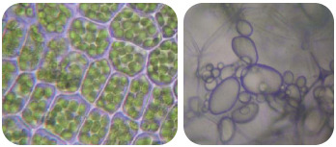
Plant cells with visible chloroplasts (left). Starch-storing potato leucoplasts (right).

Chloroplasts
Chloroplasts capture light energy from the sun and use it with water and carbon dioxide to produce sugars for food. Chloroplasts look like flat discs and are usually 2 to 10 micrometers in diameter and 1 micrometer thick. A model of a chloroplast is shown in Figure below. The chloroplast is enclosed by an inner and an outer phospholipid membrane. Between these two layers is the intermembrane space. The fluid within the chloroplast is called the stroma, and it contains one or more molecules of small, circular DNA. The stroma also has ribosomes. Within the stroma are stacks of thylakoids, sub-organelles that are the site of photosynthesis. The thylakoids are arranged in stacks called grana (singular: granum). A thylakoid has a flattened disk shape. Inside it is an empty area called the thylakoid space or lumen. Photosynthesis takes place on the thylakoid membrane.
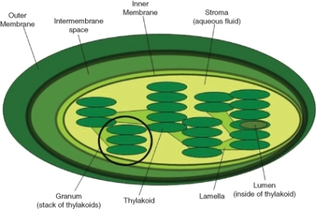
Within the thylakoid membrane is the complex of proteins and light-absorbing pigments, such as chlorophyll and carotenoids. This complex allows capture of light energy from many wavelengths because chlorophyll and carotenoids both absorb different wavelengths of light. These will be further discussed in the "Photosynthesis" concept.

The internal structure of a chloroplast, with a granal stack of thylakoids circled.

Summary
- Plant cells have a cell wall, a large central vacuole, and plastids such as chloroplasts.
- The cell wall is a rigid layer that is found outside the cell membrane and surrounds the cell, providing structural support and protection.
- The central vacuole maintains turgor pressure against the cell wall.
- Chloroplasts capture light energy from the sun and use it with water and carbon dioxide to produce sugars for food.

Practice I
- Label the Diagram of Plant Cell at http://www.neok12.com/diagram/Cell-Structures-01.htm .
- Plant vs. Animal Cells at http://www.neok12.com/quiz/CELSTR08 .
- Eukaryotic Cell Interactive Animation: Plant Cell at http://www.cellsalive.com/cells/cell_model.htm .

Review
1. List and describe three structures that are found in plant cells but not in animal cells.
2. Identify two functions of plastids in plant cells.
- In addition to plants, what other organisms have chloroplasts?
4. What is the role of the cell wall?

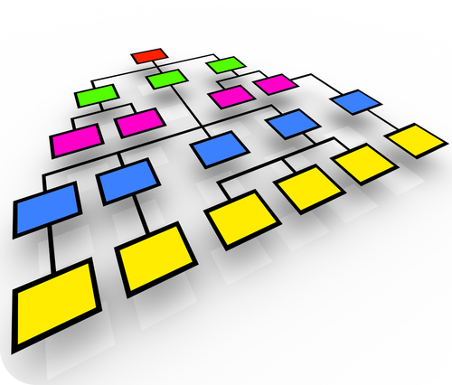
2.11 Organization of Cells
- Explain how cells are organized in living things.
Why be organized?
It can be said organization leads to efficiency. And in you, cells are organized into tissues, which are organized into organs, which are organized into organ systems, which form you. And it can be said that the human body is a very organized and efficient system.

Organization of Cells
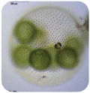
Biological organization exists at all levels in organisms. It can be seen at the smallest level, in the molecules that made up such things as DNA and proteins, to the largest level, in an organism such as a blue whale, the largest mammal on Earth. Similarly, single celled prokaryotes and eukaryotes show order in the way their cells are arranged. Single-celled organisms such as an amoeba are free-floating and independent-living. Their single-celled "bodies" are able to carry out all the processes of life, such as metabolism and respiration, without help from other cells. Some single-celled organisms, such as bacteria, can group together and form a biofilm. A biofilm is a large grouping of many bacteria that sticks to a surface and makes a protective coating over itself. Biofilms can show similarities to multicellular organisms. Division of labor is the process in which one group of cells does one job (such as making the "glue" that sticks the biofilm to the surface), while another group of cells does another job (such as taking in nutrients). Multicellular organisms carry out their life processes through division of labor. They have specialized cells that do specific jobs. However, biofilms are not considered multicellular organisms and are instead called colonial organisms. The difference between a multicellular organism and a colonial organism is that individual organisms from a colony or biofilm can, if separated, survive on their own, while cells from a multicellular organism (e.g., liver cells) cannot.
Colonial algae of the genus Volvox.

Colonial Organisms
Colonial organisms were probably one of the first evolutionary steps towards multicellular organisms. Algae of the genus Volvox are an example of the border between colonial organisms and multicellular organisms.
Each Volvox, shown in Figure above, is a colonial organism. It is made up of between 1,000 to 3,000 photosynthetic algae that are grouped together into a hollow sphere. The sphere has a distinct front and back end. The cells have eyespots, which are more developed in the cells near the front. This enables the colony to swim towards light.

Origin of Multicellularity
The oldest known multicellular organism is a red algae Bangiomorpha pubescens, fossils of which were found in 1.2 billion-year-old rock. As the first organisms were single-celled, these organisms had to evolve into multicellular organisms.
Scientists think that multicellularity arose from cooperation between many organisms of the same species. The Colonial Theory proposes that this cooperation led to the development of a multicellular organism. Many examples of cooperation between organisms in nature have been observed. For example, a certain species of amoeba (a single-celled protist) groups together during times of food shortage and forms a colony that moves as one to a new location. Some of these amoebas then become slightly differentiated from each other. Volvox, shown in Figure above, is another example of a colonial organism. Most scientists accept that the Colonial Theory explains how multicellular organisms evolved.
Multicellular organisms are organisms that are made up of more than one type of cell and have specialized cells that are grouped together to carry out specialized functions. Most life that you can see without a microscope is multicellular. As discussed earlier, the cells of a multicellular organism would not survive as independent cells. The body of a multicellular organism, such as a tree or a cat, exhibits organization at several levels: tissues, organs, and organ systems. Similar cells are grouped into tissues, groups of tissues make up organs, and organs with a similar function are grouped into an organ system.

Levels of Organization in Multicellular Organisms
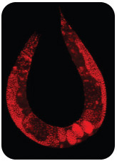
The simplest living multicellular organisms, sponges, are made of many specialized types of cells that work together for a common goal. Such cell types include digestive cells, tubular pore cells, and epidermal cells. Though the different cell types create a large, organized, multicellular structure — the visible sponge — they are not organized into true interconnected tissues. If a sponge is broken up by passing it through a sieve, the sponge will reform on the other side. However, if the sponge’s cells are separated from each other, the individual cell types cannot survive alone. Simpler colonial organisms, such as members of the genus Volvox, as shown in Figure above, differ in that their individual cells are free-living and can survive on their own if separated from the colony.
This roundworm, a multicellular organism, was stained to highlight the nuclei of all the cells in its body (red dots).
A tissue is a group of connected cells that have a similar function within an organism. More complex organisms such as jellyfish, coral, and sea anemones have a tissue level of organization. For example, jellyfish have tissues that have separate protective, digestive, and sensory functions.
Even more complex organisms, such as the roundworm shown in Figure above, while also having differentiated cells and tissues, have an organ level of development. An organ is a group of tissues that has a specific function or group of functions. Organs can be as primitive as the brain of a flatworm (a group of nerve cells), as large as the stem of a sequoia (up to 90 meters, or 300 feet, in height), or as complex as a human liver.
The most complex organisms (such as mammals, trees, and flowers) have organ systems. An organ system is a group of organs that act together to carry out complex related functions, with each organ focusing on a part of the task. An example is the human digestive system, in which the mouth ingests food, the stomach crushes and liquifies it, the pancreas and gall bladder make and release digestive enzymes, and the intestines absorb nutrients into the blood.

Summary
- Single-celled organisms are able to carry out all the processes of life without help from other cells.
- Multicellular organisms carry out their life processes through division of labor. They have specialized cells that do specific jobs.
- The Colonial Theory proposes that cooperation among cells of the same species led to the development of a multicellular organism.
- Multicellular organisms, depending on their complexity, may be organized from cells to tissues, organs, and organ systems.

Practice
- Why are multicellular organisms highly organized?
- What is a tissue?
- What is the difference between an organ and an organ system?
- How many organ systems do humans have?

Review
1. What is a cell feature that distinguishes a colonial organism from a multicellular organism?
2. What is the difference between a cell and a tissue?
3. Describe the levels of organization of an organism.

2.12 Diffusion
- Describe different types of passive transport.
What will eventually happen to these dyes?
They will all blend together. The dyes will move through the water until an even distribution is achieved. The process of moving from areas of high amounts to areas of low amounts is called diffusion.

Passive Transport
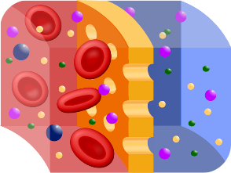
Probably the most important feature of a cell’s phospholipid membranes is that they are selectively permeable or semipermeable. A membrane that is selectively permeable has control over what molecules or ions can enter or leave the cell, as shown in Figure below. The permeability of a membrane is dependent on the organization and characteristics of the membrane lipids and proteins. In this way, cell membranes help maintain a state of homeostasis within cells (and tissues, organs, and organ systems) so that an organism can stay alive and healthy.

Transport Across Membranes
The molecular make-up of the phospholipid bilayer limits the types of molecules that can pass through it. For example, hydrophobic (water-hating) molecules, such as carbon dioxide (CO ₂ ) and oxygen (O ₂ ), can easily pass through the lipid bilayer, but ions such as calcium (Ca ²⁺ ) and polar molecules such as water (H ₂ O) cannot. The hydrophobic interior of the phospholipid bilayer does not allow ions or polar molecules through because they are hydrophilic, or water loving. In addition, large molecules such as sugars and proteins are too big to pass through the bilayer. Transport proteins within the membrane allow these molecules to pass through the membrane, and into or out of the cell. This way, polar molecules avoid contact with the nonpolar interior of the membrane, and large molecules are moved through large pores.
Every cell is contained within a membrane punctuated with transport proteins that act as channels or pumps to let in or force out certain molecules. The purpose of the transport proteins is to protect the cell's internal environment and to keep its balance of salts, nutrients, and proteins within a range that keeps the cell and the organism alive.
There are three main ways that molecules can pass through a phospholipid membrane. The first way requires no energy input by the cell and is called passive transport. The second way requires that the cell uses energy to pull in or pump out certain molecules and ions and is called active transport. The third way is through vesicle transport, in which large molecules are moved across the membrane in bubble-like sacks that are made from pieces of the membrane.
Passive transport is a way that small molecules or ions move across the cell membrane without input of energy by the cell. The three main kinds of passive transport are diffusion, osmosis, and facilitated diffusion.

Diffusion
Diffusion is the movement of molecules from an area of high concentration of the molecules to an area with a lower concentration. The difference in the concentrations of the molecules in the two areas is called the concentration gradient . Diffusion will continue until this gradient has been eliminated. Since diffusion moves materials from an area of higher concentration to the lower, it is described as moving solutes "down the concentration gradient." The end result of diffusion is an equal concentration, or equilibrium , of molecules on both sides of the membrane.
If a molecule can pass freely through a cell membrane, it will cross the membrane by diffusion ( Figure below ).
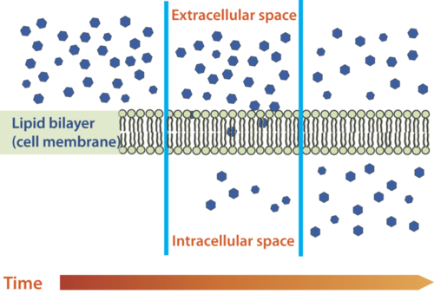
Molecules move from an area of high concentration to an area of lower concentration until an equilibrium is met. The molecules continue to cross the membrane at equilibrium, but at equal rates in both directions.

Summary
- The cell membrane is selectively permeable, allowing only certain substances to pass through.
- Passive transport is a way that small molecules or ions move across the cell membrane without input of energy by the cell. The three main kinds of passive transport are diffusion, osmosis, and facilitated diffusion.
- Diffusion is the movement of molecules from an area of high concentration of the molecules to an area with a lower concentration.

Practice I
Use this resource to answer the questions that follow.
- http://www.hippocampus.org/Biology Biology for AP* Search: Transport Mechanisms
- Is simple diffusion a form of passive transport? Explain your answer.
- What is a concentration gradient?
- Give an example of a molecule that can enter a cell by simple diffusion.

Practice II
- Diffusion, Osmosis and Active Transport at http://www.concord.org/activities/diffusion-osmosis-and-active-transport .

Review
1. What is diffusion?
2. What is a concentration gradient?
3. What is meant by passive transport?

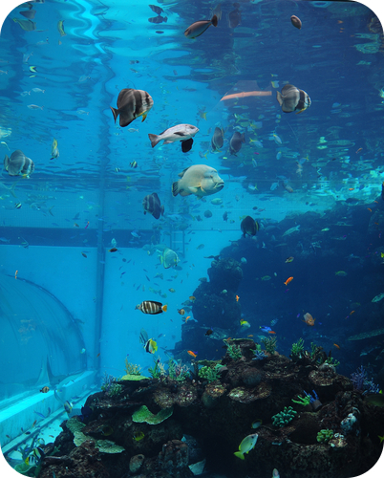
2.13 Osmosis
- Describe different types of passive transport.

Saltwater Fish vs. Freshwater Fish?
Fish cells, like all cells, have semi-permeable membranes. Eventually, the concentration of "stuff" on either side of them will even out. A fish that lives in salt water will have somewhat salty water inside itself. Put it in the freshwater, and the freshwater will, through osmosis, enter the fish, causing its cells to swell, and the fish will die. What will happen to a freshwater fish in the ocean?

Osmosis
Imagine you have a cup that has 100ml water, and you add 15g of table sugar to the water. The sugar dissolves and the mixture that is now in the cup is made up of a solute (the sugar) that is dissolved in the solvent (the water). The mixture of a solute in a solvent is called a solution.
Imagine now that you have a second cup with 100ml of water, and you add 45 grams of table sugar to the water. Just like the first cup, the sugar is the solute, and the water is the solvent. But now you have two mixtures of different solute concentrations. In comparing two solutions of unequal solute concentration, the solution with the higher solute concentration is hypertonic, and the solution with the lower solute concentration is hypotonic. Solutions of equal solute concentration are isotonic. The first sugar solution is hypotonic to the second solution. The second sugar solution is hypertonic to the first.
You now add the two solutions to a beaker that has been divided by a selectively permeable membrane, with pores that are too small for the sugar molecules to pass through, but are big enough for the water molecules to pass through. The hypertonic solution is on one side of the membrane and the hypotonic solution on the other. The hypertonic solution has a lower water concentration than the hypotonic solution, so a concentration gradient of water now exists across the membrane. Water molecules will move from the side of higher water concentration to the side of lower concentration until both solutions are isotonic. At this point, equilibrium is reached.
Osmosis is the diffusion of water molecules across a selectively permeable membrane from an area of higher concentration to an area of lower concentration. Water moves into and out of cells by osmosis. If a cell is in a hypertonic solution, the solution has a lower water concentration than the cell cytosol, and water moves out of the cell until both solutions are isotonic. Cells placed in a hypotonic solution will take in water across their membrane until both the external solution and the cytosol are isotonic.
A cell that does not have a rigid cell wall, such as a red blood cell, will swell and lyse (burst) when placed in a hypotonic solution. Cells with a cell wall will swell when placed in a hypotonic solution, but once the cell is turgid (firm), the tough cell wall prevents any more water from entering the cell. When placed in a hypertonic solution, a cell without a cell wall will lose water to the environment, shrivel, and probably die. In a hypertonic solution, a cell with a cell wall will lose water too. The plasma membrane pulls away from the cell wall as it shrivels, a process called plasmolysis. Animal cells tend to do best in an isotonic environment, plant cells tend to do best in a hypotonic environment. This is demonstrated in Figure below.
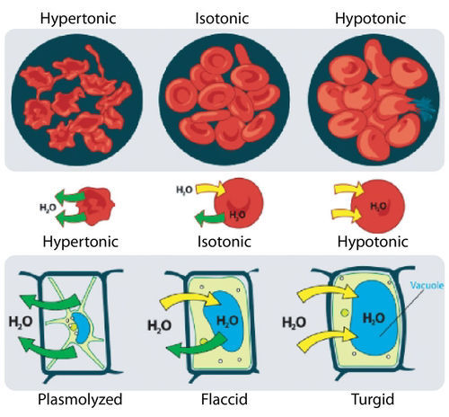
Unless an animal cell (such as the red blood cell in the top panel) has an adaptation that allows it to alter the osmotic uptake of water, it will lose too much water and shrivel up in a hypertonic environment. If placed in a hypotonic solution, water molecules will enter the cell, causing it to swell and burst. Plant cells (bottom panel) become plasmolyzed in a hypertonic solution, but tend to do best in a hypotonic environment. Water is stored in the central vacuole of the plant cell.

Osmotic Pressure
When water moves into a cell by osmosis, osmotic pressure may build up inside the cell. If a cell has a cell wall, the wall helps maintain the cell’s water balance. Osmotic pressure is the main cause of support in many plants. When a plant cell is in a hypotonic environment, the osmotic entry of water raises the turgor pressure exerted against the cell wall until the pressure prevents more water from coming into the cell. At this point the plant cell is turgid. The effects of osmotic pressures on plant cells are shown in Figure below .
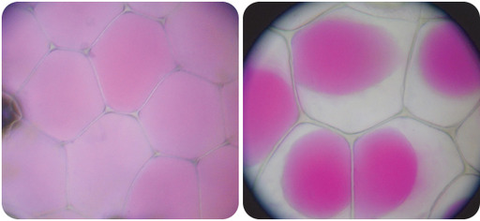
The central vacuoles of the plant cells in the left image are full of water, so the cells are turgid. The plant cells in the right image have been exposed to a hypertonic solution; water has left the central vacuole and the cells have become plasmolysed.

The action of osmosis can be very harmful to organisms, especially ones without cell walls. For example, if a saltwater fish (whose cells are isotonic with seawater), is placed in fresh water, its cells will take on excess water, lyse, and the fish will die. Another example of a harmful osmotic effect is the use of table salt to kill slugs and snails.
Diffusion and osmosis are discussed at http://www.youtube.com/user/khanacademy#p/c/7A9646BC5110CF64/34/aubZU0iWtgI (18:59).
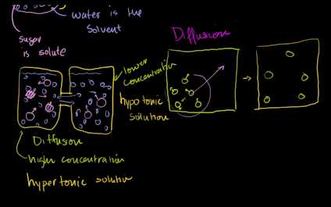
Go to http://goo.gl/eo6cZT for more content.

Controlling Osmosis
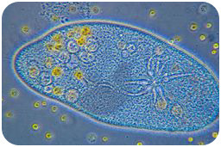
Organisms that live in a hypotonic environment such as freshwater, need a way to prevent their cells from taking in too much water by osmosis. A contractile vacuole is a type of vacuole that removes excess water from a cell. Freshwater protists, such as the paramecium shown in Figure below, have a contractile vacuole. The vacuole is surrounded by several canals, which absorb water by osmosis from the cytoplasm. After the canals fill with water, the water is pumped into the vacuole. When the vacuole is full, it pushes the water out of the cell through a pore.

The contractile vacuole is the star-like structure within the paramecium (at center-right)

Summary
- Osmosis is the diffusion of water.
- In comparing two solutions of unequal solute concentration, the solution with the higher solute concentration is hypertonic, and the solution with the lower concentration is hypotonic. Solutions of equal solute concentration are isotonic.
- A contractile vacuole is a type of vacuole that removes excess water from a cell.

Practice I
- Define osmosis.
- Is osmosis a form of diffusion? Explain your answer.
- Why is osmosis important in biology?

Practice II
- Diffusion, Osmosis and Active Transport at http://www.concord.org/activities/diffusion-osmosis-and-active-transport
- Osmosis
Go to http://goo.gl/wRS85N for more content

Review
1. What is osmosis? What type of transport is it?
2. How does osmosis differ from diffusion?

2.14 Facilitated Diffusion
- Describe different types of passive transport.
Can you help me move?
What is one of the questions no one likes to be asked? Sometimes the cell needs help moving things as well, or facilitating the diffusion process. And this would be the job of a special type of protein.

Facilitated Diffusion
Facilitated diffusion is the diffusion of solutes through transport proteins in the plasma membrane. Facilitated diffusion is a type of passive transport. Even though facilitated diffusion involves transport proteins, it is still passive transport because the solute is moving down the concentration gradient.
Small nonpolar molecules can easily diffuse across the cell membrane. However, due to the hydrophobic nature of the lipids that make up cell membranes, polar molecules (such as water) and ions cannot do so. Instead, they diffuse across the membrane through transport proteins. A transport protein completely spans the membrane, and allows certain molecules or ions to diffuse across the membrane. Channel proteins, gated channel proteins, and carrier proteins are three types of transport proteins that are involved in facilitated diffusion.
A channel protein , a type of transport protein, acts like a pore in the membrane that lets water molecules or small ions through quickly. Water channel proteins allow water to diffuse across the membrane at a very fast rate. Ion channel proteins allow ions to diffuse across the membrane.
A gated channel protein is a transport protein that opens a "gate," allowing a molecule to pass through the membrane. Gated channels have a binding site that is specific for a given molecule or ion. A stimulus causes the "gate" to open or shut. The stimulus may be chemical or electrical signals, temperature, or mechanical force, depending on the type of gated channel. For example, the sodium gated channels of a nerve cell are stimulated by a chemical signal which causes them to open and allow sodium ions into the cell. Glucose molecules are too big to diffuse through the plasma membrane easily, so they are moved across the membrane through gated channels. In this way glucose diffuses very quickly across a cell membrane, which is important because many cells depend on glucose for energy.
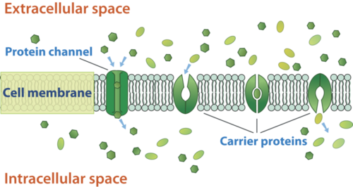
A carrier protein is a transport protein that is specific for an ion, molecule, or group of substances. Carrier proteins "carry" the ion or molecule across the membrane by changing shape after the binding of the ion or molecule. Carrier proteins are involved in passive and active transport. A model of a channel protein and carrier proteins is shown in Figure below .
Facilitated diffusion through the cell membrane. Channel proteins and carrier proteins are shown (but not a gated-channel protein). Water molecules and ions move through channel proteins. Other ions or molecules are also carried across the cell membrane by carrier proteins. The ion or molecule binds to the active site of a carrier protein. The carrier protein changes shape, and releases the ion or molecule on the other side of the membrane. The carrier protein then returns to its original shape.
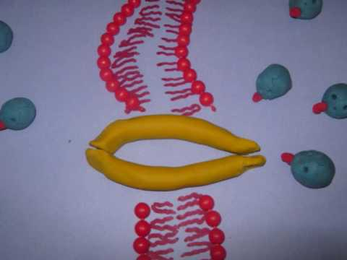
An animation depicting facilitated diffusion can be viewed at http://www.youtube.com/watch?v=OV4PgZDRTQw&feature=related (1:36).

Go to http://goo.gl/5yCvcF for more content.

Ion Channels
Ions such as sodium (Na ⁺ ), potassium (K ⁺ ), calcium (Ca ²⁺ ), and chloride (Cl ⁻ ), are important for many cell functions. Because they are polar, these ions do not diffuse through the membrane. Instead they move through ion channel proteins where they are protected from the hydrophobic interior of the membrane. Ion channels allow the formation of a concentration gradient between the extracellular fluid and the cytosol. Ion channels are very specific, as they allow only certain ions through the cell membrane. Some ion channels are always open, others are "gated" and can be opened or closed. Gated ion channels can open or close in response to different types of stimuli, such as electrical or chemical signals.

Summary
- Facilitated diffusion is the diffusion of solutes through transport proteins in the plasma membrane. Channel proteins, gated channel proteins, and carrier proteins are three types of transport proteins that are involved in facilitated diffusion.

Practice I
- Describe the structure of a transport protein.
- Give an example of a molecule transported by a transport protein.

Practice II
- Membrane Channels at http://phet.colorado.edu/en/simulation/membrane-channels .
Go to http://goo.gl/9JclYz for more content.

Review
1. Assume a molecule must cross the plasma membrane into a cell. The molecule is a very large protein. How will it be transported into the cell? Explain your answer.
2. Compare and contrast simple diffusion and facilitated diffusion. For each type of diffusion, give an example of a molecule that is transported that way.

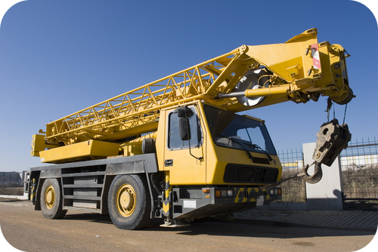
2.15 Active Transport
- Explain how different types of active transport occur.

Need to move something really heavy?
If you did, it would take a lot of energy. Sometimes, moving things into or out of the cell also takes energy. How would the cell move something against a concentration gradient? It starts by using energy.

Active Transport
In contrast to facilitated diffusion, which does not require energy and carries molecules or ions down a concentration gradient, active transport pumps molecules and ions against a concentration gradient. Sometimes an organism needs to transport something against a concentration gradient. The only way this can be done is through active transport, which uses energy that is produced by respiration (ATP). In active transport, the particles move across a cell membrane from a lower concentration to a higher concentration. Active transport is the energy-requiring process of pumping molecules and ions across membranes "uphill" - against a concentration gradient.
- The active transport of small molecules or ions across a cell membrane is generally carried out by transport proteins that are found in the membrane.
- Larger molecules such as starch can also be actively transported across the cell membrane by processes called endocytosis and exocytosis.

Homeostasis and Cell Function
Homeostasis refers to the balance, or equilibrium, within the cell or a body. It is an organism’s ability to keep a constant internal environment. Keeping a stable internal environment requires constant adjustments as conditions change inside and outside the cell. The adjusting of systems within a cell is called homeostatic regulation. Because the internal and external environments of a cell are constantly changing, adjustments must be made continuously to stay at or near the set point (the normal level or range). Homeostasis is a dynamic equilibrium rather than an unchanging state. The cellular processes discussed in both the "Passive Transport" and "Active Transport" concepts all play an important role in homeostatic regulation. You will learn more about homeostasis in other concepts.

Summary
- Active transport is the energy-requiring process of pumping molecules and ions across membranes against a concentration gradient.
- Active transport processes help maintain homeostasis.

Practice I
- What is the main difference between active transport and diffusion?
- What is cotransport?
- What molecule is required in active transport?

Practice II
- Diffusion, Osmosis and Active Transport at http://www.concord.org/activities/diffusion-osmosis-and-active-transport .
- Active Transport
Go to http://goo.gl/DV4bfz for more content.

Review
1. What is active transport?
2. Explain how cell transport helps an organism maintain homeostasis.

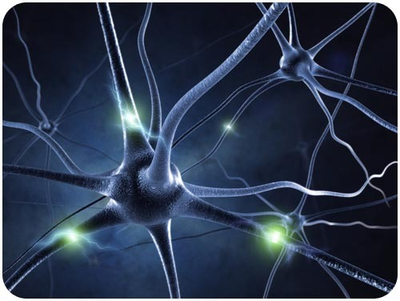
2.16 Sodium-Potassium Pump
- Explain how different types of active transport occur.
- Explain how the sodium-potassium pump functions.

What is this incredible object?
Would it surprise you to learn that it is a human cell? The image represents an active human nerve cell. How nerve cells function will be the focus of another concept. However, active transport processes play a significant role in the function of these cells. Specifically, it is the sodium-potassium pump that is active in the axons of these nerve cells.

The Sodium-Potassium Pump
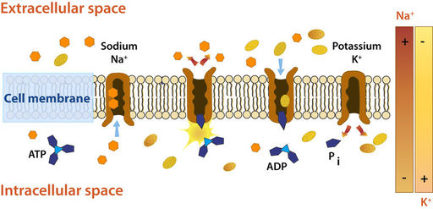
Active transport is the energy-requiring process of pumping molecules and ions across membranes "uphill" - against a concentration gradient. To move these molecules against their concentration gradient, a carrier protein is needed. Carrier proteins can work with a concentration gradient (during passive transport), but some carrier proteins can move solutes against the concentration gradient (from low concentration to high concentration), with an input of energy. As in other types of cellular activities, ATP supplies the energy for most active transport. One way ATP powers active transport is by transferring a phosphate group directly to a carrier protein. This may cause the carrier protein to change its shape, which moves the molecule or ion to the other side of the membrane. An example of this type of active transport system, as shown in Figure below, is the sodium-potassium pump, which exchanges sodium ions for potassium ions across the plasma membrane of animal cells.

The sodium-potassium pump system moves sodium and potassium ions against large concentration gradients. It moves two potassium ions into the cell where potassium levels are high, and pumps three sodium ions out of the cell and into the extracellular fluid.
As is shown in Figure above, three sodium ions bind with the protein pump inside the cell. The carrier protein then gets energy from ATP and changes shape. In doing so, it pumps the three sodium ions out of the cell. At that point, two potassium ions move in from outside the cell and bind to the protein pump. The sodium-potassium pump is found in the plasma membrane of almost every human cell and is common to all cellular life. It helps maintain cell potential and regulates cellular volume.
A more detailed look at the sodium-potassium pump is available at http://www.youtube.com/user/khanacademy#p/c/7A9646BC5110CF64/40/C_H-ONQFjpQ (13:53) and http://www.youtube.com/user/khanacademy#p/c/7A9646BC5110CF64/41/ye3rTjLCvAU (6:48).
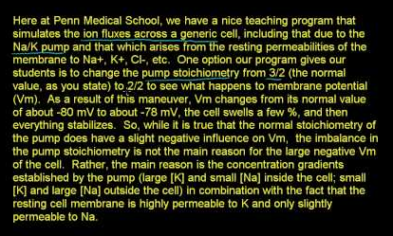
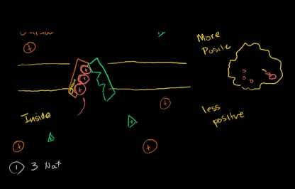
Go to http://goo.gl/IqiLuA for more content.

Go to http://goo.gl/cvnCPL for more content.

The Electrochemical Gradient
The active transport of ions across the membrane causes an electrical gradient to build up across the plasma membrane. The number of positively charged ions outside the cell is greater than the number of positively charged ions in the cytosol. This results in a relatively negative charge on the inside of the membrane, and a positive charge on the outside. This difference in charges causes a voltage across the membrane. Voltage is electrical potential energy that is caused by a separation of opposite charges, in this case across the membrane. The voltage across a membrane is called membrane potential. Membrane potential is very important for the conduction of electrical impulses along nerve cells.
Because the inside of the cell is negative compared to outside the cell, the membrane potential favors the movement of positively charged ions (cations) into the cell, and the movement of negative ions (anions) out of the cell. So, there are two forces that drive the diffusion of ions across the plasma membrane—a chemical force (the ions' concentration gradient), and an electrical force (the effect of the membrane potential on the ions’ movement). These two forces working together are called an electrochemical gradient, and will be discussed in detail in "Nerve Cell" and "Nerve Impulses" concepts.

Summary
- Active transport is the energy-requiring process of pumping molecules and ions across membranes against a concentration gradient.
- The sodium-potassium pump is an active transport pump that exchanges sodium ions for potassium ions.

Practice
Use this resource to answer the questions that follow.
- Sodium Potassium Pump (ATPase) at http://www.youtube.com/watch?v=Z9tPTDRjCYU&feature=fvwrel
- Why is the size difference between a sodium and potassium ion important?
- Are there more sodium ions on the outside of cells or the inside?
- Are there more potassium ions on the outside of cells or the inside?
- Describe the role of ATP in active transport.

Review
1. What is active transport?
2. Describe how the sodium-potassium pump functions.

2.17 Exocytosis and Endocytosis
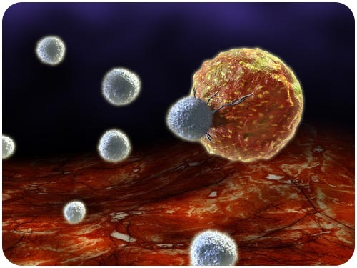
- Explain how different types of active transport occur.

What does a cell "eat"?
Is it possible for objects larger than a small molecule to be engulfed by a cell? Of course it is. This image depicts a cancer cell being attacked by a cell of the immune system. Cells of the immune system consistently destroy pathogens by essentially "eating" them.

Vesicle Transport
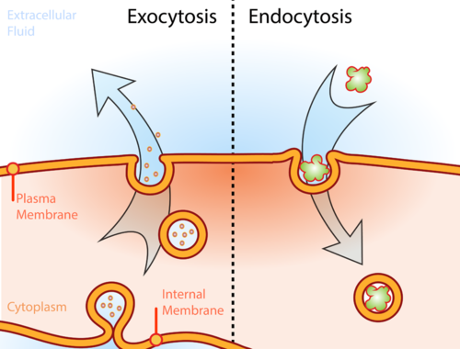
Some molecules or particles are just too large to pass through the plasma membrane or to move through a transport protein. So cells use two other active transport processes to move these macromolecules (large molecules) into or out of the cell. Vesicles or other bodies in the cytoplasm move macromolecules or large particles across the plasma membrane. There are two types of vesicle transport, endocytosis and exocytosis. Both processes are active transport processes, requiring energy.
Illustration of the two types of vesicle transport, exocytosis and endocytosis.

Endocytosis and Exocytosis
Endocytosis is the process of capturing a substance or particle from outside the cell by engulfing it with the cell membrane. The membrane folds over the substance and it becomes completely enclosed by the membrane. At this point a membrane-bound sac, or vesicle, pinches off and moves the substance into the cytosol. There are two main kinds of endocytosis:
- Phagocytosis, or cellular eating, occurs when the dissolved materials enter the cell. The plasma membrane engulfs the solid material, forming a phagocytic vesicle.
- Pinocytosis, or cellular drinking, occurs when the plasma membrane folds inward to form a channel allowing dissolved substances to enter the cell, as shown in Figure below. When the channel is closed, the liquid is encircled within a pinocytic vesicle.
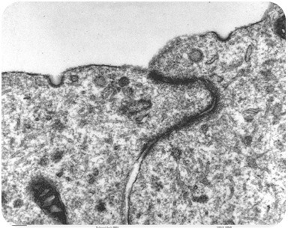
Transmission electron microscope image of brain tissue that shows pinocytotic vesicles. Pinocytosis is a type of endocytosis.

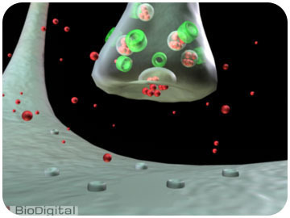
Exocytosis describes the process of vesicles fusing with the plasma membrane and releasing their contents to the outside of the cell, as shown in Figure below . Exocytosis occurs when a cell produces substances for export, such as a protein, or when the cell is getting rid of a waste product or a toxin. Newly made membrane proteins and membrane lipids are moved on top the plasma membrane by exocytosis. For a detailed animation of cellular secretion, see http://vcell.ndsu.edu/animations/constitutivesecretion/first.htm .

Illustration of an axon releasing dopamine by exocytosis.

Summary
- Active transport is the energy-requiring process of pumping molecules and ions across membranes against a concentration gradient.
- Endocytosis is the process of capturing a substance or particle from outside the cell by engulfing it with the cell membrane, and bringing it into the cell.
- Exocytosis describes the process of vesicles fusing with the plasma membrane and releasing their contents to the outside of the cell.
- Both endocytosis and exocytosis are active transport processes.

Practice
- Compare endocytosis to exocytosis.
- Describe the process of endocytosis.
- What are the differences between phagocytosis, pinocytosis, and receptor-mediated endocytosis?
- How are hormones released from a cell?

Review
1. What is the difference between endocytosis and exocytosis?
2. Why is pinocytosis a form of endocytosis?
3. Are vesicles involved in passive transport? Explain.

2.18 Autotrophs and Heterotrophs
- Describe how autotrophs and heterotrophs obtain energy.
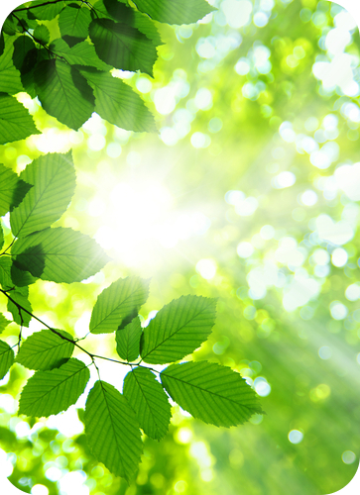
Name one major difference between a plant and an animal.
There are many differences, but in terms of energy, it all starts with sunlight. Plants absorb the energy from the sun and turn it into food. You can sit in the sun for hours and hours. You will feel warm, but you're not going to absorb any energy. You have to eat to obtain your energy.

Autotrophs vs. Heterotrophs
Living organisms obtain chemical energy in one of two ways.
Autotrophs, shown in Figure below, store chemical energy in carbohydrate food molecules they build themselves. Food is chemical energy stored in organic molecules. Food provides both the energy to do work and the carbon to build bodies. Because most autotrophs transform sunlight to make food, we call the process they use photosynthesis. Only three groups of organisms - plants, algae, and some bacteria - are capable of this life-giving energy transformation. Autotrophs make food for their own use, but they make enough to support other life as well. Almost all other organisms depend absolutely on these three groups for the food they produce. The producers, as autotrophs are also known, begin food chains which feed all life. Food chains will be discussed in the "Food Chains and Food Webs" concept.
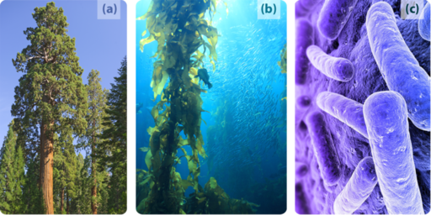
Heterotrophs cannot make their own food, so they must eat or absorb it. For this reason, heterotrophs are also known as consumers. Consumers include all animals and fungi and many protists and bacteria. They may consume autotrophs or other heterotrophs or organic molecules from other organisms. Heterotrophs show great diversity and may appear far more fascinating than producers. But heterotrophs are limited by our utter dependence on those autotrophs that originally made our food. If plants, algae, and autotrophic bacteria vanished from earth, animals, fungi, and other heterotrophs would soon disappear as well. All life requires a constant input of energy. Only autotrophs can transform that ultimate, solar source into the chemical energy in food that powers life, as shown in Figure below.

Photosynthetic autotrophs, which make food using the energy in sunlight, include (a) plants, (b) algae, and (c) certain bacteria.

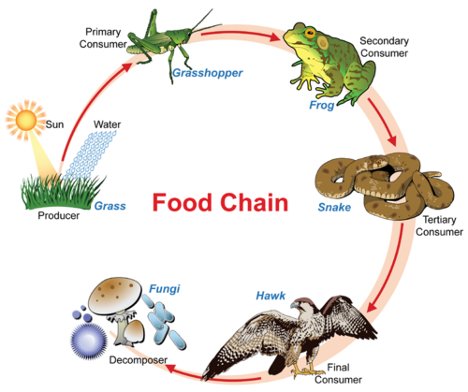
Photosynthesis provides over 99 percent of the energy for life on earth. A much smaller group of autotrophs - mostly bacteria in dark or low-oxygen environments - produce food using the chemical energy stored in inorganic molecules such as hydrogen sulfide, ammonia, or methane. While photosynthesis transforms light energy to chemical energy, this alternate method of making food transfers chemical energy from inorganic to organic molecules. It is therefore called chemosynthesis, and is characteristic of the tubeworms shown in Figure below. Some of the most recently discovered chemosynthetic bacteria inhabit deep ocean hot water vents or “black smokers.” There, they use the energy in gases from the Earth’s interior to produce food for a variety of unique heterotrophs: giant tube worms, blind shrimp, giant white crabs, and armored snails. Some scientists think that chemosynthesis may support life below the surface of Mars, Jupiter's moon, Europa, and other planets as well. Ecosystems based on chemosynthesis may seem rare and exotic, but they too illustrate the absolute dependence of heterotrophs on autotrophs for food.
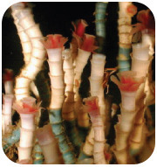
A food chain shows how energy and matter flow from producers to consumers. Matter is recycled, but energy must keep flowing into the system. Where does this energy come from? Though this food chains "ends" with decomposers, do decomposers, in fact, digest matter from each level of the food chain? (see the Energy I: Flow of Energy concept.)
Tubeworms deep in the Gulf of Mexico get their energy from chemosynthetic bacteria living within their tissues. No digestive systems needed!

Summary
- Autotrophs store chemical energy in carbohydrate food molecules they build themselves. Most autotrophs make their "food" through photosynthesis using the energy of the sun.
- Heterotrophs cannot make their own food, so they must eat or absorb it.
- Chemosynthesis is used to produce food using the chemical energy stored in inorganic molecules.

Practice
- Compare a phototroph to a chemotroph. Give examples of each.
- Compare an autotroph to a heterotroph.
- Give an example of an organic compound and an inorganic compound.

Review
1. Compare autotrophs to heterotrophs, and describe the relationship between these two groups of organisms.
2. Name and describe the two types of food making found among autotrophs, and give an example of each. Which is quantitatively more important to life on earth?
3. Trace the flow of energy through a typical food chain (describing "what eats what"), including the original source of that energy and its ultimate form after use. Underline each form of energy or energy-storing molecule, and boldface each process which transfers or transforms energy.

2.19 Glucose and ATP
- Compare and contrast glucose and ATP.
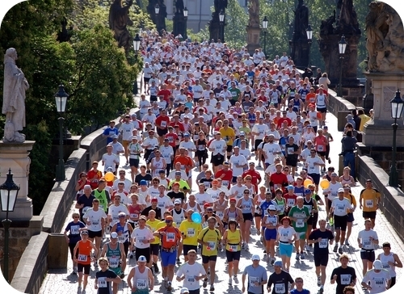
Needs lots of energy?
To run a marathon, probably. Where does this extra energy come from? Carbohydrate loading is a strategy used by endurance athletes to maximize the storage of energy, in the form of glycogen, in the muscles. Glycogen forms an energy reserve that can be quickly mobilized to meet a sudden need for glucose, which is then turned into ATP through the process of cellular respiration.

Glucose and ATP

Energy-Carrying Molecules
You know that the fish you had for lunch contained protein molecules. But do you know that the atoms in that protein could easily have formed the color in a dragonfly’s eye, the heart of a water flea, and the whiplike tail of a Euglena before they hit your plate as sleek fish muscle? Food consists of organic (carbon-containing) molecules which store energy in the chemical bonds between their atoms. Organisms use the atoms of food molecules to build larger organic molecules including proteins, DNA, and fats (lipids) and use the energy in food to power life processes. By breaking the bonds in food molecules, cells release energy to build new compounds. Although some energy dissipates as heat at each energy transfer, much of it is stored in the newly made molecules. Chemical bonds in organic molecules are a reservoir of the energy used to make them. Fueled by the energy from food molecules, cells can combine and recombine the elements of life to form thousands of different molecules. Both the energy (despite some loss) and the materials (despite being reorganized) pass from producer to consumer – perhaps from algal tails, to water flea hearts, to dragonfly eye colors, to fish muscle, to you!
The process of photosynthesis, which usually begins the flow of energy through life, uses many different kinds of energy-carrying molecules to transform sunlight energy into chemical energy and build food. Some carrier molecules hold energy briefly, quickly shifting it like a hot potato to other molecules. This strategy allows energy to be released in small, controlled amounts. An example starts in chlorophyll, the green pigment present in most plants, which helps convert solar energy to chemical energy. When a chlorophyll molecule absorbs light energy, electrons are excited and "jump" to a higher energy level. The excited electrons then bounce to a series of carrier molecules, losing a little energy at each step. Most of the "lost" energy powers some small cellular task, such as moving ions across a membrane or building up another molecule. Another short-term energy carrier important to photosynthesis, NADPH , holds chemical energy a bit longer but soon "spends" it to help to build sugar.
Two of the most important energy-carrying molecules are glucose and ATP , adenosine triphosphate. These are nearly universal fuels throughout the living world and are both key players in photosynthesis, as shown below.

Glucose
A molecule of glucose, which has the chemical formula C ₆ H ₁₂ O ₆ , carries a packet of chemical energy just the right size for transport and uptake by cells. In your body, glucose is the "deliverable" form of energy, carried in your blood through capillaries to each of your 100 trillion cells. Glucose is also the carbohydrate produced by photosynthesis, and as such is the near-universal food for life.
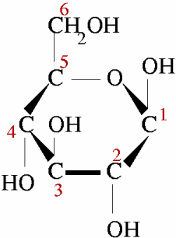
Glucose is the energy-rich product of photosynthesis, a universal food for life. It is also the primary form in which your bloodstream delivers energy to every cell in your body. The six carbons are numbered.

ATP
ATP molecules store smaller quantities of energy, but each releases just the right amount to actually do work within a cell. Muscle cell proteins, for example, pull each other with the energy released when bonds in ATP break open (discussed below). The process of photosynthesis also makes and uses ATP - for energy to build glucose! ATP, then, is the useable form of energy for your cells.
Why do we need both glucose and ATP?
Why don’t plants just make ATP and be done with it? If energy were money, ATP would be a quarter. Enough money to operate a parking meter or washing machine. Glucose would be a ten dollar bill – much easier to carry around in your wallet, but too large to do the actual work of paying for parking or washing. Just as we find several denominations of money useful, organisms need several "denominations" of energy – a smaller quantity for work within cells, and a larger quantity for stable storage, transport, and delivery to cells.
Let’s take a closer look at a molecule of ATP. Although it carries less energy than glucose, its structure is more complex. The "A" in ATP refers to the majority of the molecule, adenosine, a combination of a nitrogenous base and a five-carbon sugar. The "P" indicates the three phosphates, linked by bonds which hold the energy actually used by cells. Usually, only the outermost bond breaks to release or spend energy for cellular work.
An ATP molecule, shown below, is like a rechargeable battery: its energy can be used by the cell when it breaks apart into ADP (adenosine diphosphate) and phosphate, and then the "worn-out battery" ADP can be recharged using new energy to attach a new phosphate and rebuild ATP. The materials are recyclable, but recall that energy is not!
How much energy does it cost to do your body’s work? A single cell uses about 10 million ATP molecules per second, and recycles all of its ATP molecules about every 20-30 seconds.
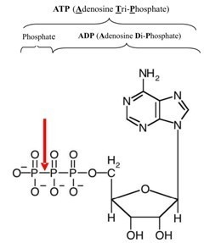
A red arrow shows the bond between two phosphate groups in an ATP molecule. When this bond breaks, its chemical energy can do cellular work. The resulting ADP molecule is recycled when new energy attaches another phosphate, rebuilding ATP.
A explanation of ATP as "biological energy" is found at http://www.youtube.com/user/khanacademy#p/c/7A9646BC5110CF64/18/YQfWiDlFEcA .
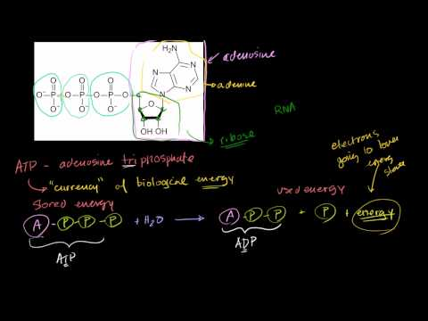
Click on the image above for more content

Summary
- Glucose is the carbohydrate produced by photosynthesis. Energy-rich glucose is delivered through your blood to each of your cells.
- ATP is the usable form of energy for your cells.

Practice
Use these resources to answer the questions that follow.
- http://www.hippocampus.org/Biology Biology for AP* Search: Glycolysis: Overview
- Where does a cell's chemical energy come from?
- How does a cell start breaking down glucose? Does this process need oxygen?
- What is the purpose of glycolysis?
- http://www.hippocampus.org/Biology Biology for AP* Search: The Glycolytic Pathway
- What is the chemical formula of glucose? Describe the structure of glucose molecules.
- Where does our glucose come from? What happens to this glucose?
- Glycolysis produces a net total of how many ATP molecules?

Review
1. The fact that all organisms use similar energy-carrying molecules shows one aspect of the grand "Unity of Life." Name two universal energy-carrying molecules, and explain why most organisms need both carriers rather than just one.
2. A single cell uses about 10 million ATP molecules per second. Explain how cells use the energy and recycle the materials in ATP.
3. ATP and glucose are both molecules that organisms use for energy. They are like the tank of a tanker truck that delivers gas to a gas station and the gas tank that holds the fuel for a car. Which molecule is like the tank of the delivery truck, and which is like the gas tank of the car? Explain your answer.

2.20 Chloroplasts
- Describe the chloroplast and its role in photosynthesis.
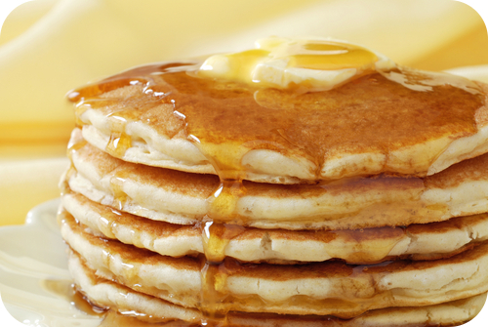
What do pancakes and chloroplasts have in common?
The chloroplast is the site of photosynthesis. Part of the photosynthesis reactions occur in an internal membrane within the organelle. The chloroplast contains many of these internal membranes, making photosynthesis very efficient. These internal membranes stack on top of each other, just like a stack of pancakes.

The Chloroplast
Chloroplasts: Theaters for Photosynthesis
Photosynthesis , the process of turning the energy of sunlight into "food," is divided into two basic sets of reactions, known as the light reactions and the Calvin cycle, which uses carbon dioxide. As you study the details in other concepts, refer frequently to the chemical equation of photosynthesis: 6CO ₂ + 6H ₂ O + Light Energy → C ₆ H ₁₂ O ₆ + 6O ₂ . Photosynthesis occurs in the chloroplast, an organelle specific to plant cells.
If you examine a single leaf of a Winter Jasmine leaf, shown in Figure below , under a microscope, you will see within each cell dozens of small green ovals. These are chloroplasts , the organelles which conduct photosynthesis in plants and algae. Chloroplasts closely resemble some types of bacteria and even contain their own circular DNA and ribosomes. In fact, the endosymbiotic theory holds that chloroplasts were once independently living bacteria (prokaryotes). So when we say that photosynthesis occurs within chloroplasts, we speak not only of the organelles within plants and algae, but also of some bacteria – in other words, virtually all photosynthetic autotrophs.
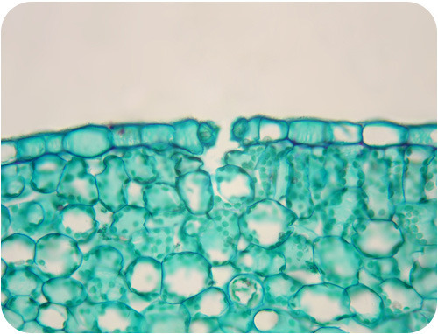
High power microscopic photo of the upper part of a Winter Jasmine leaf. Viewed under a microscope, many green chloroplasts are visible.
Each chloroplast contains neat stacks called grana (singular, granum). The grana consist of sac-like membranes, known as thylakoid membranes. These membranes contain photosystems , which are groups of molecules that include chlorophyll , a green pigment. The light reactions of photosynthesis occur in the thylakoid membranes. The stroma is the space outside the thylakoid membranes, as shown in Figure below . In addition to enzymes, two basic types of molecules - pigments and electron carriers – are key players in this process. This is where the reactions of the Calvin cycle take place.
You can take a video tour of a chloroplast at Encyclopedia Britannica: Chloroplast : http://www.britannica.com/EBchecked/media/16440/Chloroplasts-circulate-within-plant-cells .
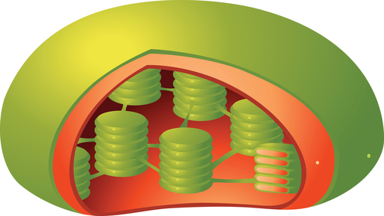
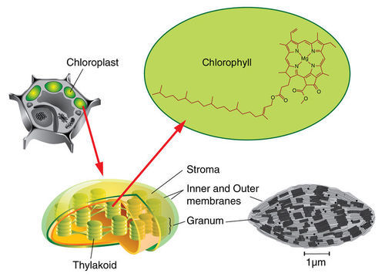
A chloroplast consists of thylakoid membranes surrounded by stroma. The thylakoid membranes contain molecules of the green pigment chlorophyll.
Electron carrier molecules are usually arranged in electron transport chains (ETCs). These accept and pass along energy-carrying electrons in small steps ( Figure below ). In this way, they produce ATP and NADPH, which temporarily store chemical energy. Electrons in transport chains behave much like a ball bouncing down a set of stairs – a little energy is lost with each bounce. However, the energy “lost” at each step in an electron transport chain accomplishes a little bit of work, which eventually results in the synthesis of ATP.
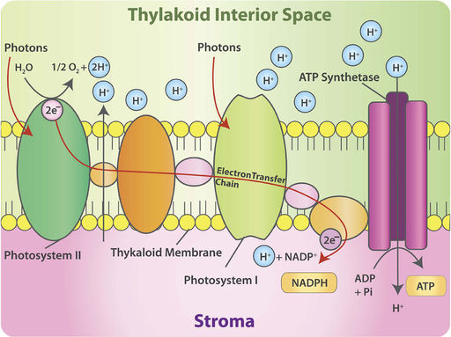
This figure shows the light reactions of photosynthesis. This stage of photosynthesis begins with photosystem II (so named because it was discovered after photosystem I). Find the two electrons (2 e ⁻ ) in photosystem II, and then follow them through the electron transport chain (also called the electron transfer chain) to the formation of NADPH. Where do the hydrogen ions (H ⁺ ) come from that help make ATP?

Summary
- Photosynthesis occurs in the chloroplast, an organelle specific to plant cells.
- The light reactions of photosynthesis occur in the thylakoid membranes of the chloroplast.
- Electron carrier molecules are arranged in electron transport chains that produce ATP and NADPH, which temporarily store chemical energy.

Practice I
Use this resource to answer the questions that follow.
- http://www.hippocampus.org/Biology Non-Majors Biology Search: Photosynthetic Structures
- What are the functions of a plant's leaves?
- Where do the photosynthetic reactions occur?
- What is a stomata?
- Describe the internal structure of a chloroplast.
- What reactions occur in the thylakoid membranes?

Practice II
- Photosynthesis at http://www.neok12.com/quiz/PLANTS06 .

Review
1. Describe the chloroplast and its role in photosynthesis.
2. Explain how the structure of a chloroplast (its membranes and thylakoids) makes its function (the chemical reactions of photosynthesis) more efficient.
3. Describe electron carriers and the electron transport chain.

2.21 Light Reactions of Photosynthesis
- List the steps of the light reactions.
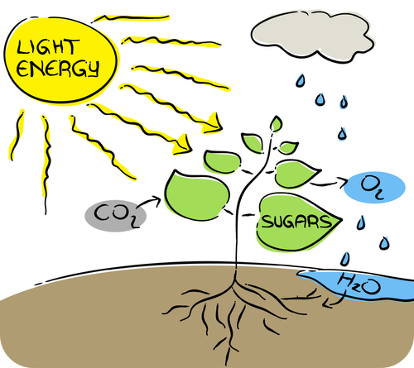
Oxygen has been described as a "waste product." How is this possible?
Essentially, oxygen is a waste product of the light reactions of photosynthesis. It is a "leftover" from a necessary part of the process. All the oxygen that is necessary to maintain most forms of life just happens to come about during this process.

Photosynthesis Stage I: The Light Reactions
An overview of photosynthesis is available at http://www.youtube.com/user/khanacademy#p/c/7A9646BC5110CF64/26/-rsYk4eCKnA (13:37).
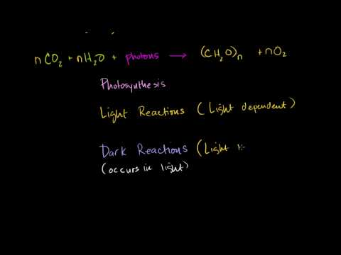
Click on the image above for more content

Chloroplasts Capture Sunlight
Every second, the sun fuses over 600 million tons of hydrogen into 596 tons of helium, converting over 4 tons of helium (4.3 billion kg) into light and heat energy. Countless tiny packets of that light energy travel 93 million miles (150 million km) through space, and about 1% of the light which reaches the Earth’s surface participates in photosynthesis. Light is the source of energy for photosynthesis, and the first set of reactions which begin the process requires light – thus the name, light reactions , or light-dependent reactions.
When light strikes chlorophyll (or an accessory pigment) within the chloroplast, it energizes electrons within that molecule. These electrons jump up to higher energy levels; they have absorbed or captured, and now carry, that energy. High-energy electrons are “excited.” Who wouldn’t be excited to hold the energy for life?
The excited electrons leave chlorophyll to participate in further reactions, leaving the chlorophyll “at a loss”; eventually they must be replaced. That replacement process also requires light, working with an enzyme complex to split water molecules. In this process of photolysis (“splitting by light”), H ₂ O molecules are broken into hydrogen ions, electrons, and oxygen atoms. The electrons replace those originally lost from chlorophyll. Hydrogen ions and the high-energy electrons from chlorophyll will carry on the energy transformation drama after the light reactions are over.
The oxygen atoms, however, form oxygen gas, which is a waste product of photosynthesis. The oxygen given off supplies most of the oxygen in our atmosphere. Before photosynthesis evolved, Earth’s atmosphere lacked oxygen altogether, and this highly reactive gas was toxic to the many organisms living at the time. Something had to change! Most contemporary organisms rely on oxygen for efficient respiration. So plants don’t just “restore” the air, they also had a major role in creating it!
To summarize, chloroplasts “capture” sunlight energy in two ways. Light "excites" electrons in pigment molecules, and light provides the energy to split water molecules, providing more electrons as well as hydrogen ions.

Light Energy to Chemical Energy
Excited electrons that have absorbed light energy are unstable. However, the highly organized electron carrier molecules embedded in chloroplast membranes order the flow of these electrons, directing them through electron transport chains (ETCs). At each transfer, small amounts of energy released by the electrons are captured and put to work or stored. Some is also lost as heat with each transfer, but overall the light reactions are extremely efficient at capturing light energy and transforming it into chemical energy.
Two sequential transport chains harvest the energy of excited electrons, as shown in Figure below .
(1) First, they pass down an ETC, which captures their energy and uses it to pump hydrogen ions by active transport into the thylakoids. These concentrated ions store potential energy by forming a chemiosmotic or electrochemical gradient – a higher concentration of both positive charge and hydrogen inside the thylakoid than outside. (The gradient formed by the H ⁺ ions is known as a chemiosmotic gradient .) Picture this energy buildup of H ⁺ as a dam holding back a waterfall. Like water flowing through a hole in the dam, hydrogen ions “slide down” their concentration gradient through a membrane protein which acts as both ion channel and enzyme. As they flow, the ion channel/enzyme ATP synthase uses their energy to chemically bond a phosphate group to ADP, making ATP.
(2) Light re-energizes the electrons, and they travel down a second electron transport chain (ETC), eventually bonding hydrogen ions to NADP ⁺ to form a more stable energy storage molecule, NADPH . NADPH is sometimes called “hot hydrogen,” and its energy and hydrogen atoms will be used to help build sugar in the second stage of photosynthesis.
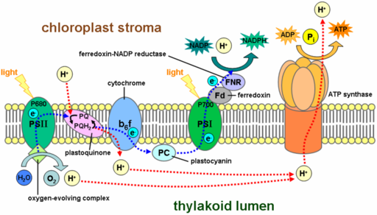
Membrane architecture: The large colored carrier molecules form electron transport chains which capture small amounts of energy from excited electrons in order to store it in ATP and NADPH. Follow the energy pathways: light electrons NADPH (blue line) and light electrons concentrated H ⁺ ATP (red line). Note the intricate organization of the chloroplast.
NADPH and ATP molecules now store the energy from excited electrons – energy which was originally sunlight – in chemical bonds. Thus chloroplasts, with their orderly arrangement of pigments, enzymes, and electron transport chains, transform light energy into chemical energy. The first stage of photosynthesis – light-dependent reactions or simply light reactions – is complete.
For a detailed discussion of photosynthesis, see http://www.youtube.com/user/khanacademy#p/c/7A9646BC5110CF64/27/GR2GA7chA_c (20:16) and http://www.youtube.com/user/khanacademy#p/c/7A9646BC5110CF64/28/yfR36PMWegg (18:51).
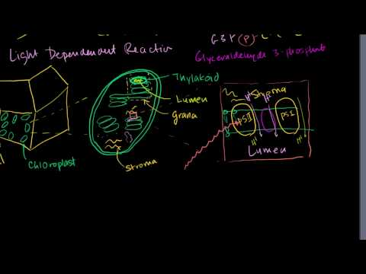
Click on the image above for more content
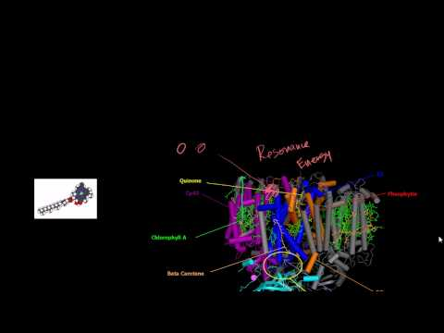
Click on the image above for more content

Summary
- The light reactions capture energy from sunlight, which they change to chemical energy that is stored in molecules of NADPH and ATP.
- The light reactions also release oxygen gas as a waste product.

Practice I
Use these resources to answer the questions that follow.
- http://www.hippocampus.org/Biology Biology for AP* Search: The Light Reactions: Overview
- What are the light reactions?
- What is the role of the photons of light?
- What drives the synthesis of ATP during this stage?
- Define chemiosmosis and photophosphorylation.
- http://www.hippocampus.org/Biology Biology for AP* Search: Photosystems I and II
- Describe the role of the plant's photosystems.
- What is a photosystem reaction center?
- Where is chlorophyll located?
- What happens at the electron acceptor?
- What is the electron transport chain and what is its role?
- Noncyclic electron flow refers to what process?
- What is the product at the end of the electron transport chain?
- http://www.hippocampus.org/Biology Biology for AP* Search: The Light Reactions: Summary
- What are the goals of the light reactions?
- Where do the electrons come from that move through the electron transport chain?
- How do hydrogen ions move into the thylakoid?
- Describe the synthesis of ATP.

Practice II
- Photosynthesis at http://johnkyrk.com/photosynthesis.html .

Review
1. Summarize what happens during the light reactions of photosynthesis.
2. Explain the role of the first electron transport chain in the formation of ATP during the light reactions of photosynthesis.

2.22 Calvin Cycle
- Describe the Calvin cycle.
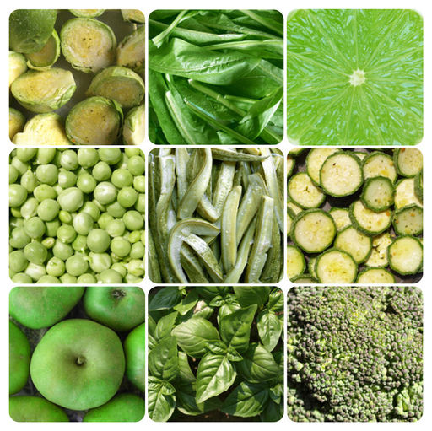
Other than being green, what do all these fruits and vegetables have in common?
They are full of energy. Energy in the form of glucose. The energy from sunlight is briefly held in NADPH and ATP, which is needed to drive the formation of sugars such as glucose. And this all happens in the Calvin cycle.

The Calvin Cycle

Making Food “From Thin Air”
You’ve learned that the first, light-dependent stage of photosynthesis uses two of the three reactants, water and light, and produces one of the products, oxygen gas (a waste product of this process). All three necessary conditions are required – chlorophyll pigments, the chloroplast “theater,” and enzyme catalysts. The first stage transforms light energy into chemical energy, stored to this point in molecules of ATP and NADPH. Look again at the overall equation below. What is left?
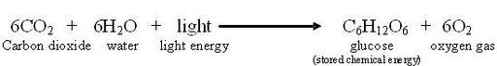
Waiting in the wings is one more reactant, carbon dioxide, and yet to come is the star product, which is food for all life – glucose. These key players perform in the second act of the photosynthesis drama, in which food is “made from thin air!”
The second stage of photosynthesis can proceed without light, so its steps are sometimes called “light-independent” or “dark” reactions (though the term "dark" reactions can be misleading). Many biologists honor the scientist, Melvin Calvin, who won a 1961 Nobel Prize for working out this complex set of chemical reactions, naming it the Calvin cycle .
The Calvin cycle has two parts. First carbon dioxide is "fixed." Then ATP and NADPH from the light reactions provide energy to combine the fixed carbons to make sugar.
The Calvin cycle is discussed at http://www.youtube.com/user/khanacademy#p/c/7A9646BC5110CF64/29/slm6D2VEXYs (13:28).
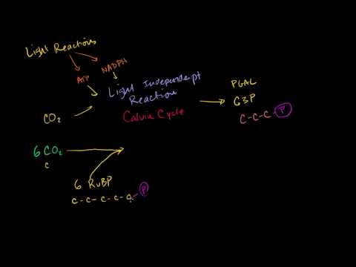
Click on the image above for more content

Carbon Dioxide is “Fixed”
Why does carbon dioxide need to be fixed? Was it ever broken?
Life on Earth is carbon-based. Organisms need not only energy but also carbon atoms for building bodies. For nearly all life, the ultimate source of carbon is carbon dioxide (CO ₂ ), an inorganic molecule. CO ₂ makes up less than 1% of the Earth’s atmosphere.
Animals and most other heterotrophs cannot take in CO ₂ directly. They must eat other organisms or absorb organic molecules to get carbon. Only autotrophs can build low-energy inorganic CO ₂ into high-energy organic molecules like glucose. This process is carbon fixation .
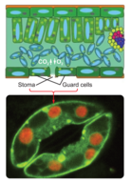
Stomata on the underside of leaves take in CO ₂ and release water and O ₂ . Guard cells close the stomata when water is scarce. Leaf cross-section (above) and stoma (below).
Plants have evolved three pathways for carbon fixation.
The most common pathway combines one molecule of CO ₂ with a 5-carbon sugar called ribulose biphosphate (RuBP). The enzyme which catalyzes this reaction (nicknamed RuBisCo ) is the most abundant enzyme on earth! The resulting 6-carbon molecule is unstable, so it immediately splits into two 3-carbon molecules. The 3 carbons in the first stable molecule of this pathway give this largest group of plants the name “C ₃ .”
Dry air, hot temperatures, and bright sunlight slow the C ₃ pathway for carbon fixation. This is because stomata , tiny openings under the leaf which normally allow CO ₂ to enter and O ₂ to leave, must close to prevent loss of water vapor ( Figure above ). Closed stomata lead to a shortage of CO ₂ . Two alternative pathways for carbon fixation demonstrate biochemical adaptations to differing environments.
Plants such as corn solve the problem by using a separate compartment to fix CO ₂ . Here CO ₂ combines with a 3-carbon molecule, resulting in a 4-carbon molecule. Because the first stable organic molecule has four carbons, this adaptation has the name C ₄ . Shuttled away from the initial fixation site, the 4-carbon molecule is actually broken back down into CO ₂ , and when enough accumulates, RuBisCo fixes it a second time! Compartmentalization allows efficient use of low concentrations of carbon dioxide in these specialized plants.
See http://www.youtube.com/user/khanacademy#p/c/7A9646BC5110CF64/31/7ynX_F-SwNY (16:58) for further information.
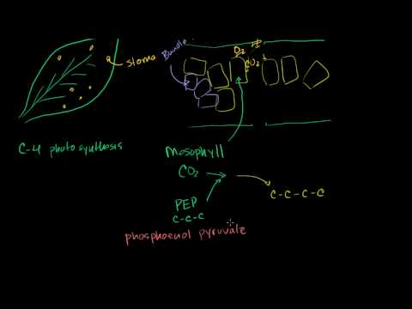
Click on the image above for more content
Cacti and succulents such as the jade plant avoid water loss by fixing CO ₂ only at night. These plants close their stomata during the day and open them only in the cooler and more humid nighttime hours. Leaf structure differs slightly from that of C ₄ plants, but the fixation pathways are similar. The family of plants in which this pathway was discovered gives the pathway its name, Crassulacean Acid Metabolism, or CAM ( Figure below ). All three carbon fixation pathways lead to the Calvin cycle to build sugar.
See http://www.youtube.com/user/khanacademy#p/c/7A9646BC5110CF64/32/xp6Zj24h8uA (8:37) for further information.
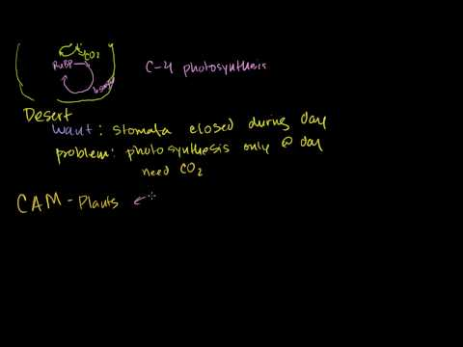
Click on the image above for more content
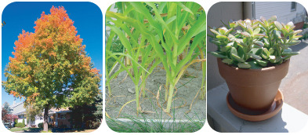
Even chemical reactions adapt to specific environments! Carbon fixation pathways vary among three groups. Temperate species (maple tree, left) use the C ₃ pathway. C ₄ species (corn, center) concentrate CO ₂ in a separate compartment to lessen water loss in hot bright climates. Desert plants (jade plant, right) fix CO ₂ only at night, closing stomata in the daytime to conserve water.

How Does the Calvin Cycle Store Energy in Sugar?
As Melvin Calvin discovered, carbon fixation is the first step of a cycle. Like an electron transport chain, the Calvin cycle, shown in Figure below , transfers energy in small, controlled steps. Each step pushes molecules uphill in terms of energy content. Recall that in the electron transfer chain, excited electrons lose energy to NADPH and ATP. In the Calvin cycle, NADPH and ATP formed in the light reactions lose their stored chemical energy to build glucose.
Use the diagram below to identify the major aspects of the process:
- the general cycle pattern
- the major reactants
- the products
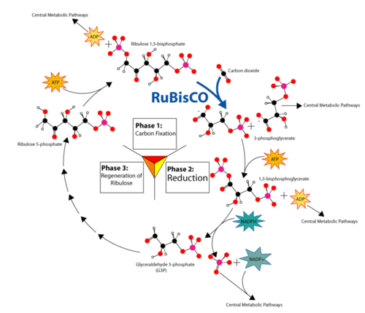
Overview of the Calvin Cycle Pathway.
First, notice where carbon is fixed by the enzyme nicknamed RuBisCo. In C ₃ , C ₄ , and CAM plants, CO ₂ enters the cycle by joining with 5-carbon ribulose bisphosphate to form a 6-carbon intermediate, which splits (so quickly that it isn’t even shown!) into two 3-carbon molecules.
Now look for the points at which ATP and NADPH (made in the light reactions) add chemical energy (“Reduction” in the diagram) to the 3-carbon molecules. The resulting “half-sugars” can enter several different metabolic pathways. One recreates the original 5-carbon precursor, completing the cycle. A second combines two of the 3-carbon molecules to form glucose, universal fuel for life.
The cycle begins and ends with the same molecule, but the process combines carbon and energy to build carbohydrates – food for life.
So, how does photosynthesis store energy in sugar? Six “turns” of the Calvin cycle use chemical energy from ATP to combine six carbon atoms from six CO ₂ molecules with 12 “hot hydrogens” from NADPH. The result is one molecule of glucose, C ₆ H ₁₂ O ₆ .

Summary
- The reactions of the Calvin cycle add carbon (from carbon dioxide in the atmosphere) to a simple five-carbon molecule called RuBP.
- These reactions use chemical energy from NADPH and ATP that were produced in the light reactions.
- The final product of the Calvin cycle is glucose.

Practice I
Use these resources to answer the questions that follow.
- http://www.hippocampus.org/Biology Biology for AP* Search: The Calvin-Benson Cycle: Overview
- What are carbon assimilation and carbon fixation?
- Why are most plants called C ₃ plants?
- Describe RuBisCo.
- What is a C ₄ plant?
- http://www.hippocampus.org/Biology Biology for AP* Search: The Conversion of Carbon Dioxide to Sugar
- How does CO ₂ enter the leaf?
- What is Ribulose-1,5-bisphosphate?
- What happens to some of the Glyceraldehyde-3-phosphate?
- What happens to RuBisCo at night?
- http://www.hippocampus.org/Biology Biology for AP* Search: The Calvin-Benson Cycle: Summary
- What eventually happens to the carbon that enters plants as part of CO ₂ ?
- What happens to the ATP and NADPH made during the light reactions?
- What happens to energy during photorespiration?
- What is a main advantage of C ₄ plants?

Practice II
- Photosynthesis at http://johnkyrk.com/photosynthesisdark.html .

Review
1. What happens during the carbon fixation step of the Calvin cycle?
2. Explain what might happen if the third step of the Calvin cycle did not occur.

2.23 Photosynthesis Summary
- Summarizes photosynthesis.
- Addresses FAQs and common misconceptions.
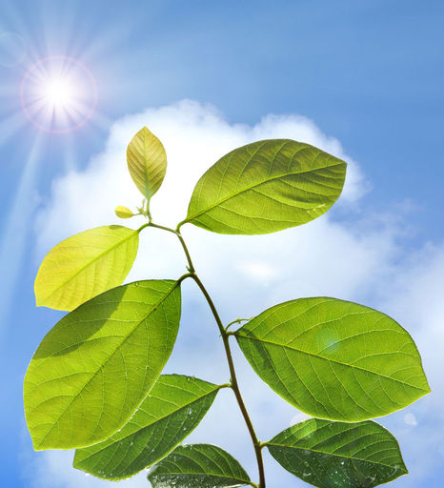
What is photosynthesis?
The process of using the energy in sunlight to make food (glucose). Is it really as simple as that? Of course not. As you have seen, photosynthesis includes many steps all conviently condensed into one simple equation. In the five concepts describing photosynthesis, this process has been presented in an introductory fashion. Obviously, much more details could have been included, though those are beyond the scope of these concepts.

Photosynthesis
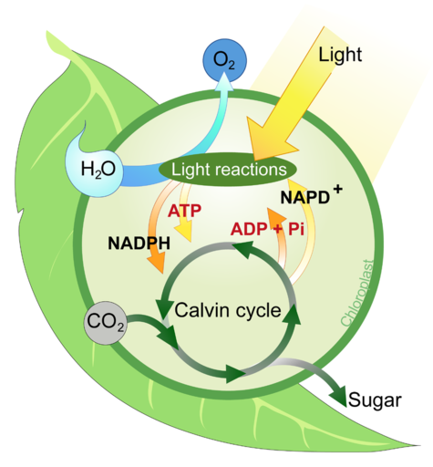

Summary
The following 10 points summarize photosynthesis.
- 6CO ₂ + 6H ₂ O + Light Energy → C ₆ H ₁₂ O ₆ + 6O ₂
- Autotrophs store chemical energy in carbohydrate food molecules they build themselves. Most autotrophs make their "food" through photosynthesis using the energy of the sun.
- Photosynthesis occurs in the chloroplast, an organelle specific to plant cells.
- The light reactions of photosynthesis occur in the thylakoid membranes of the chloroplast.
- Electron carrier molecules are arranged in electron transport chains that produce ATP and NADPH, which temporarily store chemical energy.
- The light reactions capture energy from sunlight, which they change to chemical energy that is stored in molecules of NADPH and ATP.
- The light reactions also release oxygen gas as a waste product.
- The reactions of the Calvin cycle add carbon (from carbon dioxide in the atmosphere) to a simple five-carbon molecule called RuBP.
- The Calvin cycle reactions use chemical energy from NADPH and ATP that were produced in the light reactions.
- The final product of the Calvin cycle is glucose.

FAQs
- What is photosynthesis?
The process of using the energy in sunlight to make food (glucose). But of course it is much more complex than that simple statement. Photosynthesis is a multistep biochemical pathway that uses the energy in sunlight to fix carbon dioxide, transferring the energy into carbohydrates, and releasing oxygen in the process.
- What is NADPH?
Nicotinamide adenine dinucleotide phosphate, an energy carrier molecule produced in the light reactions of photosynthesis. NADPH is the reduced form of the electron acceptor NADP ⁺ . At the end of the light reactions, the energy from sunlight is transferred to NADP ⁺ , producing NADPH. This energy in NADPH is then used in the Calvin cycle.
- Where do the protons used in the light reactions come from?
The protons used in the light reactions come from photolysis, the splitting of water, in which H ₂ O molecules are broken into hydrogen ions, electrons, and oxygen atoms. In addition, the energy from sunlight is used to pump protons into the thylakoid lumen during the first electron transport chain, forming a chemiosmotic gradient.
- How do you distinguish between the Calvin cycle and the Krebs cycle?
The Calvin cycle is part of the light-independent reactions of photosynthesis. The Calvin cycle uses ATP and NADPH. The Krebs cycle is part of cellular respiration. This cycle makes ATP and NAPH.
- Do photosynthesis and cellular respiration occur at the same time in a plant?
Yes. Photosynthesis occurs in the chloroplasts, whereas cellular respiration occurs in the mitochondria. Photosynthesis makes glucose and oxygen, which are then used as the starting products for cellular respiration. Cellular respiration makes carbon dioxide and water (and ATP), which are the starting products (together with sunlight) for photosynthesis.

Common Misconceptions
- A common student misconception is that plants photosynthesize only during daylight and conduct cellular respiration only at night. Some teaching literature even states this. Though it is true the light reactions can only occur when the sun is out, cellular respiration occurs continuously in plants, not just at night.
- The “dark reactions” of photosynthesis are a misnomer that often leads students to believe that photosynthetic carbon fixation occurs at night. This is not true. It is preferable to use the term Calvin cycle or light-independent reactions instead of dark reactions.
- Though the final product of photosynthesis is glucose, the glucose is conveniently stored as starch. Starch is approximated as (C ₆ H ₁₀ O ₅ ) _{n} , where n is in the thousands. Starch is formed by the condensation of thousands of glucose molecules.

Practice
Use this resource to answer the questions that follow.
- Avoid Misconceptions When Teaching About Plants at http://www.actionbioscience.org/education/hershey.html
- Why is it more appropriate to say chloroplasts, rather than chlorophyll, are necessary for photosynthesis?
- Why is much more than six water molecules necessary for photosynthesis?
- Do plants absorb any green light? Explain your answer.

2.24 Chemosynthesis
- Define chemosynthesis.
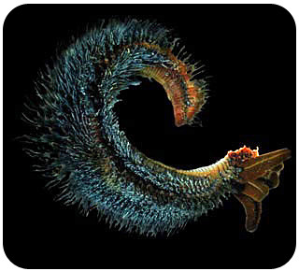
Is it possible to live in temperatures over 175°F?
It is if you're a Pompeii worm. The Pompeii worm, the most heat-tolerant animal on Earth, lives in the deep ocean at super-heated hydrothermal vents. Covering this deep-sea worm's back is a fleece of bacteria. These microbes contain all the genes necessary for life in extreme environments.

Chemosynthesis
Why do bacteria that live deep below the ocean’s surface rely on chemical compounds instead of sunlight for energy to make food?
Most autotrophs make food by photosynthesis, but this isn’t the only way that autotrophs produce food. Some bacteria make food by another process, which uses chemical energy instead of light energy. This process is called chemosynthesis . In chemosynthesis, one or more carbon molecules (usually carbon dioxide or methane, CH ₄ ) and nutrients is converted into organic matter, using the oxidation of inorganic molecules (such as hydrogen gas, hydrogen sulfide (H ₂ S) or ammonia (NH ₃ )) or methane as a source of energy, rather than sunlight. In hydrogen sulfide chemosynthesis, in the presence of carbon dioxide and oxygen, carbohydrates (CH ₂ O) can be produced:
CO ₂ + O ₂ + 4H ₂ S → CH ₂ O + 4S + 3H ₂ O
Many organisms that use chemosynthesis are extremophiles, living in harsh conditions such as the absence of sunlight and a wide range of water temperatures, some approaching the boiling point. Some chemosynthetic bacteria live around deep-ocean vents known as “black smokers.” Compounds such as hydrogen sulfide, which flow out of the vents from Earth’s interior, are used by the bacteria for energy to make food. Consumers that depend on these bacteria to produce food for them include giant tubeworms, like those pictured in Figure below . These organisms are known as chemoautotrophs. Many chemosynthetic microorganisms are consumed by other organisms in the ocean, and symbiotic associations between these organisms and respiring heterotrophs are quite common.
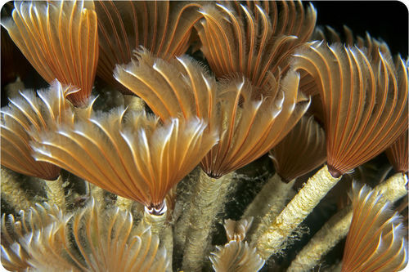
Tubeworms deep in the Gulf of Mexico get their energy from chemosynthetic bacteria. Tubeworms have no mouth, eyes or stomach. Their survival depends on a symbiotic relationship with the billions of bacteria that live inside them. These bacteria convert the chemicals that shoot out of the hydrothermal vents into food for the worm.

Summary
- Chemosynthesis is a process in which some organisms use chemical energy instead of light energy to produce "food."

Practice
Use this resource to answer the questions that follow.
- http://www.hippocampus.org/Biology Biology for AP* Search: Chemiosmosis in Plants
- How is the proton gradient established across the thylakoid membrane?
- What is the proton motive force?
- Why is the pH of the thylakoid lumen lower than that of the surrounding stroma?
- What is ATP synthase?
- What drives the synthesis of ATP?

Review
1. What is chemosynthesis?
2. Why do bacteria that live deep below the ocean’s surface rely on chemical compounds instead of sunlight for energy to make food?

2.25 Anaerobic vs Aerobic Respiration
- Define aerobic and anaerobic respiration.
How long can you hold your breath?
With or without air? In terms of producing energy, that is the key question. Can cellular respiration occur without air? It can, but it does have limitations.

The Presence of Oxygen
There are two types of cellular respiration (see "Cellular Respiration I: Introduction" concept): aerobic and anaerobic. One occurs in the presence of oxygen ( aerobic ), and one occurs in the absence of oxygen ( anaerobic ). Both begin with glycolysis - the splitting of glucose.
Glycolysis (see "Cellular Respiration II: Glycolysis" concept) is an anaerobic process - it does not need oxygen to proceed. This process produces a minimal amount of ATP. The Krebs cycle and electron transport do need oxygen to proceed, and in the presence of oxygen, these process produce much more ATP than glycolysis alone.
Scientists think that glycolysis evolved before the other stages of cellular respiration. This is because the other stages need oxygen, whereas glycolysis does not, and there was no oxygen in Earth’s atmosphere when life first evolved about 3.5 to 4 billion years ago. Cellular respiration that proceeds without oxygen is called anaerobic respiration .
Then, about 2 or 3 billion years ago, oxygen was gradually added to the atmosphere by early photosynthetic bacteria. After that, living things could use oxygen to break down glucose and make ATP. Today, most organisms make ATP with oxygen. They follow glycolysis with the Krebs cycle and electron transport to make more ATP than by glycolysis alone. Cellular respiration that proceeds in the presence of oxygen is called aerobic respiration .

Summary
- Cellular respiration always begins with glycolysis, which can occur either in the absence or presence of oxygen.
- Cellular respiration that proceeds in the absence of oxygen is anaerobic respiration.
- Cellular respiration that proceeds in the presence of oxygen is aerobic respiration.
- Anaerobic respiration evolved prior to aerobic respiration.

Practice
Use this resource to answer the questions that follow.
- http://www.hippocampus.org/Biology Biology for AP* Search: Metabolic Strategies
- What is the role of oxygen in aerobic metabolism?
- What is the role of oxygen in anaerobic metabolism?
- Aerobic metabolism involves what processes?
- Anaerobic metabolism is also known by what name?
- How is water formed in the presence of oxygen?
- Which form of metabolism produces more energy?

Review
1. Define aerobic and anaerobic respiration.
2. Why do scientists think that glycolysis evolved before the other stages of cellular respiration?

2.26 Cellular Respiration
- Name the three stages of cellular respiration.
Why eat?
Because we're hungry. Not necessarily. But biologically speaking…we eat to get energy. The food we eat is broken down, the glucose extracted, and that energy is converted into ATP.

Cellular Respiration
What happens to the energy stored in glucose during photosynthesis? How do living things make use of this stored energy? The answer is cellular respiration . This process releases the energy in glucose to make ATP (adenosine triphosphate), the molecule that powers all the work of cells.
An introduction to cellular respiration can be viewed at http://www.youtube.com/user/khanacademy#p/c/7A9646BC5110CF64/19/2f7YwCtHcgk (14:19).
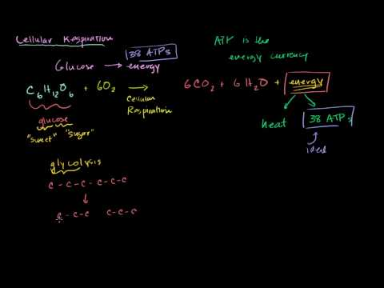
Click on the image above for more content

Stages of Cellular Respiration
Cellular respiration involves many chemical reactions. The reactions can be summed up in this equation:
C ₆ H ₁₂ O ₆ + 6O ₂ → 6CO ₂ + 6H ₂ O + Chemical Energy (in ATP)
The reactions of cellular respiration can be grouped into three stages: glycolysis (stage 1), the Krebs cycle , also called the citric acid cycle (stage 2), and electron transport (stage 3). Figure below gives an overview of these three stages, which are further discussed in the concepts that follow. Glycolysis occurs in the cytosol of the cell and does not require oxygen, whereas the Krebs cycle and electron transport occur in the mitochondria and do require oxygen.
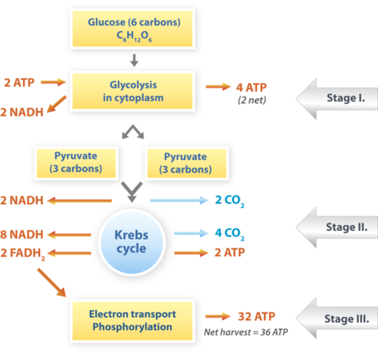
Cellular respiration takes place in the stages shown here. The process begins with a molecule of glucose, which has six carbon atoms. What happens to each of these atoms of carbon?

Structure of the Mitochondrion: Key to Aerobic Respiration
The structure of the mitochondrion is key to the process of aerobic (in the presence of oxygen) cellular respiration, especially the Krebs cycle and electron transport. A diagram of a mitochondrion is shown in Figure below .
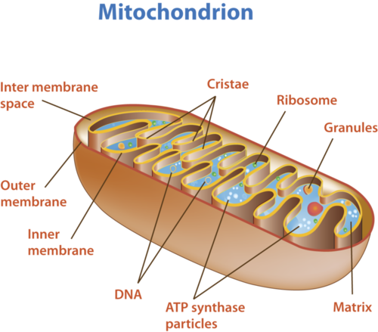
The structure of a mitochondrion is defined by an inner and outer membrane. This structure plays an important role in aerobic respiration.
As you can see from Figure above , a mitochondrion has an inner and outer membrane. The space between the inner and outer membrane is called the intermembrane space. The space enclosed by the inner membrane is called the matrix. The second stage of cellular respiration, the Krebs cycle, takes place in the matrix. The third stage, electron transport, takes place on the inner membrane.

Summary
- Cellular respiration takes the energy stored in glucose and transfers it to ATP.
- Cellular respiration has three stages: glycolysis: the Krebs cycle and electron transport.
- The inner and outer membranes of the mitochondrion play a important roles in aerobic respiration.

Practice I
Use this resource to answer the questions that follow.
- http://www.hippocampus.org/Biology Non-Majors Biology Search: Cellular Respiration
- What is the goal of cellular respiration?
- What are the two stages of cellular respiration?
- Which organisms are able to perform glycolysis?
- What is the main product of glycolysis? What happens to this product?

Practice II
- Cellular Respiration at http://www.concord.org/activities/cellular-respiration .
- Photosynthesis & Respiration at http://www.neok12.com/quiz/PHOSYN04 .

Review
1. Describe cellular respiration.
2. Using the chemical equation of cellular respiration and the above figure as a guide, describe what happens to each of the atoms of carbon during this process.
3. Describe the structure of the mitochondrion and discuss the importance of this structure in cellular respiration.
4. Assume that a new species of organism has been discovered. Scientists have observed its cells under a microscope and determined that they lack mitochondria. What type of cellular respiration would you predict that the new species uses? Explain your prediction.
5. When you exhale onto a cold window pane, water vapor in your breath condenses on the glass. Where does the water vapor come from?

2.27 Glycolysis
- Give an overview of glycolysis.
How do you slice a molecule of glucose in half?
With sharp knives? Not really. But you lyse it through glycolysis. This is an extremely important part of cellular respiration. It happens all the time, both with and without oxygen. And in the process, transfers some energy to ATP.

Cellular Respiration Stage I: Glycolysis
The first stage of cellular respiration is glycolysis . It does not require oxygen, and it does not take place in the mitochondrion - it takes place in the cytosol of the cytoplasm.
When was the last time you enjoyed yogurt on your breakfast cereal, or had a tetanus shot? These experiences may appear unconnected, but both relate to bacteria which do not use oxygen to make ATP. In fact, tetanus bacteria cannot survive if oxygen is present. However, Lactobacillus acidophilus (bacteria which make yogurt) and Clostridium tetani (bacteria which cause tetanus or lockjaw) share with nearly all organisms the first stage of cellular respiration, glycolysis. Because glycolysis is universal, whereas aerobic (oxygen-requiring) cellular respiration is not, most biologists consider it to be the most fundamental and primitive pathway for making ATP.

Splitting Glucose
The word glycolysis means “glucose splitting,” which is exactly what happens in this stage. Enzymes split a molecule of glucose into two molecules of pyruvate (also known as pyruvic acid). This occurs in several steps, as shown in Figure below . You can watch an animation of the steps of glycolysis at this link: http://www.youtube.com/watch?v=6JGXayUyNVw .
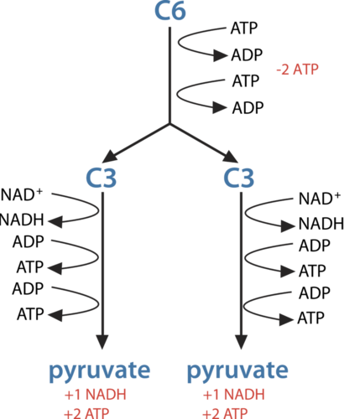
In glycolysis, glucose (C6) is split into two 3-carbon (C3) pyruvate molecules. This releases energy, which is transferred to ATP. How many ATP molecules are made during this stage of cellular respiration?

Results of Glycolysis
Energy is needed at the start of glycolysis to split the glucose molecule into two pyruvate molecules. These two molecules go on to stage II of cellular respiration. The energy to split glucose is provided by two molecules of ATP. As glycolysis proceeds, energy is released, and the energy is used to make four molecules of ATP. As a result, there is a net gain of two ATP molecules during glycolysis. During this stage, high-energy electrons are also transferred to molecules of NAD ⁺ to produce two molecules of NADH , another energy-carrying molecule. NADH is used in stage III of cellular respiration to make more ATP.
A summary of glycolysis can be viewed at http://www.youtube.com/user/khanacademy#p/c/7A9646BC5110CF64/22/FE2jfTXAJHg .
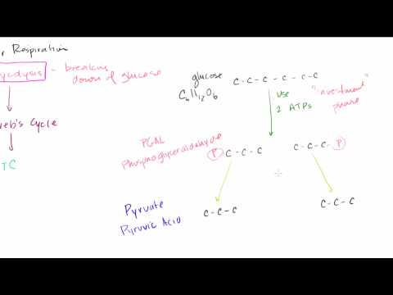
Click on the image above for more content

Summary
- The first stage of cellular respiration is glycolysis. It does not require oxygen.
- During glycolysis, one glucose molecule is split into two pyruvate molecules, using 2 ATP while producing 4 ATP and 2 NADH molecules.

Practice I
Use these resources to answer the questions that follow.
- http://www.hippocampus.org/Biology Biology for AP* Search: Glycolsis: Summary
- http://www.hippocampus.org/Biology Biology for AP* Search: Glycolysis: Overview
- How do cells get chemical energy?
- Define glycolysis. Where does glycolysis take place?
- When is the maximum amount of energy released?
- How can glycolysis be regulated?
- What is hexokinase?
- http://www.hippocampus.org/Biology Biology for AP* Search: The Glycolytic Pathway
- What does glucose supply? Where does glucose come from?
- Describe the overall process of glycolysis.
- What happens during the energy gaining phase of glycolysis?
- What is the total gain in ATP from glycolysis?
- What is an isomerase?
- Why are reactions 1, 3, and 10 considered spontaneous?
- What are the final products of glycolysis?
- http://www.hippocampus.org/Biology Biology for AP* Search: The Regulation of Glycolysis
- What are the major control points of glycolysis?
- Define feedback inhibition.
- How is PFK regulated during glycolysis?
- Is citrate an inhibitor or activator of PFK?

Practice II
- Glycolysis at http://johnkyrk.com/glycolysis.html .

Review
1. What is glycolysis?
2. Describe what happens during glycolysis. How many ATP molecules are gained during this stage?
3. Defend this statement: "Glycolysis is a universal and ancient pathway for making ATP."

2.28 Krebs Cycle
- List the steps of the Krebs cycle, and identify its products.
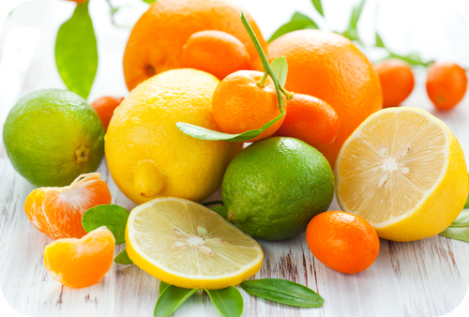
What type of acid do these fruits contain?
Citric acid. Citric acid is also the first product formed in the Krebs cycle, and therefore this acid occurs in the metabolism of virtually all living things.

Cellular Respiration Stage II: The Krebs Cycle
Recall that glycolysis, stage I of cellular respiration, produces two molecules of pyruvate. These molecules enter the matrix of a mitochondrion, where they start the Krebs cycle . The reactions that occur next are shown in Figure below . You can watch an animated version at this link: http://www.youtube.com/watch?v=p-k0biO1DT8&feature=related .
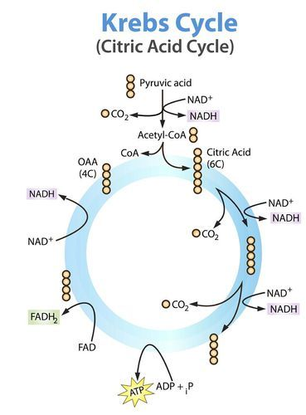
The Krebs cycle starts with pyruvic acid from glycolysis. Each small circle in the diagram represents one carbon atom. For example, citric acid is a six carbon molecule, and OAA (oxaloacetate) is a four carbon molecule. Follow what happens to the carbon atoms as the cycle proceeds. In one turn through the cycle, how many molecules are produced of ATP? How many molecules of NADH and FADH ₂ are produced?
Before the Krebs cycle begins, pyruvic acid, which has three carbon atoms, is split apart and combined with an enzyme known as CoA, which stands for coenzyme A. The product of this reaction is a two-carbon molecule called acetyl-CoA. The third carbon from pyruvic acid combines with oxygen to form carbon dioxide, which is released as a waste product. High-energy electrons are also released and captured in NADH.

Steps of the Krebs Cycle
The Krebs cycle itself actually begins when acetyl-CoA combines with a four-carbon molecule called OAA (oxaloacetate) (see Figure above ). This produces citric acid, which has six carbon atoms. This is why the Krebs cycle is also called the citric acid cycle . After citric acid forms, it goes through a series of reactions that release energy. The energy is captured in molecules of NADH, ATP, and FADH ₂ , another energy-carrying compound. Carbon dioxide is also released as a waste product of these reactions. The final step of the Krebs cycle regenerates OAA, the molecule that began the Krebs cycle. This molecule is needed for the next turn through the cycle. Two turns are needed because glycolysis produces two pyruvic acid molecules when it splits glucose. Watch the OSU band present the Krebs cycle: http://www.youtube.com/watch?v=FgXnH087JIk&feature=related .

Results of the Krebs Cycle
After the second turn through the Krebs cycle, the original glucose molecule has been broken down completely. All six of its carbon atoms have combined with oxygen to form carbon dioxide. The energy from its chemical bonds has been stored in a total of 16 energy-carrier molecules. These molecules are:
- 4 ATP (including 2 from glycolysis)
- 10 NADH (including 2 from glycolysis)
- 2 FADH ₂
The Krebs cycle is reviewed at http://www.youtube.com/user/khanacademy#p/c/7A9646BC5110CF64/23/juM2ROSLWfw .
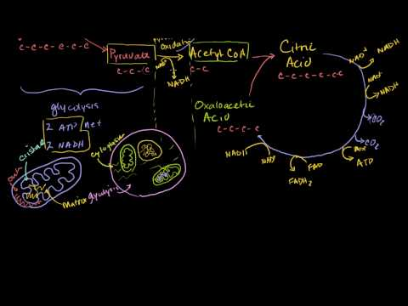
Click on the image above for more content

Summary
- The Krebs cycle is the second stage of cellular respiration.
- During the Krebs cycle, energy stored in pyruvate is transferred to NADH and FADH ₂ , and some ATP is produced.

Practice I
Use these resources to answer the questions that follow.
- The Citric Acid Cycle at http://virtuallabs.stanford.edu/other/biochem/TCA.swf .
- Where does the Krebs cycle occur in the cell?
- What is the first product of this cycle?
- How many reactions does it take to complete the cycle?
- http://www.hippocampus.org/Biology Biology for AP* Search: The TCA Cycle: Summary
- http://www.hippocampus.org/Biology Biology for AP* Search: The TCA Cycle: Overview
- Provide a definition for the Krebs or TCA cycle.
- What are the roles of NADH and FADH ₂ ?
- Will the TCA cycle occur in the absence of oxygen?
- http://www.hippocampus.org/Biology Biology for AP* Search: The TCA Cycle
- What must happen to pyruvate for it to enter the mitochondria?
- What is the function of Coenzyme A?
- Is reaction 1 reversible? Why or why not?
- How many NADH molecules are produced during the Krebs cycle?
- How do carbon atoms leave the Krebs cycle?

Practice II
- Krebs Cycle at http://johnkyrk.com/krebs.html .

Review
1. What is the Krebs cycle?
2. What are the products of the Krebs cycle?
3. Explain why two turns of the Krebs cycle are needed for each molecule of glucose.

2.29 Electron Transport
- Explain how electron transport results in many molecules of ATP.
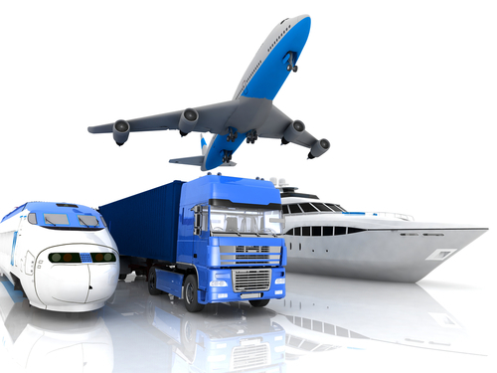
Train, truck, boat or plane?
Ways to transport. To make ATP, energy must be "transported" - first from glucose to NADH, and then somehow passed to ATP. How is this done? With an electron transport chain.

Cellular Respiration Stage III: Electron Transport
Electron transport is the final stage of aerobic respiration. In this stage, energy from NADH and FADH ₂ , which result from the Krebs cycle, is transferred to ATP. Can you predict how this happens? ( Hint: How does electron transport occur in photosynthesis?)
See http://www.youtube.com/watch?v=1engJR_XWVU&feature=related for an overview of the electron transport chain.

Transporting Electrons
High-energy electrons are released from NADH and FADH ₂ , and they move along electron transport chains , like those used in photosynthesis. The electron transport chains are on the inner membrane of the mitochondrion. As the high-energy electrons are transported along the chains, some of their energy is captured. This energy is used to pump hydrogen ions (from NADH and FADH ₂ ) across the inner membrane, from the matrix into the intermembrane space. Electron transport in a mitochondrion is shown in Figure below .
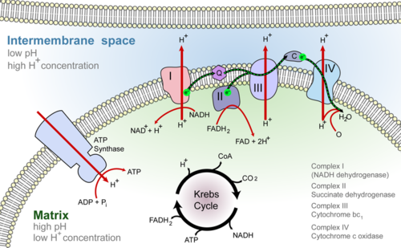
Electron-transport chains on the inner membrane of the mitochondrion carry out the last stage of cellular respiration.

Making ATP
The pumping of hydrogen ions across the inner membrane creates a greater concentration of the ions in the intermembrane space than in the matrix. This chemiosmotic gradient causes the ions to flow back across the membrane into the matrix, where their concentration is lower. ATP synthase acts as a channel protein, helping the hydrogen ions cross the membrane. It also acts as an enzyme, forming ATP from ADP and inorganic phosphate. After passing through the electron-transport chain, the “spent” electrons combine with oxygen to form water. This is why oxygen is needed; in the absence of oxygen, this process cannot occur.
A summary of this process can be seen at the following sites: http://www.youtube.com/user/khanacademy#p/c/7A9646BC5110CF64/24/mfgCcFXUZRk (17:16) and http://www.youtube.com/user/khanacademy#p/c/7A9646BC5110CF64/25/W_Q17tqw_7A (4:59).
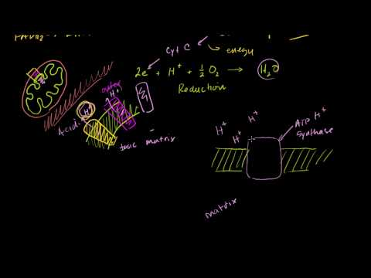
Click on the image above for more content
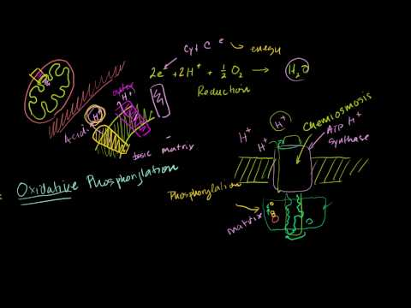
Click on the image above for more content

Summary
- Electron transport is the final stage of aerobic respiration. In this stage, energy from NADH and FADH ₂ is transferred to ATP.
- During electron transport, energy is used to pump hydrogen ions across the mitochondrial inner membrane, from the matrix into the intermembrane space.
- A chemiosmotic gradient causes hydrogen ions to flow back across the mitochondrial membrane into the matrix, through ATP synthase, producing ATP.

Practice I
Use these resources to answer the questions that follow.
- http://www.hippocampus.org/Biology Biology for AP* Search: Electron Transport, ATP Synthesis, and Chemiosmosis: Overview
- http://www.hippocampus.org/Biology Biology for AP* Search: The Electron Transport Chain
- Where, specifically, is the electron transport chain located?
- How many electrons does NADH donate to the first electron acceptor?
- What is the role of Coenzyme Q in electron transport?
- What is the role of molecular oxygen in this process?
- How is the proton gradient formed?
- What are the results of the removal of protons from the matrix?
- Define the proton-motive force.
- http://www.hippocampus.org/Biology Biology for AP* Search: The Synthesis of ATP
- What is ATP synthase?
- Describe how ATP synthase works.
- http://www.hippocampus.org/Biology Biology for AP* Search: Chemiosmosis
- Describe the chemiosmotic model.

Practice II
- Mitochondria at http://johnkyrk.com/mitochondrion.html .

Review
1. Summarize the overall task of Stage III of aerobic respiration.
2. Explain the principle of chemiosmosis.
3. What is the maximum number of ATP molecules that can be produced during the electron transport stage of aerobic respiration?

2.30 Fermentation
- Describe lactic acid fermentation and alcoholic fermentation.
When you combine grapes and yeast, what have you begun to make?
Wine. It may be slightly more complicated than that, but you need to start with grapes and yeast, and allow a natural fermentation process to occur. Essentially, this is respiration without oxygen.

Anaerobic Respiration: Fermentation
Today, most living things use oxygen to make ATP from glucose. However, many living things can also make ATP without oxygen. This is true of some plants and fungi and also of many bacteria. These organisms use aerobic respiration when oxygen is present, but when oxygen is in short supply, they use anaerobic respiration instead. Certain bacteria can only use anaerobic respiration. In fact, they may not be able to survive at all in the presence of oxygen.
An important way of making ATP without oxygen is called fermentation . It involves glycolysis, but not the other two stages of aerobic respiration. Many bacteria and yeasts carry out fermentation. People use these organisms to make yogurt, bread, wine, and biofuels. Human muscle cells also use fermentation. This occurs when muscle cells cannot get oxygen fast enough to meet their energy needs through aerobic respiration. There are two types of fermentation: lactic acid fermentation and alcoholic fermentation. Both types of fermentation are described below. You can also watch animations of both types at this link: http://www.cst.cmich.edu/users/schul1te/animations/fermentation.swf .

Lactic Acid Fermentation
In lactic acid fermentation , pyruvic acid from glycolysis changes to lactic acid. This is shown in Figure below . In the process, NAD ⁺ forms from NADH. NAD ⁺ , in turn, lets glycolysis continue. This results in additional molecules of ATP. This type of fermentation is carried out by the bacteria in yogurt. It is also used by your own muscle cells when you work them hard and fast.
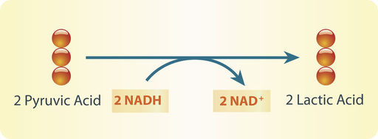
Lactic acid fermentation produces lactic acid and NAD+. The NAD+ cycles back to allow glycolysis to continue so more ATP is made. Each circle represents a carbon atom.
Did you ever run a race and notice that your muscles feel tired and sore afterward? This is because your muscle cells used lactic acid fermentation for energy. This causes lactic acid to build up in the muscles. It is the buildup of lactic acid that makes the muscles feel tired and sore.

Alcoholic Fermentation
In alcoholic fermentation , pyruvic acid changes to alcohol and carbon dioxide. This is shown in Figure below . NAD ⁺ also forms from NADH, allowing glycolysis to continue making ATP. This type of fermentation is carried out by yeasts and some bacteria. It is used to make bread, wine, and biofuels.
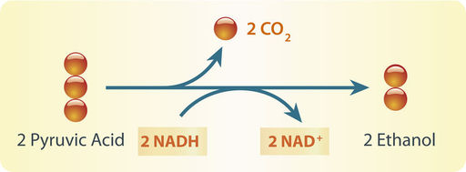
Alcoholic fermentation produces ethanol and NAD+. The NAD+ allows glycolysis to continue making ATP.
Have your parents ever put corn in the gas tank of their car? They did if they used gas containing ethanol. Ethanol is produced by alcoholic fermentation of the glucose in corn or other plants. This type of fermentation also explains why bread dough rises. Yeasts in bread dough use alcoholic fermentation and produce carbon dioxide gas. The gas forms bubbles in the dough, which cause the dough to expand. The bubbles also leave small holes in the bread after it bakes, making the bread light and fluffy. Do you see the small holes in the slice of bread in Figure below ?
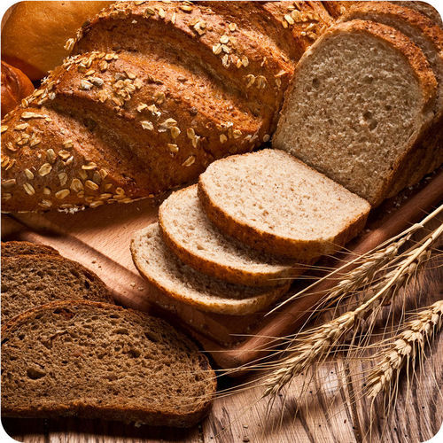
The small holes in bread are formed by bubbles of carbon dioxide gas. The gas was produced by alcoholic fermentation carried out by yeast.

Summary
- Fermentation is making ATP without oxygen, which involves glycolysis only.
- Fermentation recycles NAD ⁺ , and produces 2 ATPs.
- In lactic acid fermentation, pyruvic acid from glycolysis changes to lactic acid. This type of fermentation is carried out by the bacteria in yogurt, and by your own muscle cells.
- In alcoholic fermentation, pyruvic acid changes to alcohol and carbon dioxide. This type of fermentation is carried out by yeasts and some bacteria.

Practice
Use this resource to answer the questions that follow.
- http://www.hippocampus.org/Biology Biology for AP* Search: The Fate of Pyruvate and NADH
- Why must NAD ⁺ be regenerated?
- How are NAD ⁺ and pyruvate regenerated under aerobic conditions?
- What does "anaerobic" refer to?
- What is fermentation?
- What happens during fermentation in animals and yeast?

Review
1. What is fermentation?
2. Name two types of fermentation.
3. What is the main advantage of aerobic respiration? Of anaerobic respiration?
4. What process produces fuel for motor vehicles from living plant products? What is the waste product of this process?
5. Compare and contrast lactic acid fermentation and alcoholic fermentation. Include examples of organisms that use each type of fermentation.
6. Explain why bread dough rises when it is set aside in a warm place.

2.31 Anaerobic and Aerobic Respiration
- Compare the advantages of aerobic and anaerobic respiration.
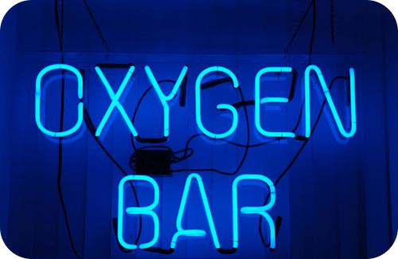
Why oxygen?
Oxygen is the final electron acceptor at the end of the electron transport chain of aerobic respiration. In the absence of oxygen, only a few ATP are produced from glucose. In the presence of oxygen, many more ATP are made.

Aerobic vs. Anaerobic Respiration: A Comparison
Aerobic respiration , which takes place in the presence of oxygen, evolved after oxygen was added to Earth’s atmosphere. This type of respiration is useful today because the atmosphere is now 21% oxygen. However, some anaerobic organisms that evolved before the atmosphere contained oxygen have survived to the present. Therefore, anaerobic respiration , which takes place without oxygen, must also have advantages.

Advantages of Aerobic Respiration
A major advantage of aerobic respiration is the amount of energy it releases. Without oxygen, organisms can split glucose into just two molecules of pyruvate. This releases only enough energy to make two ATP molecules. With oxygen, organisms can break down glucose all the way to carbon dioxide. This releases enough energy to produce up to 38 ATP molecules. Thus, aerobic respiration releases much more energy than anaerobic respiration. The amount of energy produced by aerobic respiration may explain why aerobic organisms came to dominate life on Earth. It may also explain how organisms were able to become multicellular and increase in size.

Advantages of Anaerobic Respiration
One advantage of anaerobic respiration is obvious. It lets organisms live in places where there is little or no oxygen. Such places include deep water, soil, and the digestive tracts of animals such as humans (see Figure below ).
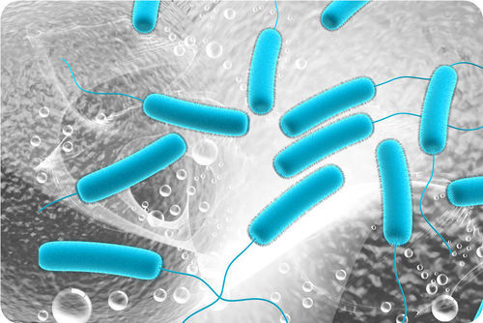
E. coli bacteria are anaerobic bacteria that live in the human digestive tract.
Another advantage of anaerobic respiration is its speed. It produces ATP very quickly. For example, it lets your muscles get the energy they need for short bursts of intense activity (see Figure below ). Aerobic respiration, on the other hand, produces ATP more slowly.
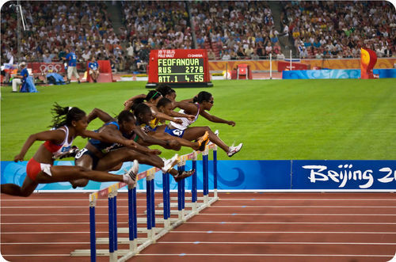
The muscles of these hurdlers need to use anaerobic respiration for energy. It gives them the energy they need for the short-term, intense activity of this sport.

Summary
- Aerobic respiration produces much more ATP than anaerobic respiration.
- Anaerobic respiration occurs more quickly than aerobic respiration.

Practice
Use this resource to answer the questions that follow.
- http://www.hippocampus.org/Biology Biology for AP* Search: The Fate of Pyruvate and NADH
- What is the role of oxygen under aerobic conditions?
- How is NAD ⁺ regenerated under anaerobic conditions?
- Which metabolism is faster, aerobic or anaerobic?
- Which cells have more mitochondria, those that metabolize aerobically or anaerobically?
- Which metabolism produces more energy, aerobic or anaerobic? Why?

Review
1. What is the main advantage of aerobic respiration? Of anaerobic respiration?
2. Tanya is on the high school track team and runs the 100-meter sprint. Marissa is on the cross-country team and runs 5-kilometer races. Explain which type of respiration the muscle cells in each runner’s legs use.

Summary
The cell is the smallest unit of structure and function of all living organisms. Cell Biology focuses on significant aspects of the cell from its structure to its division. Some organisms contain just one cell, and others contain trillions. Some have a nucleus with DNA, others do not. Some have many organelles, others do not. But all cells are surrounded by a cell membrane. And it is this semipermeable membrane that determines what can enter and leave the cell. All cells need energy, and for many organisms, this energy comes from photosynthesis and cellular respiration. All cells come from preexisting cells through the process of cell division, which can produce a new prokaryotic organism. The cell cycle, which includes mitosis, defines the life of an eukaryotic cell.

