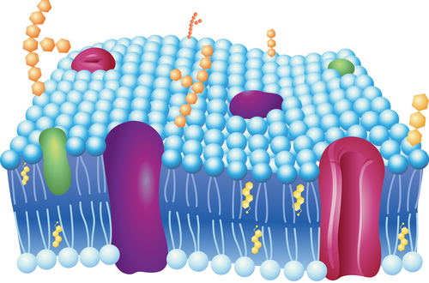
2.4 Phospholipid Bilayers
- Describe the structure and function of the plasma membrane.
All cells have a plasma membrane. This membrane surrounds the cell. So what is its role?
Can molecules enter and leave the cell? Yes. Can anything or everything enter or leave? No. So, what determines what can go in or out? Is it the nucleus? The DNA? Or the plasma membrane?

The Plasma Membrane
The plasma membrane (also known as the cell membrane) forms a barrier between the cytoplasm inside the cell and the environment outside the cell. It protects and supports the cell and also controls everything that enters and leaves the cell. It allows only certain substances to pass through, while keeping others in or out. The ability to allow only certain molecules in or out of the cell is referred to as selective permeability or semipermeability. To understand how the plasma membrane controls what crosses into or out of the cell, you need to know its composition.
The plasma membrane is discussed at http://www.youtube.com/watch?v=-aSfoB8Cmic (6:16).

A Phospholipid Bilayer
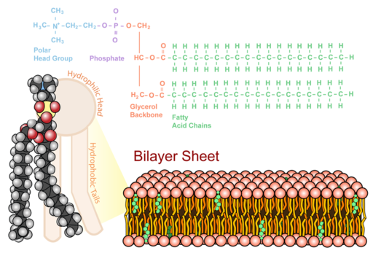
The plasma membrane is composed mainly of phospholipids, which consist of fatty acids and alcohol. The phospholipids in the plasma membrane are arranged in two layers, called a phospholipid bilayer. As shown in Figure below, each phospholipid molecule has a head and two tails. The head “loves” water (hydrophilic) and the tails “hate” water (hydrophobic). The water-hating tails are on the interior of the membrane, whereas the water-loving heads point outwards, toward either the cytoplasm or the fluid that surrounds the cell. Molecules that are hydrophobic can easily pass through the plasma membrane, if they are small enough, because they are water-hating like the interior of the membrane. Molecules that are hydrophilic, on the other hand, cannot pass through the plasma membrane—at least not without help—because they are water-loving like the exterior of the membrane.
Phospholipid Bilayer. The phospholipid bilayer consists of two layers of phospholipids, with a hydrophobic, or water-hating, interior and a hydrophilic, or water-loving, exterior. The hydrophilic (polar) head group and hydrophobic tails (fatty acid chains) are depicted in the single phospholipid molecule. The polar head group and fatty acid chains are attached by a 3-carbon glycerol unit.
See Insights into cell membranes via dish detergent at http://ed.ted.com/lessons/insights-into-cell-membranes-via-dish-detergent-ethan-perlstein for additional information on the cell membrane.

Summary
- The plasma membrane forms a barrier between the cytoplasm and the environment outside the cell. The plasma membrane has selective permeability.
- The plasma membrane is primarily composed of phospholipids arranged in a bilayer, with the hydrophobic tails on the interior of the membrane, and the hydrophilic heads pointing outwards.

Practice
Use these resources to answer the questions that follow.
- Construction of the Cell Membrane at http://www.wisc-online.com/Objects/ViewObject.aspx?ID=AP1101 .
- What are the two main components of the cell membrane?
- Describe the types of proteins that live in the cell membrane.
- Describe the orientation of the phospholipid molecule in the cell membrane.
- Cell Membranes at http://johnkyrk.com/cellmembrane.html .
- Are all cells surrounded by a membrane?
- Why are phospholipids considered an amphipathic molecule?
- What is a glycolipid?
- Describe the role of cholesterol in the cell membrane.

Review
1. Describe the role of the plasma membrane.
2. Describe the composition of the plasma membrane.
3. Explain why hydrophobic (“water-hating”) molecules can easily cross the plasma membrane, while hydrophilic (“water-loving”) molecules cannot.

2.5 Membrane Proteins
- Describe the structure and function of the plasma membrane.
Can anything or everything move in or out of the cell?
No. It is the semipermeable plasma membrane that determines what can enter and leave the cell. So, if not everything can cross the membrane, how do certain things get across?

Membrane Proteins
The plasma membrane contains molecules other than phospholipids, primarily other lipids and proteins. The green molecules in Figure below, for example, are the lipid cholesterol. Molecules of cholesterol help the plasma membrane keep its shape. Many of the proteins in the plasma membrane assist other substances in crossing the membrane.
The plasma membranes also contain certain types of proteins. A membrane protein is a protein molecule that is attached to, or associated with, the membrane of a cell or an organelle. Membrane proteins can be put into two groups based on how the protein is associated with the membrane.
Integral membrane proteins are permanently embedded within the plasma membrane. They have a range of important functions. Such functions include channeling or transporting molecules across the membrane. Other integral proteins act as cell receptors. Integral membrane proteins can be classified according to their relationship with the bilayer:
- Transmembrane proteins span the entire plasma membrane. Transmembrane proteins are found in all types of biological membranes.
- Integral monotopic proteins are permanently attached to the membrane from only one side.
Some integral membrane proteins are responsible for cell adhesion (sticking of a cell to another cell or surface). On the outside of cell membranes and attached to some of the proteins are carbohydrate chains that act as labels that identify the cell type. Shown in Figure below are two different types of membrane proteins and associated molecules.
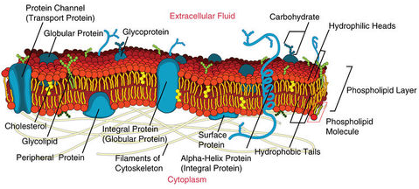
Peripheral membrane proteins are proteins that are only temporarily associated with the membrane. They can be easily removed, which allows them to be involved in cell signaling. Peripheral proteins can also be attached to integral membrane proteins, or they can stick into a small portion of the lipid bilayer by themselves. Peripheral membrane proteins are often associated with ion channels and transmembrane receptors. Most peripheral membrane proteins are hydrophilic.
Some of the membrane proteins make up a major transport system that moves molecules and ions through the polar phospholipid bilayer.

The Fluid Mosaic Model
In 1972 S.J. Singer and G.L. Nicolson proposed the now widely accepted Fluid Mosaic Model of the structure of cell membranes. The model proposes that integral membrane proteins are embedded in the phospholipid bilayer, as seen in Figure above. Some of these proteins extend all the way through the bilayer, and some only partially across it. These membrane proteins act as transport proteins and receptors proteins.
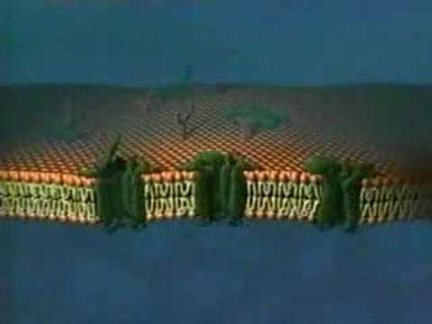
Their model also proposed that the membrane behaves like a fluid, rather than a solid. The proteins and lipids of the membrane move around the membrane, much like buoys in water. Such movement causes a constant change in the "mosaic pattern" of the plasma membrane.
A further description of the Fluid Mosaic Model can be viewed at http://www.youtube.com/watch?v=ULR79TiUj80 (1:27).
Go to http://goo.gl/3SfHzU for more content.

Extensions of the Plasma Membrane
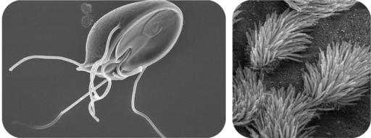
The plasma membrane may have extensions, such as whip-like flagella or brush-like cilia. In single-celled organisms, like those shown in Figure below, the membrane extensions may help the organisms move. In multicellular organisms, the extensions have other functions. For example, the cilia on human lung cells sweep foreign particles and mucus toward the mouth and nose.
Flagella and Cilia. Cilia and flagella are extensions of the plasma membrane of many cells.

Summary
- The plasma membrane has many proteins that assist other substances in crossing the membrane.
- The Fluid Mosaic Model depicts the biological nature of the plasma membrane.
- Cilia and flagella are extensions of the plasma membrane.

Practice
Use these resources to answer the questions that follow.
- Cell Membranes at http://johnkyrk.com/cellmembrane.html .
- What is the major role of many membrane proteins?
- How much of a cell's genetic material may code for membrane proteins?
- What are transmembrane proteins, and what is their main function?
- How can a protein "tunnel" form through the membrane?
- How can a protein "channel" form through the membrane?
- Construction of the Cell Membrane at http://www.wisc-online.com/Objects/ViewObject.aspx?ID=AP1101.
- How may water molecules enter the cell?
- How may ions enter the cell?
- What type(s) of protein(s) identify the cell?

Review
1. What are the main differences between the types of proteins associated with the plasma membrane?
2. Discuss the Fluid Mosaic Model.
3. What are flagella and cilia?

2.5-2.10: Transportation of matter in life

There are two ways materials move around living things and across their plasma membranes:
  - Passively: requires no ATP, happens due to the natural kinetic energy of matter where matter moves down its concentration gradient– matter moves from an area of great concentration to an area of less concentration until equilibrium is reached across the space.
  - Actively: requires ATP, “forcing” matter to move opposite of natural inclination. Matter moves up its concentration gradient – from an area of less concentration to an area of greater concentration, resulting in a larger gradient, no equilibrium

Intro 2.5-2.7: Passive forms of transport

All require no ATP, happen due to the natural kinetic energy of matter where matter moves down its concentration gradient– matter moves from an area of great concentration to an area of less concentration until equilibrium is reached across the space.

3 Main categories:
- Diffusion (AKA “Simple diffusion”)
- Osmosis
- Facilitated Diffusion (includes “Ion Channel Transport”)

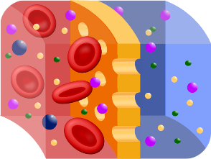
2.5 Diffusion (AKA “Simple Diffusion”)
- Describe different types of passive transport.
- Explain how they are all a form of diffusion.
What will eventually happen to these dyes?
They will all blend together. The dyes will move through the water until an even distribution is achieved. The process of moving from areas of high amounts to areas of low amounts is called diffusion. Diffusion occurs because all substances have a natural kinetic energy. This energy makes them “spread out” or diffuse.

Selective Permeability
In this class, most of the diffusion that we discuss will occur across a cell membrane. Probably the most important feature of a cell’s membranes (the plasma membrane and all other membranes surrounding membrane-bound organelles – remember it is all the same basic stuff!) is that they are selectively permeable or semipermeable. A membrane that is selectively permeable has control over what molecules or ions can enter or leave the cell, as shown in Figure below. The permeability of a membrane is dependent on the organization and characteristics of the membrane lipids and proteins. In this way, cell membranes help maintain a state of homeostasis within cells (and tissues, organs, and organ systems) so that an organism can stay alive and healthy.

Transport across Membranes
The molecular make-up of the phospholipid bilayer limits the types of molecules that can pass through it. For example, hydrophobic (water-hating) molecules, such as carbon dioxide (CO₂ ) and oxygen (O₂ ), can easily pass through the lipid bilayer, but ions such as calcium (Ca²⁺ ) and polar molecules such as water (H₂O) cannot. The hydrophobic interior of the phospholipid bilayer does not allow ions or polar molecules through because they are hydrophilic, or water loving. In addition, large molecules such as sugars and proteins are too big to pass through the bilayer. Transport proteins (a type of integral protein) within the membrane allow these molecules to pass through the membrane, and into or out of the cell. This way, polar molecules avoid contact with the nonpolar interior of the membrane, and large molecules are moved through large pores.
Every cell is contained within a membrane punctuated with transport proteins that act as channels or pumps to let in/out or force in/out certain molecules. The purpose of the transport proteins is to protect the cell's internal environment and to keep its balance of salts, nutrients, and proteins within a range that keeps the cell and the organism alive.
There are three main ways that molecules can pass across a cell membrane: The first way requires no energy input by the cell for the molecule to pass through the membrane and is called passive transport; there are three versions of passive transport you will learn about. The second and third way are both active forms of transport (must use ATP), but involve very different methods: one way requires that the cell forces certain molecules across the membrane using integral proteins called “pumps”. The final way is through vesicle transport, in which large molecules are moved across the membrane in bubble-like sacks that are made from pieces of the membrane. We will discuss active transport more starting with section 2.15.
Passive transport is a way that small molecules or ions move across the cell membrane without input of energy by the cell. The three main kinds of passive transport are diffusion, osmosis, and facilitated diffusion.

Diffusion
Diffusion is the movement of molecules from an area of high concentration of the molecules to an area with a lower concentration. The difference in the concentrations of the molecules in the two areas is called the concentration gradient. Diffusion will continue until this gradient has been eliminated. Since diffusion moves materials from an area of higher concentration to the lower, it is described as moving solutes "down the concentration gradient." The end result of diffusion is an equal concentration, or equilibrium , of molecules on both sides of the membrane.
If a molecule can pass freely through a cell membrane, it will cross the membrane by diffusion ( Figure below ). 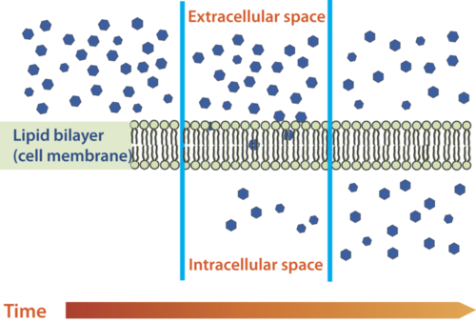
Molecules move from an area of high concentration to an area of lower concentration until an equilibrium is met. The molecules continue to cross the membrane at equilibrium, but at equal rates in both directions.

Summary
- The cell membrane is selectively permeable, allowing only certain substances to pass through.
- Passive transport is a way that small molecules or ions move across the cell membrane without input of energy by the cell. The three main kinds of passive transport are diffusion, osmosis, and facilitated diffusion.
- Diffusion is the movement of molecules from an area of high concentration of the molecules to an area with a lower concentration.

Practice I
Use this resource to answer the questions that follow.
- http://www.hippocampus.org/Biology Biology for AP* Search: Transport Mechanisms
- Is simple diffusion a form of passive transport? Explain your answer.
- What is a concentration gradient?
- Give an example of a molecule that can enter a cell by simple diffusion.

Practice II
- Diffusion, Osmosis and Active Transport at http://www.concord.org/activities/diffusion-osmosis-and-active-transport .

Review
1. What is diffusion?
2. What is a concentration gradient?
3. What is meant by passive transport?

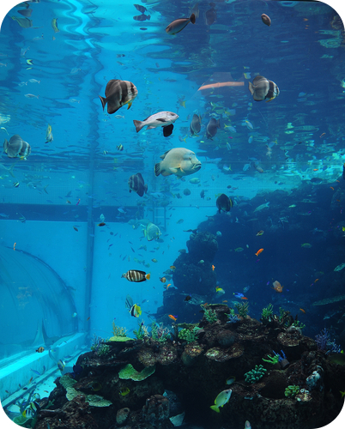
2.6 Osmosis
- Describe different types of passive transport.
Saltwater Fish vs. Freshwater Fish?
Fish cells, like all cells, have semi-permeable membranes. Eventually, the concentration of "stuff" on either side of them will even out. A fish that lives in salt water will have somewhat salty water inside itself. Put it in the freshwater, and the freshwater will, through osmosis, enter the fish, causing its cells to swell, and the fish will die. What will happen to a freshwater fish in the ocean?

Osmosis
Imagine you have a cup that has 100ml water, and you add 15g of table sugar to the water. The sugar dissolves and the mixture that is now in the cup is made up of a solute (the sugar) that is dissolved in the solvent (the water). The mixture of a solute in a solvent is called a solution.
Imagine now that you have a second cup with 100ml of water, and you add 45 grams of table sugar to the water. Just like the first cup, the sugar is the solute, and the water is the solvent. But now you have two mixtures of different solute concentrations. In comparing two solutions of unequal solute concentration, the solution with the higher solute concentration is hypertonic, and the solution with the lower solute concentration is hypotonic. Solutions of equal solute concentration are isotonic. The first sugar solution is hypotonic to the second solution. The second sugar solution is hypertonic to the first.
You now add the two solutions to a beaker that has been divided by a selectively permeable membrane, with pores that are too small for the sugar molecules to pass through, but are big enough for the water molecules to pass through. The hypertonic solution is on one side of the membrane and the hypotonic solution on the other. The hypertonic solution has a lower water concentration than the hypotonic solution, so a concentration gradient of water now exists across the membrane. Water molecules will move from the side of higher water concentration to the side of lower concentration until both solutions are isotonic. At this point, equilibrium is reached.
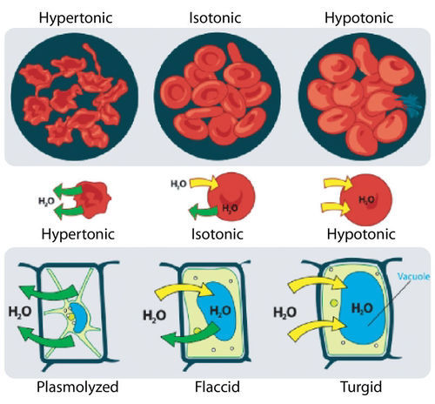
Osmosis is the diffusion of water molecules across a selectively permeable membrane from an area of higher concentration to an area of lower concentration. Water moves into and out of cells by osmosis. If a cell is in a hypertonic solution, the solution has a lower water concentration than the cell cytosol, and water moves out of the cell until both solutions are isotonic. Cells placed in a hypotonic solution will take in water across their membrane until both the external solution and the cytosol are isotonic.
A cell that does not have a rigid cell wall, such as a red blood cell, will swell and lyse (burst) when placed in a hypotonic solution. Cells with a cell wall will swell when placed in a hypotonic solution, but once the cell is turgid (firm), the tough cell wall prevents any more water from entering the cell. When placed in a hypertonic solution, a cell without a cell wall will lose water to the environment, shrivel, and probably die. In a hypertonic solution, a cell with a cell wall will lose water too. The plasma membrane pulls away from the cell wall as it shrivels, a process called plasmolysis. Animal cells tend to do best in an isotonic environment, plant cells tend to do best in a hypotonic environment. This is demonstrated in Figure below.
Unless an animal cell (such as the red blood cell in the top panel) has an adaptation that allows it to alter the osmotic uptake of water, it will lose too much water and shrivel up in a hypertonic environment. If placed in a hypotonic solution, water molecules will enter the cell, causing it to swell and burst. Plant cells (bottom panel) become plasmolyzed in a hypertonic solution, but tend to do best in a hypotonic environment. Water is stored in the central vacuole of the plant cell.

Osmotic Pressure
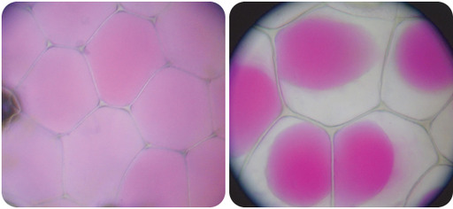
When water moves into a cell by osmosis, osmotic pressure may build up inside the cell. If a cell has a cell wall, the wall helps maintain the cell’s water balance. Osmotic pressure is the main cause of support in many plants. When a plant cell is in a hypotonic environment, the osmotic entry of water raises the turgor pressure exerted against the cell wall until the pressure prevents more water from coming into the cell. At this point the plant cell is turgid. The effects of osmotic pressures on plant cells are shown in Figure below .
The central vacuoles of the plant cells in the left image are full of water, so the cells are turgid. The plant cells in the right image have been exposed to a hypertonic solution; water has left the central vacuole and the cells have become plasmolyzed.

The action of osmosis can be very harmful to organisms, especially ones without cell walls. For example, if a saltwater fish (whose cells are isotonic with seawater), is placed in fresh water, its cells will take on excess water, lyse, and the fish will die. Another example of a harmful osmotic effect is the use of table salt to kill slugs and snails.
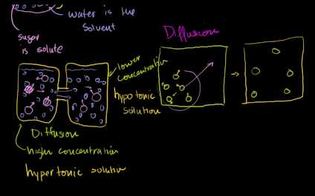
Diffusion and osmosis are discussed at http://www.youtube.com/user/khanacademy#p/c/7A9646BC5110CF64/34/aubZU0iWtgI (18:59).
Go to http://goo.gl/eo6cZT for more content.

Controlling Osmosis
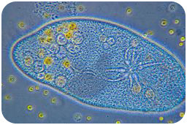
Organisms that live in a hypotonic environment such as freshwater, need a way to prevent their cells from taking in too much water by osmosis. A contractile vacuole is a type of vacuole that removes excess water from a cell. Freshwater protists, such as the paramecium shown in Figure below, have a contractile vacuole. The vacuole is surrounded by several canals, which absorb water by osmosis from the cytoplasm. After the canals fill with water, the water is pumped into the vacuole. When the vacuole is full, it pushes the water out of the cell through a pore.
The contractile vacuole is the star-like structure within the paramecium (at center-right)

Summary
- Osmosis is the diffusion of water.
- In comparing two solutions of unequal solute concentration, the solution with the higher solute concentration is hypertonic, and the solution with the lower concentration is hypotonic. Solutions of equal solute concentration are isotonic.
- A contractile vacuole is a type of vacuole that removes excess water from a cell.

Practice I
- Define osmosis.
- Is osmosis a form of diffusion? Explain your answer.
- Why is osmosis important in biology?

Practice II
- Diffusion, Osmosis and Active Transport at http://www.concord.org/activities/diffusion-osmosis-and-active-transport
- Osmosis
Go to http://goo.gl/wRS85N for more content

Review
1. What is osmosis? What type of transport is it?
2. How does osmosis differ from diffusion?

2.7 Facilitated Diffusion
- Describe different types of passive transport.
Can you help me move?
What is one of the questions no one likes to be asked? Sometimes the cell needs help moving things as well, or facilitating the diffusion process. And this would be the job of a special type of protein.

Facilitated Diffusion
Facilitated diffusion is the diffusion of solutes through transport proteins in the plasma membrane. Facilitated diffusion is a type of passive transport. Even though facilitated diffusion involves transport proteins, it is still passive transport because the solute is moving down the concentration gradient.
Small nonpolar molecules can easily diffuse across the cell membrane. However, due to the hydrophobic nature of the lipids that make up cell membranes, polar molecules (such as water) and ions cannot do so. Instead, they diffuse across the membrane through transport proteins. A transport protein completely spans the membrane, and allows certain molecules or ions to diffuse across the membrane. Channel proteins, gated channel proteins, and carrier proteins are three types of transport proteins that are involved in facilitated diffusion.
A channel protein , a type of transport protein, acts like a pore in the membrane that lets water molecules or small ions through quickly. Water channel proteins allow water to diffuse across the membrane at a very fast rate. Ion channel proteins allow ions to diffuse across the membrane.
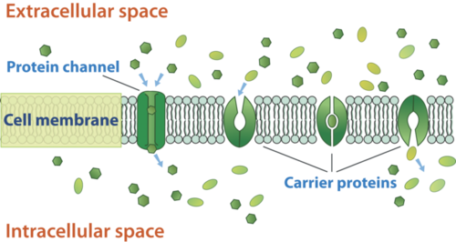
A gated channel protein is a transport protein that opens a "gate," allowing a molecule to pass through the membrane. Gated channels have a binding site that is specific for a given molecule or ion. A stimulus causes the "gate" to open or shut. The stimulus may be chemical or electrical signals, temperature, or mechanical force, depending on the type of gated channel. For example, the sodium gated channels of a nerve cell are stimulated by a chemical signal which causes them to open and allow sodium ions into the cell. Glucose molecules are too big to diffuse through the plasma membrane easily, so they are moved across the membrane through gated channels. In this way glucose diffuses very quickly across a cell membrane, which is important because many cells depend on glucose for energy.
A carrier protein is a transport protein that is specific for an ion, molecule, or group of substances. Carrier proteins "carry" the ion or molecule across the membrane by changing shape after the binding of the ion or molecule. Carrier proteins are involved in passive and active transport. A model of a channel protein and carrier proteins is shown in Figure beside .
Facilitated diffusion through the cell membrane. Channel proteins and carrier proteins are shown (but not a gated-channel protein). Water molecules and ions move through channel proteins. Other ions or molecules are also carried across the cell membrane by carrier proteins. The ion or molecule binds to the active site of a carrier protein. The carrier protein changes shape, and releases the ion or molecule on the other side of the membrane. The carrier protein then returns to its original shape.
An animation depicting facilitated diffusion can be viewed at http://www.youtube.com/watch?v=OV4PgZDRTQw&feature=related (1:36).
Go to http://goo.gl/5yCvcF for more content.

Ion Channels
Ions such as sodium (Na ⁺ ), potassium (K ⁺ ), calcium (Ca ²⁺ ), and chloride (Cl ⁻ ), are important for many cell functions. Because they are polar, these ions do not diffuse through the membrane. Instead they move through ion channel proteins where they are protected from the hydrophobic interior of the membrane. Ion channels allow the formation of a concentration gradient between the extracellular fluid and the cytosol. Ion channels are very specific, as they allow only certain ions through the cell membrane. Some ion channels are always open, others are "gated" and can be opened or closed. Gated ion channels can open or close in response to different types of stimuli, such as electrical or chemical signals.

Summary
- Facilitated diffusion is the diffusion of solutes through transport proteins in the plasma membrane. Channel proteins, gated channel proteins, and carrier proteins are three types of transport proteins that are involved in facilitated diffusion.

Practice I
- Describe the structure of a transport protein.
- Give an example of a molecule transported by a transport protein.

Practice II
- Membrane Channels at http://phet.colorado.edu/en/simulation/membrane-channels .
Go to http://goo.gl/9JclYz for more content.

Review
1. Assume a molecule must cross the plasma membrane into a cell. The molecule is a very large protein. How will it be transported into the cell? Explain your answer.
2. Compare and contrast simple diffusion and facilitated diffusion. For each type of diffusion, give an example of a molecule that is transported that way.

Intro 2.8-2.10: Active forms of transport

Requires ATP, “forcing” matter to move opposite of natural inclination. Matter moves up its concentration gradient – from an area of less concentration to an area of greater concentration, resulting in a larger gradient, no equilibrium

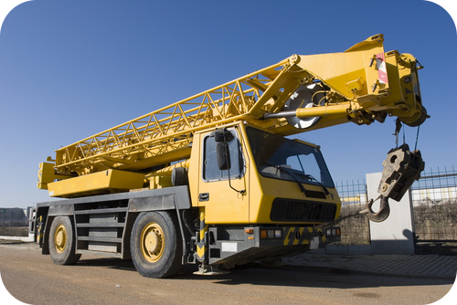
2 Main categories:
- Cell mebrane pumps
- Endocytosis/Exocytosis

2.8 Active Transport
- Explain how different types of active transport occur.
Need to move something really heavy?
If you did, it would take a lot of energy. Sometimes, moving things into or out of the cell also takes energy. How would the cell move something against a concentration gradient? It starts by using energy.

Active Transport
In contrast to facilitated diffusion, which does not require energy and carries molecules or ions down a concentration gradient, active transport pumps molecules and ions against a concentration gradient. Sometimes an organism needs to transport something against a concentration gradient. The only way this can be done is through active transport, which uses energy that is produced by respiration (ATP). In active transport, the particles move across a cell membrane from a lower concentration to a higher concentration. Active transport is the energy-requiring process of pumping molecules and ions across membranes "uphill" - against a concentration gradient.
- The active transport of small molecules or ions across a cell membrane is generally carried out by transport proteins that are found in the membrane.
- Larger molecules such as starch can also be actively transported across the cell membrane by processes called endocytosis and exocytosis.

Homeostasis and Cell Function
Homeostasis refers to the balance, or equilibrium, within the cell or a body. It is an organism’s ability to keep a constant internal environment. Keeping a stable internal environment requires constant adjustments as conditions change inside and outside the cell. The adjusting of systems within a cell is called homeostatic regulation. Because the internal and external environments of a cell are constantly changing, adjustments must be made continuously to stay at or near the set point (the normal level or range). Homeostasis is a dynamic equilibrium rather than an unchanging state. The cellular processes discussed in both the "Passive Transport" and "Active Transport" concepts all play an important role in homeostatic regulation. You will learn more about homeostasis in other concepts.

Summary
- Active transport is the energy-requiring process of pumping molecules and ions across membranes against a concentration gradient.
- Active transport processes help maintain homeostasis.

Practice I
- What is the main difference between active transport and diffusion?
- What molecule is required to do active transport? HINT: energy!

Practice II
- Diffusion, Osmosis and Active Transport at http://www.concord.org/activities/diffusion-osmosis-and-active-transport .
- Active Transport
Go to http://goo.gl/DV4bfz for more content.

Review
1. What is active transport?
2. Explain how cell transport helps an organism maintain homeostasis.

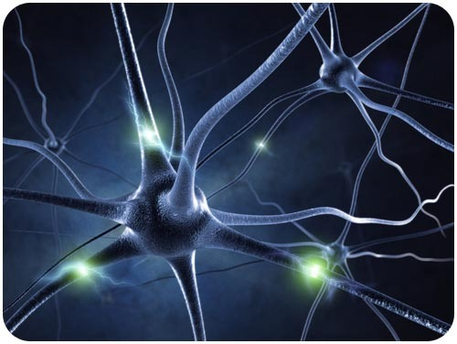
2.9 Cell Membrane Pumps (the Sodium-Potassium Pump!)
- Explain how different types of active transport occur.
- Explain how the sodium-potassium pump functions.
What is this incredible object?
Would it surprise you to learn that it is a human cell? The image represents an active human nerve cell. How nerve cells function will be the focus of another concept. However, active transport processes play a significant role in the function of these cells. Specifically, it is the sodium-potassium pump that is active in the axons of these nerve cells.

The Sodium-Potassium Pump
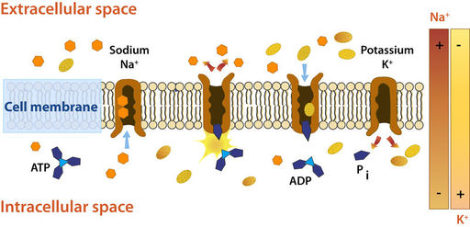
Active transport is the energy-requiring process of pumping molecules and ions across membranes "uphill" - against a concentration gradient. To move these molecules against their concentration gradient, a carrier protein is needed. Carrier proteins can work with a concentration gradient (during passive transport), but some carrier proteins can move solutes against the concentration gradient (from low concentration to high concentration), with an input of energy. As in other types of cellular activities, ATP supplies the energy for most active transport. One way ATP powers active transport is by transferring a phosphate group directly to a carrier protein. This may cause the carrier protein to change its shape, which moves the molecule or ion to the other side of the membrane. An example of this type of active transport system, as shown in Figure below, is the sodium-potassium pump, which exchanges sodium ions for potassium ions across the plasma membrane of animal cells.
The sodium-potassium pump system moves sodium and potassium ions against large concentration gradients. It moves two potassium ions into the cell where potassium levels are high, and pumps three sodium ions out of the cell and into the extracellular fluid.
As is shown in Figure above, three sodium ions bind with the protein pump inside the cell. The carrier protein then gets energy from ATP and changes shape. In doing so, it pumps the three sodium ions out of the cell. At that point, two potassium ions move in from outside the cell and bind to the protein pump. The sodium-potassium pump is found in the plasma membrane of almost every human cell and is common to all cellular life. It helps maintain cell potential and regulates cellular volume.
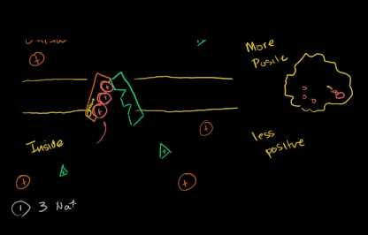
A more detailed look at the sodium-potassium pump is available at http://www.youtube.com/user/khanacademy#p/c/7A9646BC5110CF64/40/C_H-ONQFjpQ (13:53) and http://www.youtube.com/user/khanacademy#p/c/7A9646BC5110CF64/41/ye3rTjLCvAU (6:48).
Go to http://goo.gl/IqiLuA for more content.
Go to http://goo.gl/cvnCPL for more content.

The Electrochemical Gradient
The active transport of ions across the membrane causes an electrical gradient to build up across the plasma membrane. The number of positively charged ions outside the cell is greater than the number of positively charged ions in the cytosol. This results in a relatively negative charge on the inside of the membrane, and a positive charge on the outside. This difference in charges causes a voltage across the membrane. Voltage is electrical potential energy that is caused by a separation of opposite charges, in this case across the membrane. The voltage across a membrane is called membrane potential. Membrane potential is very important for the conduction of electrical impulses along nerve cells.
Because the inside of the cell is negative compared to outside the cell, the membrane potential favors the movement of positively charged ions (cations) into the cell, and the movement of negative ions (anions) out of the cell. So, there are two forces that drive the diffusion of ions across the plasma membrane—a chemical force (the ions' concentration gradient), and an electrical force (the effect of the membrane potential on the ions’ movement). These two forces working together are called an electrochemical gradient, and will be discussed in detail in "Nerve Cell" and "Nerve Impulses" concepts.

Summary
- Active transport is the energy-requiring process of pumping molecules and ions across membranes against a concentration gradient.
- The sodium-potassium pump is an active transport pump that exchanges sodium ions for potassium ions.

Practice
Use this resource to answer the questions that follow.
- Sodium Potassium Pump (ATPase) at http://www.youtube.com/watch?v=Z9tPTDRjCYU&feature=fvwrel
- Why is the size difference between a sodium and potassium ion important?
- Are there more sodium ions on the outside of cells or the inside?
- Are there more potassium ions on the outside of cells or the inside?
- Describe the role of ATP in active transport.

Review
1. What is active transport?
2. Describe how the sodium-potassium pump functions.

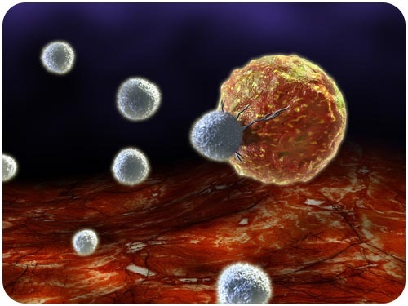
2.10 Exocytosis and Endocytosis
- Explain how different types of active transport occur.
What does a cell "eat"?
Is it possible for objects larger than a small molecule to be engulfed by a cell? Of course it is. This image depicts a cancer cell being attacked by a cell of the immune system. Cells of the immune system consistently destroy pathogens by essentially "eating" them.

Vesicle Transport
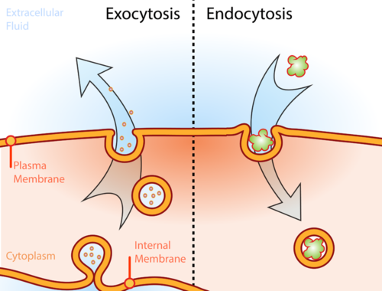
Some molecules or particles are just too large to pass through the plasma membrane or to move through a transport protein. So cells use two other active transport processes to move these macromolecules (large molecules) into or out of the cell. Vesicles or other bodies in the cytoplasm move macromolecules or large particles across the plasma membrane. There are two types of vesicle transport, endocytosis and exocytosis. Both processes are active transport processes, requiring energy.
Illustration of the two types of vesicle transport, exocytosis and endocytosis.

Endocytosis and Exocytosis
Endocytosis is the process of capturing a substance or particle from outside the cell by engulfing it with the cell membrane. The membrane folds over the substance and it becomes completely enclosed by the membrane. At this point a membrane-bound sac, or vesicle, pinches off and moves the substance into the cytosol. There are two main kinds of endocytosis:
- Phagocytosis, or cellular eating, occurs when the dissolved materials enter the cell. The plasma membrane engulfs the solid material, forming a phagocytic vesicle.
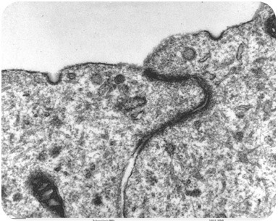
- Pinocytosis, or cellular drinking, occurs when the plasma membrane folds inward to form a channel allowing dissolved substances to enter the cell, as shown in Figure below. When the channel is closed, the liquid is encircled within a pinocytic vesicle.
Transmission electron microscope image of brain tissue that shows pinocytotic vesicles. Pinocytosis is a type of endocytosis.
Exocytosis describes the process of vesicles fusing with the plasma membrane and releasing their contents to the outside of the cell, as shown in Figure below . Exocytosis occurs when a cell produces substances for export, such as a protein, or when the cell is getting rid of a waste product or a toxin. Newly made membrane proteins and membrane lipids are moved on top the plasma membrane by exocytosis. For a detailed animation of cellular secretion, see http://vcell.ndsu.edu/animations/constitutivesecretion/first.htm .

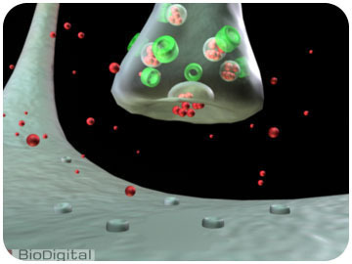
Illustration of an axon releasing dopamine by exocytosis.

Summary
- Active transport is the energy-requiring process of pumping molecules and ions across membranes against a concentration gradient.
- Endocytosis is the process of capturing a substance or particle from outside the cell by engulfing it with the cell membrane, and bringing it into the cell.
- Exocytosis describes the process of vesicles fusing with the plasma membrane and releasing their contents to the outside of the cell.
- Both endocytosis and exocytosis are active transport processes.

Practice
- Compare endocytosis to exocytosis.
- Describe the process of endocytosis.
- What are the differences between phagocytosis, pinocytosis, and receptor-mediated endocytosis?
- How are hormones released from a cell?

Review
1. What is the difference between endocytosis and exocytosis?
2. Why is pinocytosis a form of endocytosis?
3. Are vesicles involved in passive transport? Explain.

