More on Photosynthesis
Light-dependent reaction
      - Pigments are responsible for absorbing the wavelengths of light necessary for the light-dependent reaction of photosynthesis to occur
      - Remember ROYGBIV when thinking about wavelengths of light in the visible spectrum
        - Chlorophylls
          - Absorb mostly red and blue wavelengths of light; reflect green
        - Carotenoids
          - Absorb mostly green light and reflect yellow and orange
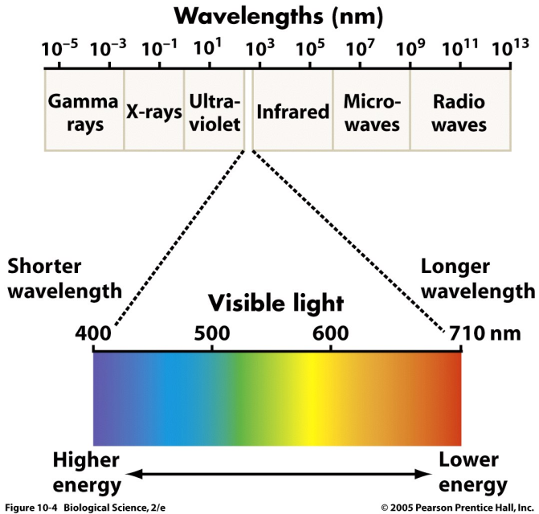  VIOLET RED | 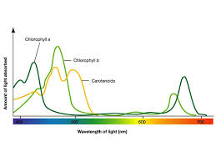  Chloro b  Chloro a  Carotenoids  absorption  Wavelength of light

    - H₂O molecules are broken into hydrogen protons (positive ions), electrons, and oxygen atoms.
        - The electrons replace those originally lost from chlorophyll when it was “excited” by the light.
        - The protons are used to make a small amount of ATP that will be used in the next step
        - The oxygen atoms, however, form oxygen gas (O₂), which is a waste product of photosynthesis. The oxygen given off by photoautotrophs supplies most of the oxygen in our atmosphere.
    - The ATP generated, from what happens to the H protons resulting from the spitting of water, during this step of photosynthesis is used in the next step

Light-independent reaction (AKA “Calvin Cycle”, “Dark Reaction”)
    - Happen in the stroma of the chloroplast of eukaryotes
    - Does NOT require light but does not ONLY happen in the dark…see plant adaptations below!
    - This is the “glucose building” step that uses the ATP generated in the first reaction
      - Carbon fixing occurs during this step
        - breaking apart carbon dioxide in order to incorporate the carbon into organics, like glucose;
        - fixing inorganic carbon into an organic compound
    - Gas exchange occurs
      - Stoma are small openings on plants, often leaves, where the exchange of gases occurs
        - Oxygen (generated in the first step) exits, carbon dioxide enters
        - Some water is also lost in this process…the evolution of a plant will dictate how it performs photosynthesis to deal with water loss from stomata
          - There are three variations/adaptations that we will discuss:
            - C3 plants: stoma open during the day
              - high rate of photosynthesis, high rate of growth
              - ex. “rainforest plants”
            - C4 plants: partially open stomata during the day
              - The C₄ pathway is designed to efficiently fix CO₂ at low concentrations
              - ex: “corn”
            - CAM plants: closed stomata during the day, only open at night
              - CAM plants live in very dry condition and, unlike other plants, open their stomata to fix CO₂ only at night
              - ex: “desert plants”

- Temperature, carbon dioxide concentration and light intensity are three factors that can affect the rate of photosynthesis
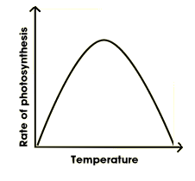 | 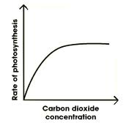 | 