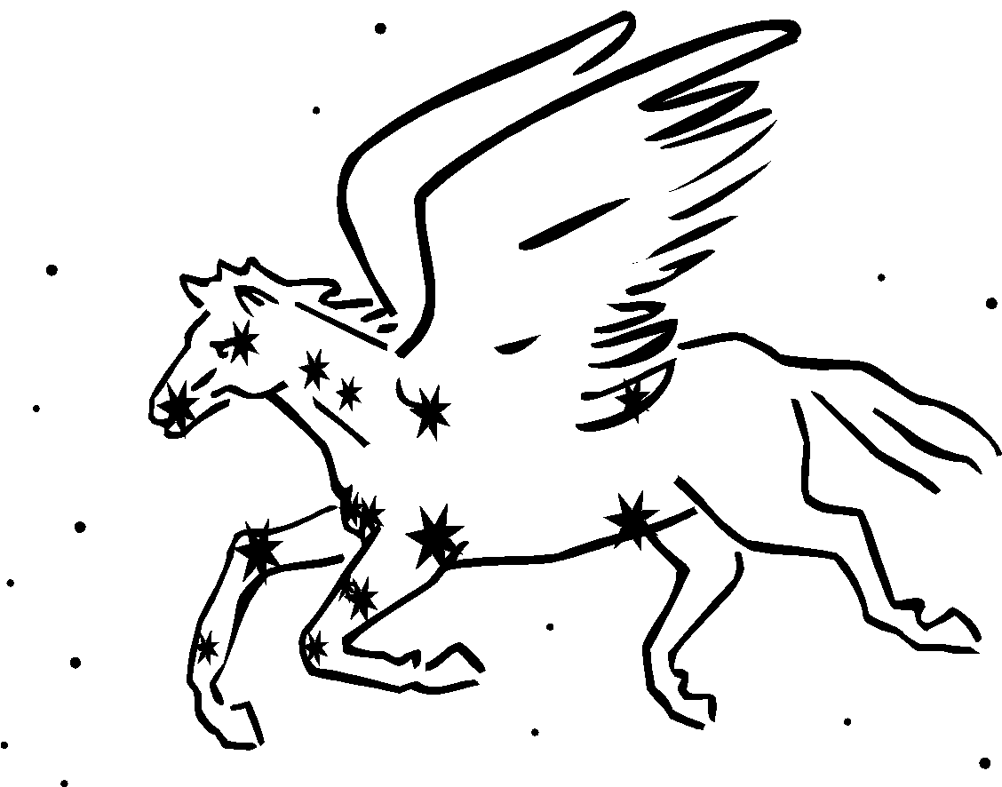  2018-19 | Human Anatomy  & Physiology  Mrs. Sheets, MS.Ed | Website: SheetsBiology.weebly.com  Email: Jsheets2192@columbus.k12.oh.us  Remind: text @SheetsAnat to 81010 or (614) 721-8445

Welcome to CAHS Anatomy & Physiology! Please know that I have high expectations for your success in learning; I teach with the goal of inspiring you to find the subject matter both, worthwhile and interesting to learn.

The focus of this introductory human anatomy & physiology course will be in developing a broad understanding of the structures and their functions in the human body. This course is intended for students in grades 10-12 who have been successful both Biology and Chemistry and have an interest in learning more about the human body.

The pace is swift and your daily participation is expected. Just as in every CAHS course, there is daily homework, as everyone is expected to study/review what they need to even when there is no actual assignment. Some of what you need to know involves memorizing terminology and this may require a great deal of practice. Most of the quarter points will result from quiz/test scores.

Opportunities to view real organs include dissection (sheep heart, fetal pig or rat) and participating in live and recorded surgical videoconferences. Having enrolled in the course, you should feel generally comfortable with images of blood, surgeries, and organs.
………………………………………………………………………………………………………………..
Expected Course Timeline:
1st Semester  Unit 1: How we learn/ Intro to the nervous system, Requirements of Life (Chapters 2-4), Basic terminology (Ch. 1)  Unit 2: Tissues (Ch.5) and Integumentary system (Ch 6)  Unit 3: Skeletal system. Joints (Ch. 7, 8)  Unit 4: Muscular system (Ch. 9) | 2nd Semester  Unit 5: Cardiovascular system, Blood (Ch. 14-16)  Unit 6: Respiratory system (Ch. 19)  Unit 7: Digestive system (Ch. 17)  Unit 8: Urinary system (Ch. 20)  Unit 9: Reproductive systems (Ch. 13-22)
The Endocrine and Lymphatic/Immunity systems will be discussed throughout the course along with the other systems. If there is time remaining at the end of the course, we will get into more details of the Nervous system (Chapters 10-11).
Textbook: Hole’s Human Anatomy & Physiology, 12th edition
………………………………………………………………………………………………………………..
Communication:

As a courtesy to all, grades and attendance information will be communicated through Infinite Campus – I work to ensure that this info is always current, so please check often to stay informed. Please contact me as soon as you have any questions or concerns. I make parent contact regarding individual progress and behaviors primarily through Infinite Campus messaging/email.

Parents and Students may contact me (please include student’s first & last name) one of a few ways.
By messaging me via Infinite Campus, by direct email, with the Remind app, or by calling the CAHS main office and leaving a message.

*Please use the course webpage: SheetsBiology.weebly.com for class events, due dates, and resources.

Track Academic Progress:
The district grading policy will be followed. Quarterly grade information will be frequently updated on Infinite Campus. Most of the quarter grades will be based on quiz/test scores, though there is some value given for class engagement and assignments. Please check grades often and contact me as soon as there is an issue or question.

Classroom Policies and Procedures:
Class Rules: Be prepared, follow directions, behave respectfully and adhere to all district and CAHS guidelines every day. In addition, there is no food allowed in the science lab, only water.

Sleeping in class is inappropriate and unacceptable. If you are ill, see the nurse or arrange to go home.

Keep your device from being a distraction (out of sight/hearing/touch unless specifically permitted to use it.) Per CAHS policy, devices may be confiscated for a time or until a parent meets with administrator to pick up. Abuse of the device policy may also result in loss of engagement points and/or administrative discipline.

Class Materials: In addition to a pencil and a science notebook (folder/binder) where you keep all of your notes and reference, you will need colored pencils and index cards throughout the year.

Lab Fee: There is a lab fee for all CAHS sciences; the fee for A&P is $10.00 payable via Infinite Campus

Hall Passes: Hall pass availability is limited and to be used for restroom use. Your timeliness, class behavior and recent usage may limit your use of the pass.

Attendance and Quizzes: Attendance is required and can seriously affect your grade. Success depends on your presence and your active participation. You are expected to complete all assignments missed for knowledge and experience regardless of grade-earning status. It is your responsibility to seek out the class content/materials provided in class the day(s) that you are absent.

Any work due on a day of excused absence is due the day you return to school to earn full credit. If you arrive to school late, after class has met, it is your responsibility for dropping off due work. Access the class website for more information and resources to assist you due to missed class time.

Missed quizzes may be made up due to an excused absence and you must arrange for make-up on the day of your return. If you arrive to CAHS after our class has met for the day – see me that day. Missed quizzes that you do not arrange to make up will result in a possible exemption or zero earned. Remember that the lowest quiz score of the quarter will be dropped from your quarter grade calculation. A missed quiz, or first absence on a quiz day, will count as your dropped quiz for the quarter. All others missed will need to be made up to avoid a zero.

If you have an unexcused absence/tardy you may earn a zero for mandatory work/quizzes missed.

Suspension is treated as an unexcused absence. All assignments should be picked up during the beginning of your suspension for any opportunity to turn them in for credit. It is your responsibility to avoid suspension.

Tardiness: You are expected to be in the room and near your seat and ready to begin by the bell or you are considered tardy. The CAHS tardy policy is enforced; tardiness may result in a detention and/or loss of points.

Classwork and Homework: All paper-based assignments will be available in a student-accessible file located centrally in the classroom for anyone who needs a copy. Homework may be mandatory or optional; optional HW will not be accepted after the “due by” date and will not be calculated into your grade if missing, incomplete or incorrect. All collected homework is due on the date specified and at the very beginning of class. Any mandatory assignment that is turned in after the start of class is considered late and will receive a reduction in points. Classwork and optional HW will never be accepted late.

Academic Honesty: Academic misconduct will not be tolerated. All work you submit must be your own and must not be shared for copying. Both, the copied and the copier will be penalized. All resources must be cited when reporting. Ask me if you are unsure about this policy.

NEED EXTRA HELP? I am available mods 13/14 and some days after school by appointment – JUST ASK! Please use the class website (SheetsBiology.weebly.com) for pertinent information.

