Name: ___________________________________________ Date: _________ Mods: ______
A&P of the Heart Overview
http://www.bostonscientific.com/lifebeat-online/heart-smart.html?
TASKS: ^{1.} Briefly outline the following information – focus on what you do not currently know well, ^{2.} view the interactives for clarification and ^{3.} take the quizzes for some practice
1a. How Your Heart Works:
- The Chambers and Valves in Your Heart  - Your Blood Vessels  - Coronary vessels  - What do coronary arteries/veins do?  - What is CAD?  - Peripheral arteries (QUIZ 3 and after)  - Locate major ones  - What is PAD?  - Blood Pressure (QUIZ 3 and after)  - Normal BP  - Systolic # is  - Diastolic # is  1b. Your Heart's Electrical System | 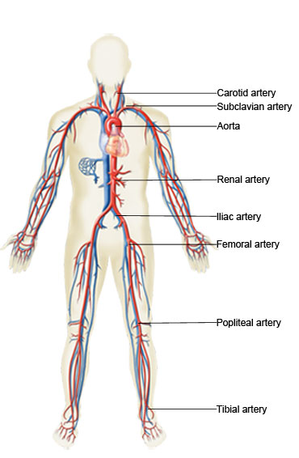
- Parts of the Electrical System

- When Your Heart Has Problems
- CAD  - Heart Attack  - Bradycardia | - Tachycardia  - Heart failure  Peripheral artery disease (PAD)
- List some Heart Healthy tips for avoiding Heart Disease:

- Try the “Are you Heart Smart” Quizzes

Label the Parts of Your Heart

Label Your Heart's Electrical System

Name Your Heart's Blood Vessels

Define Common Heart Problems

