Name: ___________________________________________ Date: _________ Mods: ______
Blood Vessel Review (ch. 15.4)

Basics of Blood Vessels https://www.youtube.com/watch?v=d4HQDD-lGyE&nohtml5=False

- In which type of vessel is blood pressure (BP) the highest?
  - The lowest?

- What causes atherosclerosis?

  - What happens to BP when having this condition?

  - What happens to the lumen of the blood vessel?
Heart Sounds and Blood Pressure
https://www.youtube.com/watch?v=ALqdHnD7c18&nohtml5=False

- What is happening to ventricles during
  - Systole?

  - Diastole?

- The closing of which valves causes the sound of
  - “Lub”?

  - “Dub”?

- What is “pulse”?

  - Which type of vessel do we feel for pulse?

  - Where is the radial artery located?
  - Where is the carotid artery located?
- Chart the flow of blood from heart to tissues and back again:
Ventricle Arteries ____________ ______________ _____________
Atria Veins
- Normal BP is around ____________/ ____________

  - The top number is Systole, the bottom number is _____________

  - Using a sphygmomanometer, put the cuff on the arm where the ______________ artery is located.

- Why take blood from a vein as opposed to an artery?

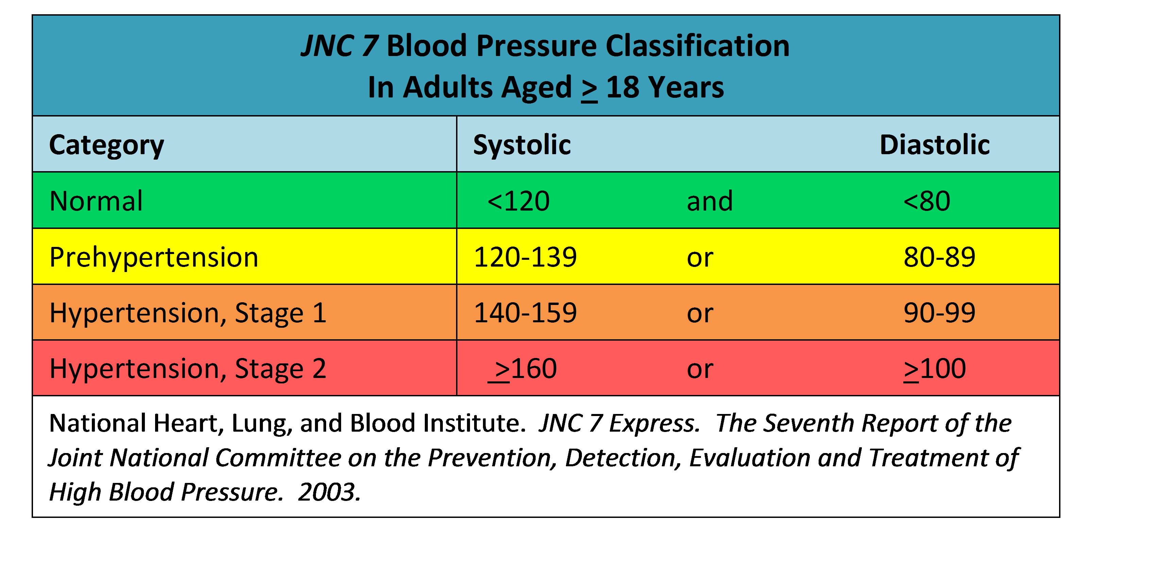
Blood pressure categories
The five blood pressure ranges as recognized by the American Heart Association are:
- Normal blood pressure
Congratulations on having blood pressure numbers that are within the normal (optimal) range of less than 120/80 mm Hg. Keep up the good work and stick with heart-healthy habits like following a balanced diet and getting regular exercise.
- Prehypertension (early stage high blood pressure)
Prehypertension is when blood pressure is consistently ranging from 120-139/80-89 mm Hg. People with prehypertension are likely to develop high blood pressure unless steps are taken to control it.
- Hypertension Stage 1
Hypertension Stage 1 is when blood pressure is consistently ranging from 140-159/90-99 mm Hg. At this stage of high blood pressure, doctors are likely to prescribe lifestyle changes and may consider adding blood pressure medication.
- Hypertension Stage 2
Hypertension Stage 2 is when blood pressure is consistently ranging at levels greater than 160/100 mm Hg. At this stage of high blood pressure, doctors are likely to prescribe a combination of blood pressure medications along with lifestyle changes.
- Hypertensive crisis
This is when high blood pressure requires emergency medical attention. If your blood pressure is higher than 180/110 mm Hg and you are NOT experiencing symptoms such as chest pain, shortness of breath, back pain, numbness/weakness, changes in vision or difficulty speaking, wait about five minutes and take it again. If the reading is still at or above that level, you should CALL 9-1-1 and get help immediately.
Your blood pressure numbers and what they mean
Your blood pressure is recorded as two numbers:
- Systolic blood pressure (the upper number) — indicates how much pressure your blood is exerting against your artery walls when the heart beats.
- Diastolic blood pressure (the lower number) — indicates how much pressure your blood is exerting against your artery walls while the heart is resting between beats.
Which number is more important?
Typically, more attention is given to systolic blood pressure (the top number) as a major risk factor for cardiovascular disease for people over 50. In most people, systolic blood pressure rises steadily with age due to the increasing stiffness of large arteries, long-term build-up of plaque and an increased incidence of cardiac and vascular disease. However, elevated systolic or diastolic blood pressure alone may be used to make a diagnosis of high blood pressure. And, according to recent studies, the risk of death from ischemic heart disease and stroke doubles with every 20 mm Hg systolic or 10 mm Hg diastolic increase among people from age 40 to 89.

