Regulation of the Digestive System Practice
- Name the two body systems responsible for the communication that occurs between all other systems/organs.
  - Which of those two do you associate with neurons, electrochemical signaling?
  - Which of those two do you associate with hormones, chemical signaling?
- Which organ does gastrin act on?

- Which organ releases intestinal gastrin into the blood?

- Which organ responds to intestinal gastrin?

- Does gastrin stimulate or inhibit stomach digestive activity?

- In which of the three phases of gastric secretion (cephalic, gastric, intestinal) is the nervous system largely at play vs. the endocrine system?

- Which of the three phases of gastric secretion (cephalic, gastric, intestinal) is “stomach juice” secretion stimulated/promoted?

- Which hormone both, stimulates the liver to produce bile and the pancreas to secrete fluid rich in enzymes?

- Which hormone stimulates the pancreas to secrete fluid high in bicarbonate ions but low in enzymes?

- What is the role of bile?

- Label: pancreatic duct, gallbladder, pancreas, bile duct, duodenum

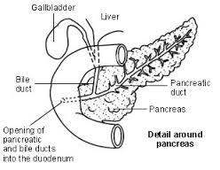
Maintenance of Blood Sugar
