Enzyme Lab Make up
Procedure: Put each sample in a deep well, add 10 drops of hydrogen peroxide to each and wait two minutes for reaction to proceed
Well A: Raw potato
Well C: Raw Liver
Well E: Cooked liver
Well G: Sand

After ten minutes, measure the height of the column of foam produced by the reaction happening in each well.
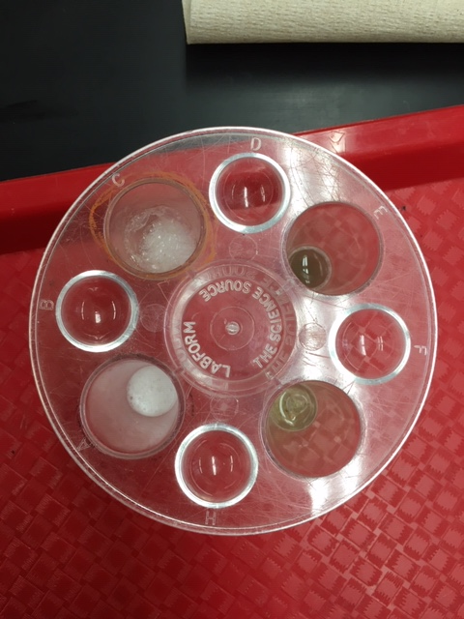
Observations after 2 minutes:

Well C: Raw Liver A: Raw Potato G: Sand E: Cooked Liver
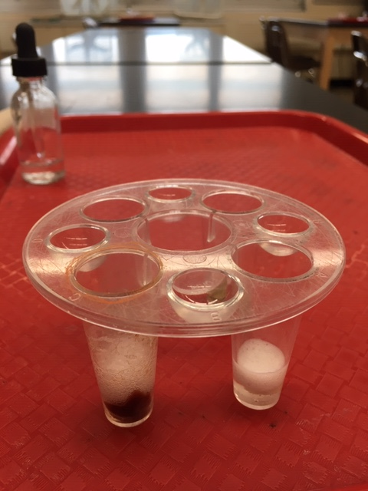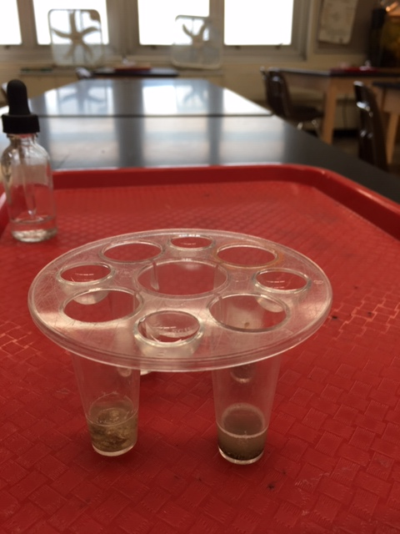
Quantitative (Height of foam data) and qualitative (observations – see, feel by touching reaction chamber) data collected and recorded in data table
Add 10 more drops of Hydrogen Peroxide. Did the reaction start again (evidence: more bubble production)?
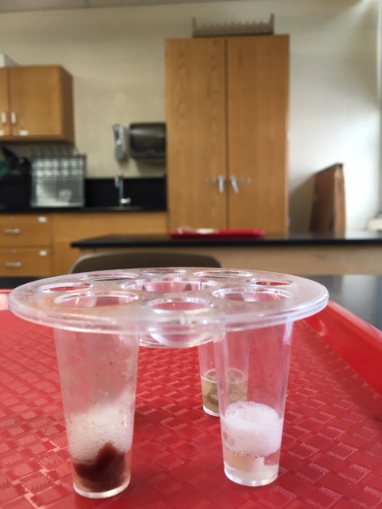
C: Raw Liver – Yes! A: Raw Potato-Yes! G: Sand- no E: Cooked Liver- still no

