Gout

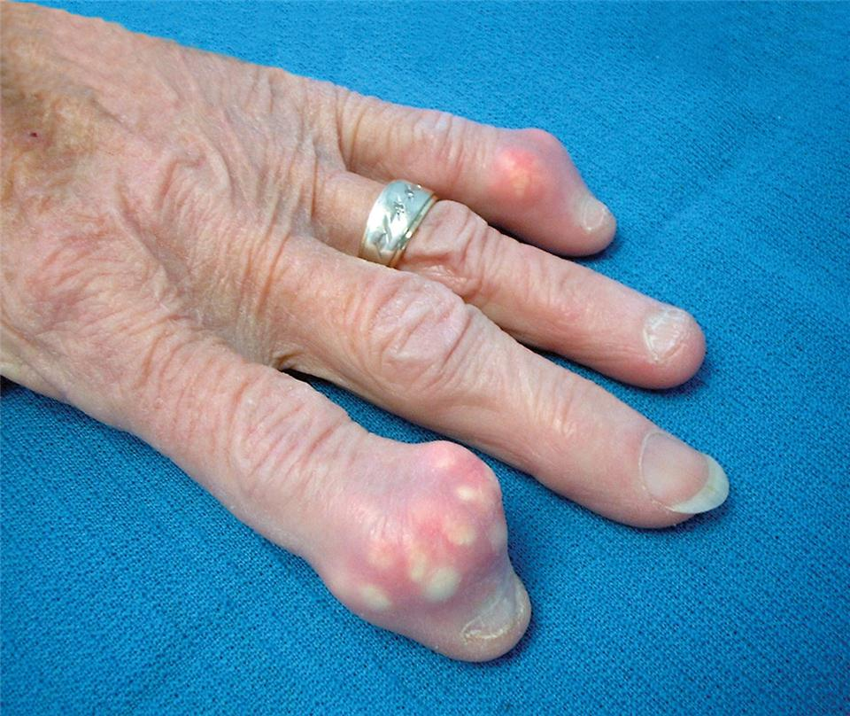

In the last stage, chronic gout affects multiple joints all the time. In this stage, pain at multiple joints persists and large lumps of uric acid deposits called tophi (singular:tophus) are present. Chronic inflammation and the presence of tophi in the joints can accelerate joint degeneration, which can lead to deformity and disability.
In advanced chronic gout, damage to the kidney caused by uric acid deposit can cause kidney failures. Other conditions, such as hypertension (high blood pressure), albuminuria (abnormal presence of albumin protein in the urine indicating kidney disease), and urolithiasis (urinary stone in the urinary tract) can also develop.

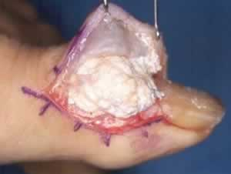
Surgical removal of the the uric acid deposit in gout.

