Name: __________________________________________________ Date: ___________ Mods:_____

**Intro to Joints: How bones come together**

1. Where (between which bones) is the glenohumeral joint?
2. Where is the sacroiliac joint?
3. Where is the a[cromioclavicular](https://en.wikipedia.org/wiki/Acromioclavicular_joint) (AC) joint?
4. Where are the intercarpal (IC) joints?
5. Which of the joints asked about in questions 1-4 is capable of the greatest range of motion?
6. In the picture below, circle any interphalengeal (IP) joint. Draw a square around any metacarpophalengeal (MC) joint

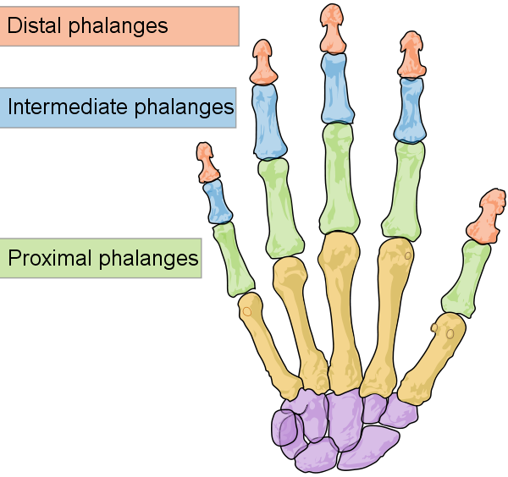

1. Which is the best description of the location of the A1 pulley?
2. Metacarpophalangeal joint (MP joint)
3. Interphalageal jopint (IP joint)
4. Intercarpal joint (IC joint)

|  |  |
| --- | --- |
| Flexor tendon pulley system of thumb | Image result for a1 pulley |

