From Introduction to “Microscopy” at KHANACADEMY
https://www.khanacademy.org/science/biology/structure-of-a-cell/introduction-to-cells/a/microscopy

Microscopes and lenses
Although cells vary in size, they’re generally quite small. For instance, the diameter of a typical human red blood cell is about eight micrometers (0.008 millimeters). To give you some context, the head of a pin of is about one millimeter in diameter, so about 125 red blood cells could be lined up in a row across the head of a pin. With a few exceptions, individual cells cannot be seen with the naked eye, so scientists must instead use microscopes (micro- = “small”; -scope = “to look at”) to study them. A microscope is an instrument that magnifies objects otherwise too small to be seen, producing an image in which the object appears larger. Most photographs of cells are taken using a microscope, and these pictures can also be called micrographs.
From the definition above, it might sound like a microscope is just a kind of magnifying glass. In fact, magnifying glasses do qualify as microscopes; since they have just one lens, they are called simple microscopes. The fancier instruments that we typically think of as microscopes are compound microscopes, meaning that they have multiple lenses. Because of the way these lenses are arranged, they can bend light to produce a much more magnified image than that of a magnifying glass.
In a compound microscope with two lenses, the arrangement of the lenses has an interesting consequence: the orientation of the image you see is flipped in relation to the actual object you’re examining. For example, if you were looking at a piece of newsprint with the letter “e” on it, the image you saw through the microscope would be “ə." More complex compound microscopes may not produce an inverted image because they include an additional lens that “re-inverts” the image back to its normal state.
What separates a basic microscope from a powerful machine used in a research lab? Two parameters are especially important in microscopy: magnification and resolution.
Magnification is a measure of how much larger a microscope (or set of lenses within a microscope) causes an object to appear. For instance, the light microscopes typically used in high schools and colleges magnify up to about 400 times actual size. So, something that was 1 mm wide in real life would be 400 mm wide in the microscope image.
The resolution of a microscope or lens is the smallest distance by which two points can be separated and still be distinguished as separate objects. The smaller this value, the higher the resolving power of the microscope and the better the clarity and detail of the image. If two bacterial cells were very close together on a slide, they might look like a single, blurry dot on a microscope with low resolving power, but could be told apart as separate on a microscope with high resolving power.

Both magnification and resolution are important if you want a clear picture of something very tiny. For example, if a microscope has high magnification but low resolution, all you’ll get is a bigger version of a blurry image. Different types of microscopes differ in their magnification and resolution.

Light microscopes
Most student microscopes are classified as light microscopes. In a light microscope, visible light passes through the specimen (the biological sample you are looking at) and is bent through the lens system, allowing the user to see a magnified image. A benefit of light microscopy is that it can often be performed on living cells, so it’s possible to watch cells carrying out their normal behaviors (e.g., migrating or dividing) under the microscope.

Electron microscopes
Some cutting-edge types of light microscopy (beyond the techniques we discussed above) can produce very high-resolution images. However, if you want to see something very tiny at very high resolution, you may want to use a different, tried-and-true technique: electron microscopy.
Electron microscopes differ from light microscopes in that they produce an image of a specimen by using a beam of electrons rather than a beam of light. Electrons have much a shorter wavelength than visible light, and this allows electron microscopes to produce higher-resolution images than standard light microscopes. Electron microscopes can be used to examine not just whole cells, but also the subcellular structures and compartments within them. One limitation, however, is that electron microscopy samples must be placed under vacuum in electron microscopy (and typically are prepared via an extensive fixation process). This means that live cells cannot be imaged.
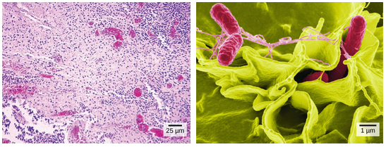
Images of Salmonella bacteria taken via light microscopy and scanning electron microscopy. Much more detail can be seen in the scanning electron micrograph.
Image credit: OpenStax Biology. Credit a: modification of work by CDC/Armed Forces Institute of Pathology, Charles N. Farmer, Rocky Mountain Laboratories; credit b: modification of work by NIAID, NIH; scale-bar data from Matt Russell.
In the image above, you can compare how Salmonella bacteria look in a light micrograph (left) versus an image taken with an electron microscope (right). The bacteria show up as tiny purple dots in the light microscope image, whereas in the electron micrograph, you can clearly see their shape and surface texture, as well as details of the human cells they’re trying to invade.
“Compound Microscope Parts”, from Microscope.com
https://www.microscope.com/education-center/microscopes-101/compound-microscope-parts/
The four basic, structural components of a compound microscope are the head, base, stage and arm.
- Head/Body houses the optical parts in the upper part of the microscope
- Base of the microscope supports the microscope and houses the illuminator
- Stage is the platform on which the specimen to be studied is placed over a hole (“aperture”) for light to pass through
- Arm connects to the base and supports the microscope head. It is also used to carry the microscope.
When carrying a compound microscope always take care to lift it by both the arm and base, simultaneously.
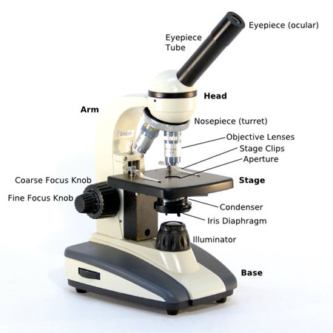
OPTICAL COMPONENTS
There are two optical systems in a compound microscope: Eyepiece Lenses and Objective Lenses:
Eyepiece or Ocular is what you look through at the top of the microscope. Typically, standard eyepieces have a magnifying power of 10x.
Eyepiece Tube holds the eyepieces in place above the objective lens.
Objective Lenses are the primary optical lenses on a microscope. They range from 4x-100x and typically, include, three, four or five on lens on most microscopes.
Nosepiece houses the objectives. This piece rotates so that different objectives can be conveniently selected. Standard objectives include 4x, 10x, 40x and 100x
Coarse and Fine Focus knobs are used to focus the microscope. Increasingly, they are coaxial knobs - that is to say they are built on the same axis with the fine focus knob on the outside. Some microscopes they are separate knobs with the fine focus being smaller. Coaxial focus knobs are more convenient since the viewer does not have to grope for a different knob.
Stage Clips are used to hold the slide in place. The viewer is required to move the slide manually to view different sections of the specimen.
Illuminator is the light source for a microscope, typically located in the base of the microscope
Condenser is used to collect and focus the light from the illuminator on to the specimen. It is located under the stage often in conjunction with an iris diaphragm.
Iris Diaphragm controls the amount of light reaching the specimen. It is located above the condenser and below the stage.

