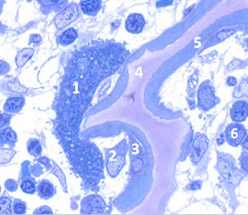
http://www.euroclast.eu/osteoclasts/
Figure 1 - Osteoclasts in bone
A light microscopic image of bone cells in a young mammal.
1. Osteoclast, note how the cell is much larger than any of the other cells around. It has multiple nuclei and is formed through fusion of a number of osteoclast precursor cells. The cell is attached to a spicule of bone which is it degrading. This can be seen as the dark blue line, which is bone, is interrupted.
2. An osteoblast forming bone. The dark blue material is recently laid down bone and with time the cell may become embedded within it and become and osteocyte.
3. An osteocyte, almost completely surrounded by bone matrix, much of which it has produced itself when it was an active osteoblast.
4. The pink material is cartilage matrix. Long bones start life as cartilage and only over time become bone. The staining used here is Toluidine blue and this differentiates between cartilage (pink) and bone (blue).
5. Blue is bone matrix. Note another osteoblast on its way to becoming surrounded by bone.
6. Bone marrow cells.

