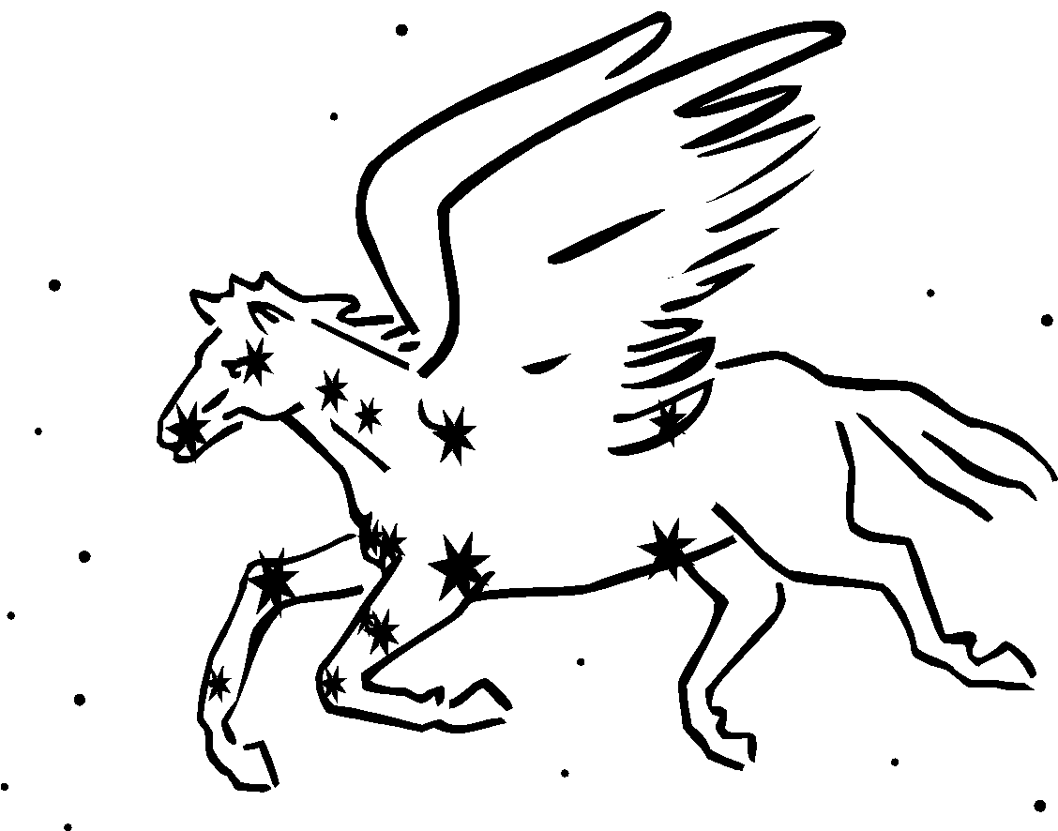  2019-20 | Human Anatomy  & Physiology  Mrs. Sheets, MS.Ed | Website: SheetsBiology.weebly.com  Email: Jsheets2192@columbus.k12.oh.us  Remind: text @SheetsAnat to 81010 or (614) 721-8445

Welcome to CAHS Anatomy & Physiology! Please know that I have high expectations for your success in learning; I teach with the goal of inspiring you to find the subject matter both, worthwhile and interesting to learn.

The focus of this course will be in developing a broad understanding of the structures and their functions in the human body. This course is intended for students who have been successful in both Biology and Chemistry and have an interest in learning about the human body. The pace is swift and your daily participation is expected. Just as in every CAHS course, plan for daily homework, as you are expected to study/review what you need to even when there is no actual assignment. Some of what you need to know involves memorizing terminology and this may require a great deal of practice.

Opportunities to view real organs include dissection (sheep heart, fetal pig or rat) and participating in live and recorded surgical videoconferences. Having enrolled in the course, you should feel generally comfortable with images of blood, surgeries, and organs.
…………………………………………………………………………………………………

CAHS Expectations: Follow the CAHS norms (BeCAHS) and aspire to the IB Learner Profile attributes
…………………………………………………………………………………………………

Expected Course Timeline:
1st Semester  Unit 1: How we learn/ Intro to the communications systems, Requirements of Life (Chapters 2-4), Basic terminology (Ch. 1)  Unit 2: Tissues (Ch.5) and Integumentary system (Ch 6)  Unit 3: Skeletal system. Joints (Ch. 7, 8)  Unit 4: Muscular system (Ch. 9) | 2nd Semester  Unit 5: Cardiovascular system, Blood (Ch. 14-16)  Unit 6: Respiratory system (Ch. 19)  Unit 7: Digestive system (Ch. 17)  Unit 8: Urinary system (Ch. 20)  Unit 9: Reproductive systems (Ch. 13-22)  Unit 10: Nervous System (Ch. 10-12)
The Endocrine (Ch. 13) and Lymphatic/Immunity (Ch.16) systems will be discussed throughout the course along with the other systems.

Textbook: Hole’s Human Anatomy & Physiology, 12th edition

Class Materials: In addition to a pencil and a science notebook (folder/binder) where you keep all of your materials, you will need colored pencils and index cards throughout the year.

Lab Fee: There is a lab fee for all CAHS sciences; the fee for A&P is $10.00 payable via Infinite Campus
………………………………………………………………………………………………………………..

Communication and Tracking Academic Progress:
Please check the Infinite Campus Parent/Student portal often. As a courtesy to all, grades and attendance data will be communicated here daily. Please contact me as soon as you have any questions or concerns. I can be reached via email, Remind, or by calling the CAHS main office and leaving a message. When contacting me, please include student’s first & last name in your communication. I make parent contact regarding individual progress and behaviors primarily through Infinite Campus messaging/email.

*Please use the course webpage: SheetsBiology.weebly.com for class events, due dates, and resources.

NEED EXTRA HELP? I am available mods 13/14 and some days after school by appointment – JUST ASK!

Policies and Procedures:
Class Rules: Be prepared, follow directions, and adhere to all Student Handbook guidelines. You are expected to behave respectfully and responsibly; ways to do that include:

- Respecting yourself by being attentive and completing your original work on time. Please ask questions when you need clarification. Sleeping in class is inappropriate - If you are ill, see the nurse and/or arrange to go home.

Academic Honesty Policy: All work you submit must be your own and must not be shared for copying. The copied and the copier are both penalized. You can do your work! Please communicate to me your mastery or need for help. If caught cheating, both the copied and copier will be penalized.

- Respecting others by following directions, participating in class, maintaining a positive attitude, following lab safety rules, and keeping your device from being a distraction (out of sight/hearing/touch unless specifically permitted to use it.) Per CAHS policy, devices may be confiscated for a time or until a parent meets with administrator to pick up. Abuse of the device policy may also result in loss of engagement points and/or administrative discipline per CAHS policy.

- Respecting property by not touching another’s personal possessions or class/lab materials without asking, taking good care of class/lab equipment, putting materials back. CCS policy prohibits eating in the classroom.

*Failure to abide by rules may result in warning/reminding, guardian contact, administrative referral, or removal from class/activity.

Grading: Refer to the district grading policy for grade bands. Quarterly grade information is updated continuously on Infinite Campus. Most of the quarter grade is based on quiz scores, though there is some value given for class engagement, assignments, labs, and occasional extra credit. The lowest quiz score of the quarter will be exempted from quarter grade calculation.

Classwork and Homework: All paper-based assignments will be available in a student-accessible file located centrally in the classroom for anyone who needs a copy. Homework may be mandatory or optional; optional HW will not be accepted after the “due by” date and will not be calculated into your grade if missing, incomplete or incorrect. All collected homework is due on the date specified and at the very beginning of class. Any mandatory assignment that is turned in after the start of class is considered late and will receive a reduction in points. Classwork and optional HW will never be accepted late.

Attendance and Quizzes: Attendance is required and can seriously affect your grade. Success depends on your presence and your active participation. You are expected to complete all assignments missed for knowledge and experience regardless of grade-earning status. It is your responsibility to seek out the class content/materials provided in class the day(s) that you are absent.

Any work due on a day of excused absence is due the day you return to school to earn full credit. If you arrive to school late, after class has met, it is your responsibility for dropping off due work. Access the class website for more information and resources to assist you due to missed class time.

Missed quizzes may be made up due to an excused absence and you must arrange for make-up on the day of your return. If you arrive late to CAHS after our class has met – contact me that day. Missed quizzes that you do not arrange to make up will result in a possible exemption or zero earned. A missed quiz, or first absence on a quiz day, will count as your dropped quiz for the quarter. Remaining “excused” missed quizzes will need to be made up on the day of return. If you have an unexcused absence/tardy you may earn a zero for mandatory work/quizzes missed.

Suspension is treated as an unexcused absence. All assignments due while suspended should be picked up at the beginning of suspension for opportunity to turn them in for credit on or before the day of return. It is your responsibility to avoid suspension.

Tardiness: You are expected to be in the room and near your seat and ready to begin by the bell or you are considered tardy. The CAHS tardy policy is enforced; tardiness may result in a detention and/or loss of points.

Hall Passes: Hall pass availability is limited and to be used for restroom use. Your timeliness, class behavior and recent usage may limit your use of the pass.

